Software Requirements Specification

Development of Technical

Requirements for Land Information System (LIS), Needs Assessment and Preparation of a Roadmap for Establishing the Land Information System (LIS) for Georgia

|  |  |
| --- | --- |
| Document permissions | Confidential – client |
| Project number | GR/CS/CQS/04 |
| Project name | Development of Technical Requirements for Land Information System (LIS), Needs Assessment and Preparation of a Roadmap for Establishing the LIS |
| Report title | Software Requirement Specification |
| Report number | 005 |
| Release number | 03-00 |
| Report date | 07th Aug 2025 |
| Client | MEPA |
| Client representative | Lali Durmishidze |
| Project manager | Lali Durmishidze |

Document history

|  |  |  |  |  |  |
| --- | --- | --- | --- | --- | --- |
| Date | Release | Prepared | Approved | Authorised | Notes |
| 26/05/25 | 01-00 | RMSI |  |  | First Draft |
| 08/09/25 | 02-00 | RMSI |  |  | Incorporation of client feedback and an enhanced version with ISO/IEC/IEEE 29148 compliance |
| 29/10/25 | 03-00 | RMSI |  |  | Incorporation of PIU Feedback + Finalised Functional Catalogue + WB Feedback |
| 07/11/25 | 04-00 | RMSI |  |  | Incorporation of feedback of PIU |
| 13/11/25 | 05-00 | RMSI |  |  | Incorporation of feedback of PIU |

|  |  |
| --- | --- |
| **Land Information System (LIS) — Executive Summary**  Software Requirements Specification (Release 02‑00) | |
| Client: MEPA / Land Management Agency (LMA) | Date: 09 Sep 2025 |
| ***Purpose & Mandate***  *Defines LIS software for Georgia under LMA/MEPA, consolidating stakeholder and system needs into precise, testable requirements aligned to ISO/IEC/IEEE 29148.*  ***Strategic Objective***  *Unify land data and services across 20+ agencies into a single authoritative platform to improve evidence-based decision‑making, transparency, and citizen service delivery.*  ***What LIS Delivers***  *✓ Central spatial database; automated ETL; secure internal/public portals; mobile app with offline sync.*  *✓ Interagency integration via secure APIs; OGC WMS/WFS; open‑data endpoints where appropriate.*  *✓ Analytics, dashboards, and statutory reporting (e.g., National Land Balance); LULC change‑detection alerts.*  ***Architecture & Governance***  *✓ On-prem hosting in MEPA data centre; clustered web/app/GIS and database tiers; no single points of failure.*  *✓ Standards-based and vendor-neutral (ISO 19152 LADM, ISO 19115, OGC, WCAG 2.1 AA).*  ***Implementation & Cost***   * *Effort baseline: ≈ 172–184 person-months, based on 1,101 Function Points and a productivity assumption of 25 hours per Function Point.* * *Development & integration cost: ≈ USD 1.50 million, inclusive of accelerated delivery, seniorised staffing, enhanced non-functional assurance, multi-agency integration complexity, and a one-year post–go-live warranty.* * *Operations & Maintenance: Twenty (20) months following completion of the warranty period, budgeted at approximately 15% of the development cost per year, pro-rated for the 20-month duration (totaling approximately USD 375,000).* * *Delivery window: 8 months, achieved through increased concurrent staffing, parallel workstreams, early environment readiness, and continuous integration/continuous deployment (CI/CD) practices.*   ***Expected Outcomes***   * *Faster, transparent e-services.* * *Stronger data governance and inter-agency coordination; secure, role-based access with full audit trails.* * *• Improved policy and planning via integrated analytics, dashboards, and timely official reporting.* | **At a Glance**   |  | | --- | |  | | **20+**  Agencies | | NAPR, NFA, APA, NWA, RDA, GA, SRCA |  |  | | --- | |  | | **≈700**  Users | | ≈500 internal + ≈200 field |  |  | | --- | |  | | **99.9% / 24h / 4h**  Non‑functional | | Uptime / RTO / RPO |  |  | | --- | |  | | **8 month**  Schedule | | Parallel workstreams |   **Key Specs**  **Standards:** ISO/IEC/IEEE 29148; ISO 19152; ISO 19115; OGC WMS/WFS; WCAG 2.1 AA  **Hosting:** MEPA on-prem; clustered services; DR planned  **Security:** RBAC, TLS, audit logs, SIEM integration  **APIs:** REST/JSON (primary), SOAP (legacy as needed) |

Note: Figures are indicative baselines and subject to procurement, integration partner availability, and detailed design.

Contents

1 Introduction 7

1.1 Purpose 7

1.2 Scope 7

1.3 Definitions, Acronyms, and Abbreviations 10

1.4 References 12

1.5 Document Overview 12

1.6 Document Conventions 13

2 Overall Description 14

2.1 Product Perspective 14

2.2 Product Functions 16

2.3 User Classes and Characteristics 20

2.4 Operating Environment 23

2.5 Design and Implementation Constraints 28

2.6 User Documentation 30

2.7 Assumptions and Dependencies 32

3 Specific Requirements 34

3.1 Functional Requirements 34

3.1.1 User Management and Security 34

3.1.2 Core Data Management and Integration 44

3.1.3 Spatial Analysis and Visualisation 53

3.1.4 Electronic Service Delivery 61

3.1.5 Reporting & Decision Support 70

3.1.6 Field and Mobile Services 76

3.1.7 Transparency and Open Data 81

3.2 External Interface Requirements 85

3.2.1 User Interfaces 85

3.2.2 Hardware Interfaces 86

3.2.3 Software Interfaces 86

3.2.4 Communication Interfaces 87

3.3 Non-Functional Requirements 88

3.3.1 Performance Requirements 88

3.3.2 Security Requirements 88

3.3.3 Usability and Accessibility Requirements 89

3.3.4 Software Quality Attributes 90

3.4 Logical Database Requirements 91

3.5 UML Component Diagram 92

3.6 Design Constraints 92

3.7 Business Rules and Constraints 93

4 Appendices 94

4.1 Appendix A — Effort & Cost Estimation (Multi‑Model, Self‑Contained) 94

4.2 Summary 94

4.2.1 Function Point Analysis (Primary Method) 95

4.2.2 Warranty & Operations Support 97

4.2.3 Basis of Cost Estimate 97

4.2.4 Cross‑Check Models (Not for Pricing; for Sanity) 98

4.2.5 Schedule Commitment & Reasons (8 Months) 99

4.2.6 Assumptions & Risks 99

4.2.7 Final Baseline Summary 100

4.3 Appendix B: Requirements Traceability Matrix (RTM) 100

4.3.1 SRS to SyRS/StRS Traceability 100

4.4 Appendix C: Verification Traceability Matrix (VTM) 117

4.4.1 Performance Requirements — Verification 117

4.4.2 Security Requirements — Verification 118

4.4.3 Usability & Accessibility — Verification 119

4.4.4 Reliability & Availability — Verification 120

4.4.5 External Interface & Communication — Verification 120

4.4.6 Functional Use Cases — Verification 121

4.4.7 Privacy & Open Data — Verification” beneath existing performance/security rows 125

4.4.8 V&V Governance and Evidence 126

4.5 Appendix D: Glossary 127

4.5.1 Foundational Project and Stakeholder Terminology 127

4.5.2 Domain-Specific Concepts 128

4.5.3 (Estimation) Terminology (Function Point / COCOMO / UCP) 131

4.5.4 (Estimation) Terminology (Function Point / COCOMO / UCP) 132

# Introduction

## Purpose

This Software Requirements Specification (SRS) defines the software requirements for the Land Information System (LIS) to be developed for the Land Management Agency (LMA) under Georgia’s Ministry of Environmental Protection and Agriculture (MEPA). Its purpose is to explicitly state what the LIS software must do to satisfy all identified stakeholder and system requirements, using clear, testable language without bias toward any specific technology or vendor. This SRS serves as a binding agreement among stakeholders (clients and end users) and the software development team, detailing all functional and non-functional requirements that the LIS must meet. It is written in accordance with ISO/IEC/IEEE 29148:2018 requirements engineering standards and incorporates requirements from the Stakeholder Requirements Specification (StRS) and System Requirements Specification (SyRS) for the LIS. The SRS will guide the design, development, and verification of the LIS, ensuring that the final system meets Georgia’s land information management goals and complies with relevant standards and policies.

## Scope

The Land Information System (LIS) is envisioned as a comprehensive national geospatial platform for land administration, planning, and management in Georgia. While operated by LMA under MEPA, it will serve multiple government agencies and the public. The scope of the LIS software encompasses all components and services needed to unify and manage land-related data from over 20 government agencies in a single authoritative system. It covers internal government portals, public-facing e-services, data integration pipelines, analytics tools, and specialised modules for various land management domains. Key in-scope capabilities include:

* **Centralised Spatial Database & Data Integration:** Establish a single “source of truth” spatial database consolidating cadastral, land use/land cover, environmental, agricultural, and other land-related datasets from all participating agencies. The system must provide automated Extract-Transform-Load (ETL) processes for the regular import of external agency data into the LIS, including transformation, quality validation, versioning, and audit trails. Data from authoritative sources (e.g. NAPR’s cadastre, NFA’s forest data, APA’s protected areas, NWA’s vineyard cadastre, Georgian Amelioration’s irrigation data, SRCA’s soil/climate data, etc.) will be routinely integrated. The LIS maintains historical versions of datasets and ensures data integrity via validation rules and conflict resolution for multi-user edits.
* **Internal Government Portal:** Provide a secure, role-based web application for LMA and other authorised agency staff to view and manage land information. The back-office portal must support the creation and editing of spatial data (with full GIS functionality such as drawing parcels, editing attributes, and applying topology rules), the management of workflows (e.g., reviewing and approving land-use applications), the generation of maps and reports, and system administration tasks. This portal will offer advanced GIS tools (layer control, analysis functions, editing tools) in a browser-based interface, avoiding reliance on standalone desktop GIS software. Role-based access control tailors the interface to each user’s permissions (e.g., data editors, approvers, administrators) to streamline their tasks. The internal portal operates on government networks (intranet/VPN) for security.
* **Public Portal and E-Services:** Provide a user-friendly public-facing web portal for citizens, landowners, farmers, businesses, and other external stakeholders to access land information and conduct land-related transactions online. The public portal must allow users to search and view non-sensitive land data via interactive maps and simple queries, without login for basic information. The public portal must be bilingual (entirely in Georgian and English) and comply with accessibility standards (WCAG 2.1 AA) to ensure usability for all citizens. It must be accessible via standard web browsers on desktops and mobile devices (responsive design) without requiring any special plugins.
* **Specialised Sector Modules:** Include integrated functional modules addressing specific sectoral workflows and analytical needs in land management. These modules are part of the LIS (not standalone applications) and share the centralised database and interface. Identified modules cover: Land Use/Land Cover (LULC) Mapping & Change Detection – tools to classify land cover from satellite imagery and automatically detect changes over time (e.g. deforestation, urban expansion); Pasture Management – an e-service and internal workflow for pastureland lease applications and monitoring of pasture use; Forestry Management – features for National Forestry Agency to update forest compartment data, issue forest use permits, and monitor illegal logging (with integration of field reports and satellite alerts); Protected Areas Management – tools for the Agency of Protected Areas to zone and regulate activities around protected territories (including an alert system for encroachments); Vineyard Cadastre – capabilities for the National Wine Agency to maintain a registry of vineyards and grape varieties, track wine production land, and issue relevant certifications; Irrigation and Amelioration – integration of data and workflows related to irrigation infrastructure and land amelioration managed by Georgian Amelioration; Soil and Agro-ecological Data Integration – incorporate soil quality maps, climate data, and research from SRCA for analyses like land suitability and degradation assessment. These modules provide domain-specific functionality (business rules, data sets, analysis models) while adhering to the LIS’s unified standards and interface. They ensure that the LIS serves the needs of multiple sectors (agriculture, environment, forestry, etc.) within a single platform.
* **Mobile Field Application:** Provide a mobile application (Android and iOS) for field officers (approximately 200 users across agencies such as forestry rangers, agricultural extension officers, and protected area inspectors) to use LIS capabilities in the field. The mobile app must operate offline to support remote areas with no connectivity: users can download relevant maps and forms, collect data (GNSS coordinates, photos, observations) offline, and later synchronise with the central system when network connectivity is available. Field use cases include conducting site inspections and surveys, verifying ground truth for reported land changes, reporting incidents (e.g. illegal land use or environmental damage) which create cases in LIS, and updating the status of tasks assigned to them. The app shall leverage device sensors (GNSS for location, camera for photos) and provide an intuitive interface with extensive controls and support for local language (Georgian), allowing non-technical staff to use it with minimal training. It will clearly indicate the offline/online status and automatically sync data when a connection is restored. This extends LIS functionality to on-site operations, ensuring that field-collected data is seamlessly integrated into the central LIS database.
* **Advanced Analytics, Reporting, and Decision Support:** Provide tools to derive insights and support evidence-based decision-making from the integrated land data. The system will support spatial queries and analysis (e.g., filtering parcels by attributes and performing buffer or overlay operations) in real time via the user interface. Advanced geoprocessing functions will be available to internal analysts, including terrain analysis (slope, elevation), network analysis (finding optimal routes or service areas), multi-criteria analysis for land suitability, and change-detection algorithms for time-series satellite imagery. The LIS will automate specific analyses—for example, generating land cover change alerts by comparing new satellite images with baseline data, or running crop suitability models based on soil, climate, and terrain datasets. The system must support 3D visualisation of geospatial data (e.g., terrain and land features) to help specialists and planners better understand topography and the potential impacts of land-use decisions. Reporting capabilities include the on-demand generation of standard reports required by law or policy, notably the annual National Land Balance Report, which aggregates land categories as mandated by the Law on Sustainable Management of Agricultural Land. At the press of a button, the LIS must compile necessary statistics from its database and output the report in the required format (with appropriate tables, maps, and figures). Other reports (e.g., on land degradation, forest cover, soil fertility, or project-specific indicators) will also be supported. The system will provide a dashboard for real-time monitoring of key performance indicators (KPIs) and metrics, including the number of new applications this month, the percentage of agricultural land in active use, and the area of degraded land identified. These dashboards provide decision-makers with an at-a-glance view and will update automatically as new data becomes available. Overall, the analytics and reporting functions transform raw data into actionable information, supporting evidence-based policy decisions and transparency.
* **Interoperability and Integration:** Ensure the LIS can effectively exchange data with external systems and adhere to open standards. The LIS will expose standard web services for geospatial data, including OGC-compliant services such as Web Map Service (WMS) and Web Feature Service (WFS), allowing other systems or users to consume maps and GIS data directly. It will also provide a RESTful API (and/or SOAP, where needed) for retrieving LIS data and submitting transactions from external applications. Critically, the LIS must integrate in real-time with key government information systems: for example, a two-way integration with NAPR’s National Cadastre so that LIS can receive up-to-date parcel and ownership information and possibly push back specific updates or flags; integrations with systems of the National Forestry Agency (NFA), Agency of Protected Areas (APA), National Wine Agency (NWA), Rural Development Agency (RDA), Georgian Amelioration (GA), Scientific-Research Centre of Agriculture (SRCA), and others to exchange data on forests, protected zones, vineyards, farmers, irrigation infrastructure, soil data, etc. via secure APIs. The LIS will not duplicate or replace other agencies’ core systems; for instance, it will not perform legal property registration (which remains NAPR’s mandate) or general financial management tasks. Instead, LIS consumes authoritative data from those systems and links to them as needed. Any functionality that properly belongs in another system is explicitly outside the scope of LIS. The LIS will also rely on authoritative base datasets (such as topographic maps and orthophotos) from providers like NAPR or the National Spatial Data Infrastructure, rather than generating them itself.
* **Out of Scope:** Functionality not related to land information management or that duplicates existing systems is outside the scope of LIS. The LIS will not replicate NAPR’s legal cadastre registration functions (title registration, issuance of legal ownership certificates) or any other agency’s non-land business systems (e.g., it will not manage internal finance, HR, or general document management for agencies, except where directly tied to land service workflows). It is not intended to serve as a general GIS for unrelated domains. Hardware procurement (such as purchasing servers or field devices) is outside the software scope, though hardware requirements are identified for planning purposes. The LIS is also not responsible for improving the intrinsic quality of source data provided by other agencies (each source agency remains responsible for the accuracy of its data). However, LIS will flag quality issues and support correction workflows. Any future modules or services beyond those defined in the StRS/SyRS documents would be considered a separate scope unless formally added to requirements.

In summary, this SRS encompasses all software requirements for developing a vendor-neutral, comprehensive Land Information System for LMA/MEPA that meets Georgia’s land governance needs. It emphasises capabilities and standards rather than specific technologies. The LIS requirements are specified to be system-independent—describing what the software must do and the standards it must support, without prescribing any particular commercial software product or proprietary solution. This ensures competition and flexibility in implementation while guaranteeing the system delivers the needed functionality.

## Definitions, Acronyms, and Abbreviations

Acronyms and terms used in this SRS are defined below for clarity:

|  |  |  |
| --- | --- | --- |
| **Acronym** | **Full Term** | **Definition** |
| **LIS** | Land Information System | Integrated platform for land-related data management and services. |
| **LMA** | Land Management Agency | The agency under MEPA is responsible for LIS operation. |
| **MEPA** | Ministry of Environmental Protection and Agriculture | Parent ministry for LMA. |
| **NAPR** | National Agency of Public Registry | Maintains legal cadastre and parcel registry. |
| **NFA** | National Forestry Agency | Manages forest inventory and operations. |
| **APA** | Agency of Protected Areas | Regulates activities in protected zones and parks. |
| **NWA** | National Wine Agency | Oversees vineyard cadastre and wine production. |
| **RDA** | Rural Development Agency | Manages farmer registries, subsidies, and agro-programs. |
| **GA** | Georgian Amelioration | Handles irrigation and amelioration infrastructure. |
| **GNSS** | Global Navigation Satellite System | Satellite network providing global positioning service |
| **SRCA** | Scientific-Research Centre of Agriculture | Provides agro-ecological and climate data. |
| **NSDI** | National Spatial Data Infrastructure | Framework for sharing and standardising geospatial data across Georgia. |
| **GIS** | Geographic Information System | System for capturing, storing, analysing, and visualising spatial data. |
| **ETL** | Extract, Transform, Load | Data pipeline for importing and transforming data from multiple sources. |
| **BPM** | Business Process Management | Approach for managing organisational workflows efficiently. |
| **BPMN** | Business Process Model and Notation | Standard graphical notation for business process workflows. |
| **RTO** | Recovery Time Objective | Maximum acceptable time to restore the system after a failure. |
| **RPO** | Recovery Point Objective | The maximum acceptable period in which data might be lost due to a failure. |
| **OGC** | Open Geospatial Consortium | Publishes geospatial data/service standards (e.g., WMS, WFS). |
| **WMS** | Web Map Service | OGC standard for serving georeferenced map images over the web. |
| **WFS** | Web Feature Service | OGC standard for serving spatial vector data features. |
| **ISO** | International Organization for Standardization | Global body defining data, software, and metadata standards. |
| **WCAG** | Web Content Accessibility Guidelines | Accessibility standards for web interfaces. |
| **COTS** | Commercial Off-The-Shelf | Pre-packaged software products are available commercially. |
| **UML** | Unified Modelling Language | Diagramming standard for visualising software systems. |

(Additional domain-specific terms are defined in the project’s glossary document. In this SRS, “the System” refers to the LIS software system.)

## References

This SRS is based on and traceable to the content of the following source documents and standards, which contain the higher-level stakeholder needs, system requirements, and relevant guidelines:

* **Final_LMA_StRS** – Stakeholder Requirements Specification (StRS), version 2.0, 07 Aug 2025. This document captures the needs, expectations, and constraints of all LIS stakeholders in business terms (the “what” and “why” from the users’ perspective). It served as the primary reference for defining LIS software features and ensuring that each software requirement is traceable to a stakeholder need.
* **LMA_LIS_SyRS** – System Requirements Specification (SyRS), version 2.0, 07 Aug 2025. This comprehensive document defines the system-level functional and non-functional requirements for the entire LIS (including hardware, software, integration, and architecture considerations) in accordance with ISO 29148. It provides detailed technical requirements (with identifiers such as FUN-xx, SEC-xx, etc.), which have been adapted and refined here into software-specific requirements.
* **NFR_Checklist_Template.docx** – Non-Functional Requirements Checklist. A guideline checklist enumerating quality requirements (performance, security, usability, etc.) was used to ensure that all relevant non-functional criteria were included in this SRS.
* **ISO/IEC/IEEE 29148:2018 – Requirements Engineering:** The international standard that defines best practices for writing stakeholder, system, and software requirements. This SRS adheres to the structure and language guidelines recommended by this standard to ensure its requirements are clear, complete, and testable.
* **ISO 19152:2012 – Land Administration Domain Model (LADM):** An international standard model for land administration information. Served as a reference for designing the LIS logical data model, ensuring the database aligns with global best practices for cadastre and land records.
* **ISO 19115:2014 – Geographic Information – Metadata:** International standard for geospatial metadata. Referenced to ensure LIS implements proper metadata for its datasets and services.
* **Applicable Georgian Laws and Policies** – e.g., the Law on Sustainable Management of Agricultural Land (2019), Law on Personal Data Protection (2011), and other regulations. These inform specific LIS requirements, such as producing the annual Land Balance report (mandated by law) and protecting personal data (LIS must enforce privacy and security measures for any personal information). Compliance with relevant national e-government standards and data-sharing policies is assumed.

## Document Overview

This SRS is organised into the following sections, following the IEEE 29148 recommended structure for software requirements:

* **Section 2 – Overall Description:** Provides background and context for the LIS software. It describes the product’s perspective in its broader environment, the system's primary functions, user classes and characteristics, the operating environment, design and implementation constraints, user documentation needs, and assumptions and dependencies. This section gives a high-level understanding of the LIS and the environment in which it will operate.
* **Section 3 – Specific Requirements:** Details the requirements that the LIS software must fulfil. It is subdivided into:
  + **Functional Requirements (3.1):** A catalogue of use cases that the software must support, describing the system’s behaviour for various scenarios. Each use case definition includes its triggers, the main flow of events, the actors involved, and the outcomes, providing a functional specification of what the system will do.
  + **External Interface Requirements (3.2):** Specifications of how the software interacts with external entities. This encompasses user interfaces (including look and feel and usability requirements), hardware interfaces (interactions with devices and equipment, if applicable), software interfaces (integration with other software systems or APIs), and communication interfaces (protocols and network requirements).
  + **Non-Functional Requirements (3.3):** Quality attributes and global requirements the software must meet, such as performance targets, security controls, usability and accessibility criteria, reliability, and maintainability. These are organised by category for clarity.
  + **Logical Database Requirements (3.4):** Requirements related to the system’s data storage and data model. This includes data schema expectations, storage capacity requirements, data retention policies, and compliance with data model standards such as LADM.
  + **Design Constraints (3.5):** Mandated design decisions or constraints on the implementation, such as regulatory constraints, required use of specific standards or technologies, and other design guidelines that must be adhered to (e.g., system must be deployable on-premises, must use open standards, etc.).
* **Section 4 – Appendices:** Additional supporting information and analysis. Appendix A provides a Software Effort and Cost Estimation for developing and deploying the LIS, using Function Point Analysis (FPA) to estimate size and effort, and translating those estimates into a schedule and cost. Other appendices may include data dictionaries or detailed analysis results as needed.

Each requirement is traceable back to one or more stakeholder or system requirements in the StRS/SyRS (traceability matrices are maintained separately). BPMN & UML diagrams (such as use case diagrams, class diagrams, activity flows, and a high-level deployment diagram) are included in the project documentation to illustrate the requirements from multiple perspectives.

## Document Conventions

This SRS follows the IEEE 29148 standard structure for requirements specification. Each requirement is uniquely labelled with an identifier in square brackets following the pattern [SRS-<Category>-<Number>], where “Category” is a short code for the requirement type (e.g., BUS for business, USR for user, FUN for functional, PRF for performance, SEC for security, REL for reliability, etc.). For example, [SRS-BUS-001] denotes Business requirement #1. Requirements are prioritised as Critical (C), High (H), Medium (M), or Low (L), reflecting their importance or impact. Non-functional requirements (quality attributes) are similarly identified by category codes (e.g., PRF for performance, SEC for security).

# Overall Description

## Product Perspective

The LIS software is a central hub in Georgia’s land information ecosystem, interfacing with numerous external agencies and users. It is both a data integration platform and an application platform. Figure 1 depicts the high-level system context and deployment architecture of LIS within MEPA’s IT environment. In summary:

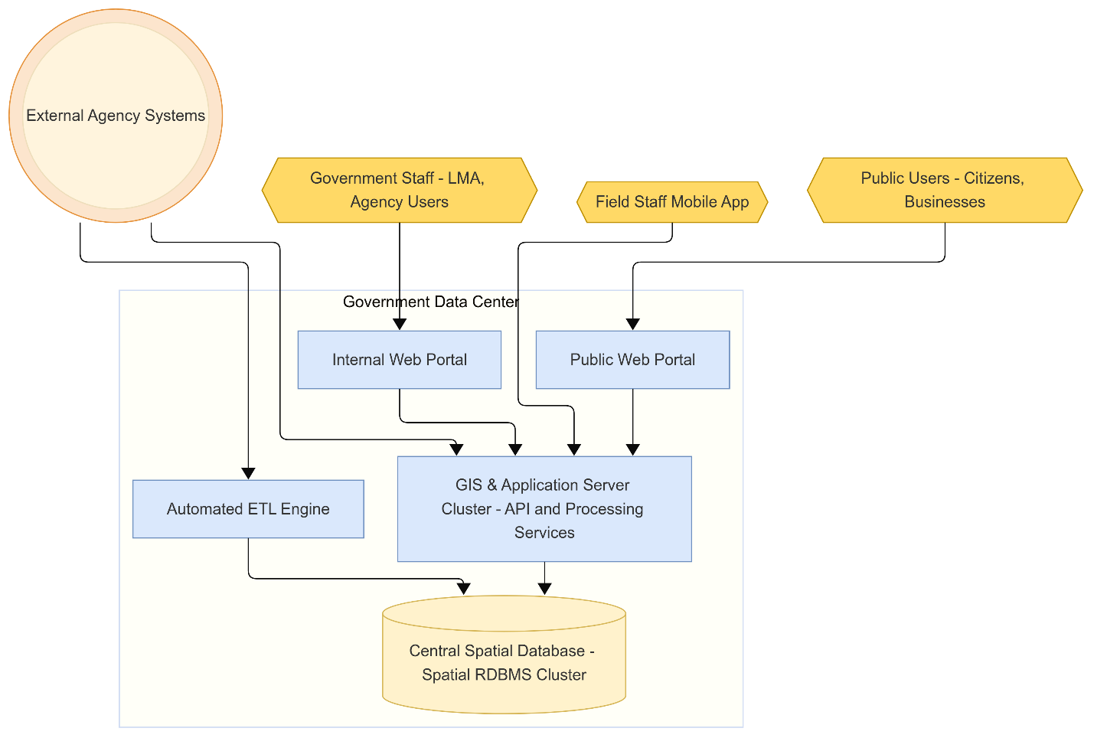

**Figure 1: LIS Context and Deployment Diagram.** *The LIS operates on MEPA’s infrastructure (data centre servers). It comprises Web Portals for internal and public users, a cluster of GIS/Application services (including API and processing engines), a central spatial database, and an ETL engine for data integration. Government staff access the Internal Portal through a secure network (intranet or VPN), while the public accesses the Public Portal via the internet. Field staff use a mobile application that syncs via the application/API services. The LIS integrates with external agency systems through scheduled ETL jobs and real-time APIs. External agencies provide data to LIS, which then publishes data/services (e.g., OGC web services) for external systems. All components within the data centre are redundantly deployed (clustered) to eliminate single points of failure.*

* **System Context:** The LIS is deployed on MEPA’s government data centre infrastructure and integrates with external systems while providing services to users. Internally, it consists of multiple components: web portals for internal users (government staff) and external users (public), a cluster of application servers (handling business logic, GIS processing, and APIs), a central spatial database, and an ETL engine for data exchange with other systems. External agency systems (e.g., NAPR, NFA) connect to the LIS either through scheduled batch data transfers or real-time web service APIs. Field users connect via a mobile app that synchronises through the same application servers.
* **Deployment Architecture:** The LIS adopts a multi-tier architecture for scalability and reliability. It includes:
  + A Presentation Tier with two primary front-ends: an Internal Web Portal (accessible on the government intranet or via secure VPN for authorised agency staff) and a Public Web Portal (accessible via the internet to citizens and external users). Both are browser-based applications. Additionally, a Mobile Application serves field staff, enabling them to work offline and sync data through the server tier when they are online.
  + A Service/Business Logic Tier consisting of application servers and GIS servers. These handle user requests, execute workflows, run GIS analyses, and enforce business rules. They also host an API gateway that exposes LIS functionality and data to external systems via REST/JSON or SOAP services, as well as OGC-compliant endpoints for geospatial data. This tier is designed to be scalable (multiple server instances in a cluster) and, where possible, stateless to support load balancing.
  + A Data Tier with a central spatial database that stores all land data (vector maps, attribute data, documents, etc.) and maintains version histories. The database is replicated for high availability (e.g., an active-passive failover to avoid downtime). A separate data integration/ETL component is responsible for importing data from external sources into the database and ensuring consistency.
* All these components are deployed on virtual servers in MEPA’s on-premises data centre. The system will utilise multiple Virtual Machines (VMs) segmented by function, such as separate VMs for web front-end, GIS processing services, and the database, to distribute the load effectively. Redundancy is built in by clustering VMs for critical functions (web/app and database) to eliminate single points of failure. If one instance goes down, others continue serving users.
* MEPA’s data centre environment (as of 2025) has substantial capacity (on a Microsoft Hyper-V virtualisation farm with ~824 logical CPU cores and ~11 TB RAM across servers). The SyRS capacity planning indicates that LIS can be allocated on the order of 6–10 VMs, utilising roughly 40–100 CPU cores and 200–600 GB RAM in total across tiers, and about 7–15 TB of storage for its data needs (to accommodate large volumes of spatial data, including high-resolution imagery). This capacity will be adjusted as needed to meet performance requirements (see Section 3.3).
* **External Interfaces (Context):** In operation, the LIS interfaces with:
  + **Human Users:** Internal staff (LMA and other agencies) access the internal portal over secure government networks; field staff use the mobile app on tablets/phones; public users access the public portal via the internet on various devices.
  + **External Systems:** The LIS exchanges data with external agency systems. For example, a two-way integration with NAPR’s cadastre ensures that LIS can fetch the latest parcel and ownership data, and possibly send back updates or flags (such as an LIS case reference for a parcel). Similar data interfaces exist for other agencies, including NFA’s forest database, APA’s protected area registry, NWA’s vineyard cadastre, RDA’s farmer registry, and GA’s irrigation data, among others. These interfaces use web services or file transfers as appropriate, all of which are secured and in standardised formats. The LIS also exposes open geospatial services (WMS/WFS/WCS) to allow systems or users (e.g., a national geoportal or GIS analysts) to retrieve maps or data directly from LIS.
* **Assumptions and Dependencies**
  + A1. Participating agencies (e.g., NAPR, NFA, APA, NWA, GA, SRCA) shall provide dataset access and regular updates in accordance with the interface requirements in Section 3.2 and agree on service levels for timeliness and accuracy.
  + A2. Identity federation or national eID shall be made available by the government IdP for SSO integration.
  + A3. MEPA shall provide LIS hosting, backup, and DR infrastructure in accordance with the Section 3.3 targets.
* All components in the LIS deployment are hosted within MEPA’s secure government data centre, benefiting from existing infrastructure like power backups, physical security, and network connectivity. The design also anticipates establishing a Disaster Recovery (DR) capability at a secondary site (currently an infrastructure gap) to meet resilience requirements – see Section 3.3 for RTO/RPO targets and assumptions regarding DR.

Overall, the LIS functions as the central piece of a broader land information ecosystem: it consolidates data from many sources, provides users with unified access and tools, and shares data with others via services. This hub-and-spoke integration context (LIS as the hub) underlies many of the requirements in this document.

Although modules encapsulate domain-specific logic, the LIS adopts a centralised spatial database model with schema partitioning per module rather than separate physical databases. Microservice data stores were assessed and rejected to ensure referential integrity, simplified version control, and unified governance.

## Product Functions

At a high level, the LIS software must fulfil several primary functions, each corresponding to major groups of use cases and providing distinct value to stakeholders. These core functional areas are summarised below (details and specific scenarios are elaborated in Section 3.1):

* **Central Data Consolidation and Management:** The LIS must serve as an authoritative land data repository for Georgia. It integrates and consolidates data from multiple agencies into a unified spatial database, eliminating discrepancies between siloed datasets. Functions include:
  + **Automated Data Import/Update:** The system shall regularly ingest data from external sources (e.g. new or updated cadastral parcel records from NAPR, updated forest inventory from NFA, new soil survey data from SRCA) via scheduled ETL jobs or API calls. Imported data is transformed to LIS’s schema, coordinate system, and standards, with validation to ensure no corrupt or invalid data enters the system.
  + **Data Editing and Maintenance:** Authorised users (e.g., LMA editors, agency data custodians) shall be able to update non-spatial attributes (e.g., land use, tenure type, ownership, zoning, document references) of existing spatial records through the internal portal’s GIS or tabular interface. Attribute edits shall be treated as atomic transactions — meaning each update is applied directly to the production database after validation of business rules (e.g., domain constraints, code lists, referential integrity). Because attribute edits typically affect isolated records and do not modify feature geometries or topology, they shall not, by default, trigger check-out or versioning mechanisms. Instead, row-level transaction locks (database-level) may be used transiently to prevent concurrent update conflicts.

All attribute modifications shall be logged in the audit trail, recording the edited field(s), the previous and new values, the user ID, the timestamp, and the source layer.

* + **Quality Control:** The system must enforce data quality rules. Specific critical edits may require a review/approval workflow before they become official (e.g., if a regional user changes a protected area boundary, a supervisor must approve it). This ensures the centralised database remains internally consistent and trustworthy for all users.
* **Spatial Analysis and Decision Support:** The LIS must provide tools for users to analyse spatial information and support decision-making:
  + **Advanced Geoprocessing Functions:** Internal analysts require a suite of GIS analysis tools available within LIS. The system shall support operations such as spatial overlays (e.g., intersecting proposed irrigation networks with soil maps), proximity analysis (e.g., finding all wells within 1 km of a particular area), network analysis (e.g., distance to the nearest road), and terrain analysis (e.g., slope, elevation profiles). An example use case is multi-criteria land suitability modelling – the user selects several data sets and criteria (soil type, slope, rainfall, etc.), and the system computes a suitability score/map for a particular land use or crop. These analysis tools allow agencies to perform complex planning tasks directly in LIS, rather than exporting data to external GIS software.
  + **3D Visualisation: The system shall offer basic 3D visualisation** capabilities for terrain and spatial data in three dimensions. For instance, users could view land use in a hilly area in 3D to assess how slope might affect land-use decisions, or visualise planned infrastructure relative to the terrain. This can be achieved via WebGL in the browser. Advanced 3D analysis (like line-of-sight, viewshed or 3D city models) is a lower priority, but the architecture must not preclude adding such features.
* **Reporting and Information Dissemination:** The LIS must make it easy to produce needed reports, maps, and data outputs:
  + **Cartographic Map Production:** The system must include tools for creating high-quality printable maps for publication or official use. GIS specialists must be able to select an area/layer and produce a map with proper symbology, legend, scale bar, north arrow, titles, etc., in accordance with national cartographic standards. The LIS must allow some level of layout editing (either through templates or a lightweight map layout designer) and then export the map to PDF or image format. This function enables routine map-making (for reports, presentations, or citizen requests) to be done directly in LIS.
* **Public Accessible Services:** A key function of LIS is to deliver public-facing services online and to streamline the internal workflows behind those services:
  + **Dashboards and Visualisations:** As mentioned, LIS will provide interactive dashboard views for monitoring and decision support. Each agency or user role should have a customised dashboard on its internal portal homepage. Dashboards are updated from live data and help managers track KPIs and workload. Publicly accessible dashboards should provide a comprehensive visualisation of economic, ecological, and social indicators, disaggregated by administrative units and over time. The dashboards shall incorporate socioeconomic indicators such as population density, income levels, and employment by sector; ecological indicators including land cover types, biodiversity indices, and key climate variables (e.g., temperature and precipitation); and economic indicators such as agricultural production, land value, infrastructure density, and revenues from natural resources. In addition, the dashboards should integrate analytical components presenting land balance and LCLU status, LCLU dynamics and trends, as well as agricultural indicators encompassing crop types and distribution, yields, land use categories, water use and irrigation efficiency, energy consumption, production costs, trade flows (exports and imports), profitability, and sustainability metrics.
  + **Interactive Map Queries:** Users (internal or public) can query the data by interacting with maps. For instance, clicking on a parcel on the map will show its details. Users can search for parcels that meet specific criteria (e.g., area > 10 ha and agricultural) and have them highlighted. They can also draw a buffer around a point to find nearby features, etc. The systems should enable users to access multi-criteria, spatial decision-making tool to determine if an area is suitable for a particular use, such as agriculture, urban development, or industrial activity, by rating each factor and combining the results to create an overall suitability index, e.g., land use suitability analysis to identify the most appropriate areas for a specific purpose by evaluating factors like soil type, slope, climate, proximity to infrastructure, legal restrictions, socio-economic development trends, etc. This also includes access to the LCLU time-series maps, essential for visualizing and analyzing environmental trends, urbanization, deforestation, agricultural expansion, and other landscape dynamics, as well as querying land balance by administrative boundaries and time-series. These queries must execute quickly on the server and present results on the map or as reports.
  + **Change Detection and Monitoring:** The LIS shall include specialized analytics to detect changes in land conditions over time automatically. When significant changes are detected, the system must flag these and potentially generate an alert or case for investigation. This supports proactive monitoring of illegal activities or environmental changes. Another example is anomaly detection in farmland (e.g., identifying fields with a low vegetation index relative to expectations, indicating a potential issue). Such analytics may leverage external geospatial data (imagery) and machine learning models where applicable.
  + **Decision Support Models:** Beyond raw analysis, LIS will include configurable models to support decisions. Examples: a crop suitability recommendation tool that, given a parcel or area, analyzes soil, climate, and market data to suggest optimal crops and provides yield projections (to help investors or farmers); an erosion risk model that combines slope, rainfall, and vegetation cover datasets to highlight high erosion risk zones; or an investment planning tool that allows economic scenario modeling for land development projects. These are essentially built on the GIS analysis functions but tailored to specific policy needs. The system must enable adjusting parameters and assumptions in these models (weights, thresholds) without code changes (through configuration or scripts).
  + **Automated Statutory Reports:** The system shall generate specific official reports on demand, using its current data. Chief among these is the “Land Balance” report, which summarizes land distribution by categories at national and municipal levels and is required annually by Georgian law. The LIS will calculate all necessary figures from the LCLU spatial database (available LCLU classes, etc.) and compile them into a report format (e.g., PDF, Excel or with tables and explanatory text and thematic map) with a single button press. This replaces a manual process that took weeks, thus saving time and ensuring consistency. Similarly, other reports (such as periodic land degradation reports, greenhouse gas inventories related to land use, and reports for UN conventions) will be automated as needed by configuring their queries in LIS.
  + **Ad-hoc Queries and Statistical Summaries:** Should enable users (with appropriate access) to query the database for custom statistics or lists. For example, an LMA analyst might query “total pasture area leased in 2024 vs available” or “list of land parcels with pasture category owned by the state in X region with area > 5 ha”, etc. The LIS should provide a query builder or reporting module for such purposes. Users can filter, aggregate, and output results as thematic maps, dashboards and in standard formats (Excel, CSV, PDF report) for further analysis if needed. This empowers staff to get answers from the data without requiring a database administrator to write SQL queries.
  + **Case Management:** For non-application workflows, LIS will also support general case management (such as managing incident reports or enforcement actions). A “case” may originate from an anomaly detection alert or a citizen complaint and then follow a workflow through investigation, resolution, and closure. The system must provide tools to manage case metadata, assign cases to officers, track progress, attach evidence (such as documents and photos), and produce outcome reports.
* **Field Data Collection and Feedback:** The LIS must bridge the gap between office and field operations:
  + **Field Surveys & Inspections:** Through the mobile application, field officers can receive assignments (e.g., “inspect land plot X for unauthorised construction”), navigate to sites using maps/GNSS, and fill out digital survey forms on the spot. They can take photos or videos as evidence, and the app will automatically attach coordinates and timestamps. If they are out of network, the data is stored locally until they reconnect.
  + **Incident Reporting:** Field staff or even public users must be able to report incidents (like illegal logging, or an observed wildfire in a grassland) which create cases in LIS. Field officers using the app can drop a pin on the map, categorise the incident, add notes and photos, and submit. The LIS will log it and route it as a case for investigation by the appropriate agency (e.g., NFA for illegal logging, APA for something in a protected area).
  + **Data Sync and Update:** When back online, the mobile app syncs new data (surveys, updates) to the LIS server, which then updates the centralised database. Conversely, the app can pull down the latest data (map layers, assigned tasks) for offline use. The synchronisation shall handle conflicts gracefully (e.g., if two field officers edited the same object offline, the server must flag conflicts for resolution).
* **Integration and Data Exchange:** LIS must function in an ecosystem of systems:
  + **External System Integration:** For each key external system, the LIS provides or consumes an interface. For example, NAPR Cadastre Integration: LIS shall consume cadastral parcel data and ownership info from NAPR in near real-time. If NAPR exposes a web service, LIS will call it to fetch updates (or NAPR can push updates to LIS’s API). LIS stores references to NAPR’s unique IDs to maintain linkage (no duplicate parcel IDs). Similarly, LIS will integrate with the Farmer Registry (RDA) – e.g., to verify farmer identities or livestock counts when processing pasture applications; with Georgian Amelioration’s system – e.g., to incorporate irrigation network data for planning; and so on. Each of these integrations has specific data elements and access methods defined in the SyRS. All external data exchange must be secure, using authentication (API keys, tokens) and encryption.
  + **Open Data Services:** The LIS will publish specific datasets as open data or shared services. For instance, it might provide a public WMS for “Land Use Map of Georgia” that anyone can view in GIS software, or a REST API endpoint for “GetParcelInfo(parcel_id)” that returns public details of a given parcel. These interfaces enable other government portals or third-party applications (like an investor’s app) to use LIS data programmatically. The system will enforce access control on APIs as appropriate (some might be public, others only for other government systems with credentials).
  + **Interoperability Standards:** All data exchange will use agreed formats – e.g., JSON or XML for APIs, ISO/OGC standards for spatial data (GeoJSON, GML for vector data, GeoTIFF for raster), CSV/Excel for tabular data, etc. This ensures that integrating systems can easily parse and use the information. The LIS will maintain metadata for its datasets (ISO 19115-compliant) and provide that metadata to users or systems querying the data, to ensure clarity on definitions, coordinate reference systems, data currency, etc.

By fulfilling the above functions, the LIS will transform the current fragmented approach to land information into a unified, efficient digital platform. Each function is derived from specific stakeholder requirements (detailed in StRS) and mapped to system requirements (SyRS), ensuring traceability and that real-world needs are met. The following sections expand on these requirements in detail.

## User Classes and Characteristics

The LIS will be used by a diverse set of user groups, each with different needs, expertise, and usage patterns. Designing for these user classes is crucial to ensure the system is usable and practical. The primary user categories are:

* **Internal Government Staff Users:** Both, external and internal users, approximately 500 government employees across various central and regional agencies will use the LIS portal as part of their jobs. This group includes:
  + **LMA Central Staff:** Core users from LMA headquarters who manage national spatial database on LCLU. They include GIS specialists, data managers, analysts, and policy officers. Many are technically skilled in GIS and database use – they will utilise advanced features for editing geospatial data, performing analysis, and generating reports. However, some LMA staff (e.g. administrative officials or managers) may be less technical; the system must accommodate both power users and occasional users.
  + **Other Agency Users:** Staff from partner agencies that contribute to or use LIS data. This includes NFA (forestry officers managing forest data and permits), APA (protected areas specialists reviewing activities near protected zones), NWA (wine cadastre managers tracking vineyard info), RDA (agriculture program staff looking up land info for subsidies), Georgian Amelioration (engineers planning irrigation projects), SRCA (scientists analyzing soil and climate data), and potentially others. Some of these agencies have dedicated GIS or IT experts, while others do not. Thus, the LIS internal portal’s UI must be role-tailored: offering an expert mode with complete GIS toolsets for those who need it, and a simplified interface for general staff focusing on forms and basic queries. The system must not overwhelm non-GIS users, but still empower advanced users.
  + **Administrators and IT Personnel:** A subset of internal users with administrative privileges, likely in MEPA’s IT unit or super-users at key agencies. They will manage system configurations, including user accounts and roles, permissions, reference data (such as lookup tables for land types), and monitoring of system processes (e.g., verifying the success of the latest NAPR data import). These users require access to administrative modules or dashboards that general users won’t see. They typically have strong IT backgrounds. The LIS must provide them with tools to easily configure settings, view system logs/status, and manage data without needing to access servers or databases directly.
* **Characteristics of Internal Users:** They access LIS in an office environment (desktop PCs with standard web browsers, connected to the government network). They undergo training on the LIS when it’s introduced. However, the system must still be intuitive so that daily tasks are efficient and occasional users don’t forget how to perform actions. Many internal users handle sensitive and critical data, so the UI must support complex workflows (like multi-step editing with validation) but also protect against errors (e.g., confirmation prompts for destructive actions). Bilingual capability: Some government staff, especially at central agencies and NAPR, are comfortable with English, but Georgian is the primary working language for most, so the internal portal will be in Georgian by default (with English available as a toggle for those who prefer it). Security is vital: all internal users must log in, and their actions are permission-controlled and audited.
* **Field Staff Users:** Approximately 200 field offices across various agencies will use the LIS mobile application for on-site work. This group includes forest rangers, protected area rangers, agricultural extension officers, land surveyors, and others who primarily work in the field rather than at a desk. Key characteristics:
  + Field users often operate in remote and outdoor environments (mountains, forests, farms) where internet connectivity is poor or non-existent. They may go for hours or days without a network. The mobile app must therefore function offline for extended periods, allowing them to load necessary data in advance and sync later.
  + Many field staff are not highly tech-savvy. They might not have prior experience with GIS or complex apps beyond perhaps using messaging or simple mobile tools. The LIS mobile UI must be straightforward, with large buttons, minimal text entry (use dropdowns, checkboxes where possible), and use of visual cues (like map-based inputs) rather than requiring technical knowledge. Training will be provided, but the goal is that the app can be picked up and used with minimal instructions.
  + Field staff tasks include conducting inspections (e.g., verifying if land use on the ground matches what’s in the system), collecting data (survey measurements, photographs, notes about land conditions), and reporting any incidents or changes observed. The app must streamline these tasks: e.g., allow a ranger to quickly geo-tag a photo of illegal logging and categorise it as an incident report in a few taps.
  + Physical conditions: devices may be rugged tablets or smartphones that these users carry. The software must account for bright sunlight (high-contrast UI option), possible gloves (large touch targets), and intermittent use (the app might be opened, used briefly, then closed many times; it must resume quickly and not drain battery in the background). Also, the app must clearly indicate when it’s offline vs online, and show pending sync operations so users know their data will be uploaded.
  + Language: The mobile app will be in Georgian (with possibly icons and minimal text for ease). Any critical alerts or buttons must be understandable (e.g., using standard icons for sync, GNSS, etc.).
  + Field users generally work individually and are responsible for timely reporting. The system must not assume it can get support while in the field, so it must be robust (e.g., handle errors gracefully and log them for later) and straightforward to use under pressure.
* **Public Users (External Users):** This is potentially the largest user group, comprising anyone from the general public who needs land information or services, which could be millions of individuals. However, their usage may be infrequent or one-time. It includes:
  + **Citizens and Landowners:** For example, a citizen might use LIS to look up the boundaries of a plot they own or to apply for a land-use permit. These users may have minimal knowledge of land management or technology. The public portal must assume no prior training or GIS familiarity. It must provide a simple search function (by address, parcel number, or by clicking on a map) to find information. It must guide users step-by-step through any application process with clear instructions in plain language. Help features (FAQs, tooltips, example forms) are essential for this group.
  + **Farmers:** Many farmers might use the system to check soil or climate data for their land, apply for subsidies or leases, or report issues like drought impact. They may not have high computer literacy and often will access via mobile devices if available. The design must consider lower-end mobile phones and possibly lower bandwidth (for rural areas). It must avoid heavy pages and not require installation.
  + **Business and Professional Users:** This subset includes surveyors, notaries, real estate developers, environmental consultants, researchers, and investors. They likely have a higher interest in the data and may use the portal more regularly. They might appreciate more advanced features such as being able to download data, use an API, or get more detailed metadata. For example, a surveyor might want to download coordinates of a parcel boundary, or a developer might want to see zoning and restrictions on multiple parcels. The system must accommodate these needs in a controlled way (perhaps through a registration or request for bulk data). Nonetheless, their primary interface remains the same public portal, with possibly optional advanced tools.
  + **International Users / Researchers:** Users from outside Georgia or working for international organisations (e.g., a UN agency, an NGO, or foreign investor) who need English-language access to the data. They will use the English version of the portal. They may have expectations of data being provided in internationally recognised formats and coordinate systems. The LIS must ensure that, for example, an English user sees measurement units they expect (with conversions if needed) and can download metadata/documents in English. They might also use the LIS for obtaining open data for analysis – hence the need for standard APIs and data formats.
* **Characteristics of Public Users:** They access the LIS via the public internet, using a variety of devices (smartphones, tablets, laptops, desktop PCs) and browsers. The design must be responsive (mobile-friendly) and tested on common browsers (Chrome, Safari, Firefox, Edge). The user interface must be highly intuitive and forgiving – clear labels, guided steps, undo/cancel options, and helpful error messages. Many users will not be familiar with maps, so the map interface must be simple: for instance, one-click to zoom to their location, or a straightforward search bar. The public portal must also accommodate users with disabilities, in line with accessibility standards (e.g., proper text alternatives, navigation via keyboard, high contrast mode toggles).
* Because external users cannot be trained, the portal must include user assistance in the form of FAQs, help icons next to fields (explaining what specific terms mean), maybe short tutorial videos for complicated services, etc.
* Load expectations: At peak (e.g., when a new program is announced and everyone applies), the portal might see significant traffic (potentially thousands of users concurrently). It must handle these loads gracefully (see performance requirements).

In summary, design implications for user classes: - The internal portal requires a rich, data-dense interface that is both powerful and user-friendly for power users, yet configurable enough to avoid overwhelming casual staff. It must support bilingual UI (Georgian primary, English secondary), and role-based customisation (e.g., hide advanced menus from basic users). It can assume some training has been given. - The mobile app must be ultra-simple and reliable offline, focusing on the core tasks that field users do, with minimal typing and maximum use of device features (GPS, camera). - The public portal must be designed for maximum simplicity, guidance, and accessibility, with bilingual support and mobile responsiveness. It must treat every external user as a novice, yet also not frustrate expert users by providing avenues for advanced use (like data downloads or APIs) separately.

These distinct user needs have been carefully considered in formulating the requirements to ensure each user class can achieve their goals with the LIS.

## Operating Environment

The LIS software will be deployed in the government-controlled IT environment managed by MEPA’s IT department, primarily within MEPA’s on-premises data centre. The operating environment includes the hardware, software, network, and infrastructure conditions under which LIS must run:

* **Server Infrastructure:** The LIS will run on virtualised servers (VMs) in MEPA’s data centre, which uses virtualisation technology (standards-compliant virtualisation platform) to provision computing resources. LIS will be distributed across multiple VMs corresponding to its tiered architecture:
  + **Web/Application Servers:** hosting the internal and public portal applications, web services (APIs), and business logic components. These will be set up as a cluster of multiple VMs behind a load balancer to handle concurrent user load and provide redundancy. If one application server VM fails, others continue serving requests, ensuring high availability.
  + **GIS/Map Servers:** if required, separate VMs may be allocated for intensive geospatial processing tasks (e.g., rendering map tiles, performing heavy spatial analysis). This depends on the final software stack (for instance, if using an open-source map server like GeoServer, it might run on its own VM). Specific product selection is outside the SRS scope and shall meet Section 3.2 interface standards.
  + **Database Servers:** the spatial database will likely run on a dedicated database server VM (or cluster of two VMs for failover). A high-availability configuration (either active-passive with failover clustering or active-active replication) will be used so that if the primary database instance goes down, the secondary can take over with minimal downtime. The database server VMs will run a modern server OS (Linux or Windows, depending on DB choice) and be configured with ample memory and CPU for query performance and storage for large datasets.
* The SyRS analysis indicates that existing hardware resources in MEPA’s data centre are sufficient to allocate on the order of dozens of CPU cores and hundreds of GB of RAM to the LIS across these VMs. For planning purposes, approximately 40–100 CPU cores and 250+ GB RAM in total may be allocated initially, with scalability available as needed. Storage for LIS data will reside on the data centre’s Storage Area Network (SAN), preferably using high-performance disks (SSD/NVMe) given the I/O demands of spatial queries and large raster files. Estimated storage allocation is ~10 TB to start (to accommodate vector data for ~3.5 million parcels, plus many raster layers and historical versions) with room to grow.
* The LIS environment will not use external cloud services for primary hosting, due to government data sovereignty policies (i.e., all production data stays on government servers). Cloud may be used for specific non-production tasks (like code repositories or backup replication, if approved), but the core system runs on-premises.
* **Client Environment – Internal Users:** Internal users will typically access LIS from standard office desktop or laptop computers within government offices. These PCs run Windows OS (mostly) with modern web browsers (Chrome, Edge, or Firefox) installed. The LIS internal web application must be compatible with at least the latest two versions of major browsers. Since heavy GIS processing is done server-side, high-end client machines are not strictly required for basic use; however, some power users (e.g., those doing 3D visualisation or using multiple high-resolution monitors) may benefit from better hardware (multi-core CPUs, 16+ GB RAM, possibly a discrete GPU for rendering). The SyRS recommended upgrading ~60 workstations for such power users to ensure smooth performance when dealing with complex maps or large datasets. Still, the system’s design assumption is that any modern PC with a browser can use the internal portal without special software (no thick client installs, no browser plugins needed).
* **Client Environment – Public Users:** Public users will use their own devices, which vary widely. The LIS public portal must support:
  + **Desktop:** Access via common browsers on Windows or Mac desktops/laptops. Since many Georgian citizens may use older PCs, the portal must be tested on a range of browser versions and ensure graceful degradation (e.g., if WebGL or fancy graphics aren’t supported on an older browser, provide a simplified experience rather than failing).
  + **Mobile:** Many users, especially younger or those without computers, will use smartphones/tablets (Android or iOS) to access the portal. The LIS portal must use responsive web design so that it works on small screens: menus turn into mobile-friendly formats, maps can be panned/zoomed via touch, and forms are vertical and scrollable on a phone. It must support at least Android Chrome and iOS Safari, which cover most mobile users. No separate app installation is required for public access – it’s all through the web browser.
* The portal must be optimised not to be too bandwidth-heavy, because some users may have slow internet (e.g., in rural areas). For instance, map data must be tiled and load progressively; large downloads must be optional.
* **Mobile App Environment (Field):** Field staff will use rugged tablets or smartphones provided by their agencies. Target platforms are Android (primary) and iOS. The app will be developed cross-platform or separately for both. Typical devices might be Android tablets with 4G connectivity, GNSS, and a camera. The app must support at least Android 10+ and iOS 13+ to cover currently used OS versions and future updates. Key requirements:
  + Must function offline: so, the device must have sufficient storage (e.g., 64 GB or more) to store offline map tiles and collected data. The app will allow downloading chunks of map data for offline use (for an area of interest) when connected.
  + Use device sensors: integrate with device GPS for geolocation (needs accurate coordinates, possibly using external Bluetooth GNSS receivers if high precision is required, though typically internal GNSS (~3-5m accuracy) might suffice for many tasks). Also, use the camera for photo capture within the app, and the microphone if voice notes are allowed (not a stated requirement, but could be helpful).
  + Handle real-world conditions: The software must be usable in outdoor conditions – e.g., it might include an “offline mode” indicator, a sync button for when back in coverage, and must be robust against the app being suspended or the phone going to sleep between uses. If the app is running and the user moves in and out of the network, it must seamlessly switch to offline mode without constant error pop-ups.
  + Security: mobile devices could be lost, so the app must have user authentication (PIN, password or device biometric to open the app) and must store data encrypted locally if sensitive. It must also be able to wipe its local data if a wrong password is entered too many times or if commanded by the server (to protect sensitive data like personal info in field forms).
* **Network Environment:**
  + **Internal Network:** Users in LMA’s main office and other ministry offices likely have high-speed LAN connections to the data centre. Regional offices may connect over a wide-area network (WAN) or a secure VPN over the internet to the central servers. Network latency might be low in Tbilisi and higher in remote regions. The internal portal must be optimised for at least moderate connections (e.g., 5-10 Mbps) and be tolerant of some latency, as identified in SyRS testing, where 10 Mbps was considered acceptable for UI performance.
  + **Internet:** Public users connect over the public internet. The LIS will be hosted in a government data centre that has a decent internet uplink (bandwidth). Still, the system must be prepared for heavy usage periods and potential denial-of-service attacks (the infrastructure must have DDoS protection measures at the network level). All public communication will be over HTTPS for encryption.
  + **Offline & Sync:** Field operations assume no continuous network. The design uses a store-and-forward approach: data captured offline is stored on the device, and when a connection (cellular or Wi-Fi) is available, it syncs. Synchronisation logic must handle partial connectivity (e.g., spotty cell signals) gracefully, perhaps by supporting the resumption of uploads/downloads.
* **Protocols:** See Communication Interfaces (Section 3.2.4) for specifics, but at a high level the network environment will rely on standard TCP/IP protocols, with HTTP(S) for web traffic, possibly VPN tunnels for internal access from outside, and secure channels for any data exchange (e.g., FTPS/SFTP if file transfers are used for ETL, SMTP with TLS for emails, etc.).
* **Software Environment & Dependencies:**
  + **Server OS & Platforms:** The LIS servers will run on standard server operating systems. It could be a mix of Windows Server (especially if using .NET-based components or specific COTS GIS servers) and Linux (standard for open-source GIS tools or if using PostgreSQL/PostGIS). Requirements do not mandate the exact OS choices, but the system must comply with government IT policies (which may list approved OS and databases).
  + **Database:** The LIS shall employ a centralised, spatially-enabled relational database management system (RDBMS) that supports ACID transactions, spatial indexing, versioned data management, and integration with enterprise authentication.

The system database shall conform to the ISO 19152:2012 – Land Administration Domain Model (LADM) logical schema, ensuring that all core classes (Party, RRR, BAUnit, SpatialUnit, Source, etc.) are implemented as relational tables with enforced referential integrity and geometry constraints.

The selected RDBMS must:

* + Support native storage and querying of spatial geometries (2D/3D vector data).
  + Provide transactional consistency and rollback capabilities for editing operations.
  + Enable role-based access control (RBAC) integrated with the LIS security framework.
  + Support replication and backup for high availability and disaster recovery.
  + Be compliant with OGC Simple Features Specification (SFS) for SQL.

The implementation will utilise a spatially-enabled open-source RDBMS consistent with the project’s cost efficiency and vendor-neutrality principles. The database schema and data model shall remain platform-agnostic, allowing deployment on equivalent enterprise-grade spatial RDBMS platforms if required in future.

* + **GIS/Map Services:** The application will need a GIS server or libraries for spatial functions. The requirement is that the solution must support OGC services and high-performance map rendering.
  + **Application Framework:** The LIS web portal will be a web application, likely built with a standard web framework (Java EE/Spring, .NET, or similar). The environment must support the runtime (Java Virtual Machine, .NET CLR, etc.). Since requirements dictate no specific tech stack (vendor-neutral approach), it is assumed the developers will choose a stack that is well-supported in government. Still, the requirement is simply that the environment can host the chosen application (which it can, as VMs can be provisioned with any needed middleware/app servers).
  + **Integration Middleware:** If an API gateway or enterprise service bus (ESB) is needed for managing external APIs (for security, rate limiting, logging), that will be part of the deployment. For example, an API management tool could be installed to publish the LIS APIs to external consumers with proper authentication and throttling.
  + **Dependency on External Libraries:** If open-source components are used (e.g., a library for PDF generation or a JavaScript map library like OpenLayers/Leaflet for the frontend), the environment needs to include those in the application deployment. All chosen components must be stable, well-supported versions to ensure reliability.
* **Compliance with Standards:** The runtime environment and tools must support all necessary standards. For instance, the coordinate reference systems used in Georgia (likely EPSG:32638 WGS 84 / UTM zone 38N, etc.) must be supported by the spatial DB and map server. The environment must allow configuration to produce metadata in ISO 19115 format. If a national Public Key Infrastructure is used for digital signatures on documents, the server environment might need to integrate with that.
* **Security Environment:** The servers will be hardened according to government cybersecurity standards. They will run behind firewalls, and communications will be over TLS. The environment likely includes an Active Directory or identity provider for internal user accounts – LIS might integrate with that for single sign-on if required (so the environment providing LDAP/AD services is relevant).
* **Assumed Physical Environment:** The LIS runs in a modern data centre with climate control, UPS power, and on-site monitoring. It doesn’t have special physical environment needs beyond that. The one consideration is Disaster Recovery (DR): currently, MEPA does not have a secondary DR site (as identified in the analysis as a 100% gap). A design decision (and project investment) is to establish a DR capability. This means the environment will include either an off-site data centre or cloud backup arrangement where data is regularly backed up and from which the system can be restored in case the primary site is lost. The requirements around RTO/RPO (Section 3.3) assume that such a DR infrastructure will be put in place (e.g., funding for a backup site is part of the project) – if not, the system would operate with just backups and significantly longer recovery time, which would not meet the stated requirements. It is assumed that environment will be enhanced with DR servers or storage to meet resilience needs.

In summary, the LIS will operate in a web-based, enterprise IT environment: server-side heavy, utilising MEPA’s existing virtual infrastructure and networks, and accessible via standard client devices. This environment must support the LIS’s high load (hundreds of concurrent users, large data volumes) and integration duties, which our requirements in Section 3 account for (e.g., performance tuning, security measures appropriate to this deployment setting).

## Design and Implementation Constraints

The design of the LIS software is subject to several constraints and guiding principles stemming from stakeholder decisions, governmental policies, and technical standards. These constraints must be adhered to during development and implementation:

* **Standards Compliance:** The LIS must conform to relevant international and national standards for land information systems. This includes using the ISO 19152 Land Administration Domain Model (LADM) as a reference for the data model and ensuring data structures (parcels, rights, parties, etc.) align with LADM concepts. Geospatial service interfaces must follow OGC standards (WMS, WFS, etc.) for interoperability. Metadata about datasets must follow ISO 19115. Compliance with these standards is not optional; it is a required design constraint to ensure LIS can interoperate with other systems and meet donor expectations of following best practices.
* **Open and Vendor-Neutral Architecture:** A core constraint is that the system must be vendor-neutral and avoid proprietary lock-in. Practically, this means the design must prefer open standards and open-source solutions where they meet requirements, or use widely adopted technologies that multiple vendors can support. If any commercial off-the-shelf (COTS) components are used, they must be replaceable or integrateable without needing fundamental redesign. This also implies the system specification does not assume a specific vendor’s platform – it describes interfaces and behaviors that can be implemented on different stacks.
* **Non-Duplication of Existing Systems’ Functions:** It was decided by stakeholders that LIS must not replicate or replace the core functions of existing authoritative systems like NAPR’s cadastre or other agencies’ primary systems. This is a design constraint to maintain clear institutional roles and avoid conflicting data sources. Concretely, this means:
  + LIS will not include a module to perform legal property registration or issue legal ownership titles – those remain with NAPR. LIS will incorporate NAPR’s data and provide viewing/editing of parcel geometry for planning, but any legal changes must go through NAPR and then be reflected in LIS.
  + LIS will not try to manage things like financial accounting, HR, or generic document management for agencies (outside of the context of land service workflows). Agencies will continue using their systems for those purposes.
  + LIS will not create its own separate identifiers for entities that are already identified in other systems (e.g., it will use NAPR’s parcel ID as the primary key for parcels in LIS, rather than generating a new ID, to maintain consistency).
* If a requirement arises that encroaches on another system’s domain, the design must find an integrative approach (e.g., linking or referencing that system) instead of duplicating functionality.
* **Georgian Legal and Policy Constraints:** The design must comply with Georgian laws and policies related to data and IT:
  + **Personal Data Protection:** The system will store personal data (like landowner names, applicant contact info). Georgian law mandates strict protection of personal data. The design must ensure proper access controls (only authorised users see personal information), data encryption in transit and at rest for sensitive fields, and features like audit logs for access to personal data. Also, data sharing through LIS (like showing owner names to other agencies) must align with legal allowances (e.g., government agencies can share data under specific frameworks).
  + **Language:** By law and policy, government services in Georgia must be available in Georgian; providing English is also expected for business/international use. So multi-language support is a design requirement (all interface elements and outputs must be in Georgian with an option for English).
  + **Accessibility:** If there are government regulations or commitments about digital service accessibility, LIS must meet them (which align with WCAG standards).
  + **Records Management:** Some outputs (permits, reports) might need to be digitally signed or follow official archival formats as per Georgian regulations. The design must consider integration with e-signature infrastructure if required for the legal validity of documents.
* **Government IT Policies (Technology Stack Constraints):** The system must adhere to MEPA’s and the broader government’s IT policies. This often includes:
  + Use of approved operating systems and databases – e.g., the government might have a list of supported software (Windows Server, Red Hat Linux, Oracle DB, MS SQL, PostgreSQL, etc.). The chosen components must be on that list to ease approval and support.
  + Security guidelines – e.g., mandatory password complexity rules, use of TLS 1.2 or above for encryption, use of government Public Key Infrastructure for any certificates, etc. The system design must incorporate these from the start (for instance, ensure the web servers can be configured for the required cypher suites).
  + Deployment constraints – e.g., government might require on-premises hosting (which assumed), and perhaps that the system is containerised (if the IT strategy is moving to containerization) or that it integrates with central logging/monitoring solutions in the data centre. If such policies exist, LIS must comply (for example, if the data centre uses a centralised SIEM for logs, LIS servers must send logs to it).
* The design must also consider maintainability as per policy – e.g., if the government mandates that all custom systems provide source code escrow or documentation, our design deliverables must include complete documentation.
* **Data Sovereignty and Local Hosting:** As noted, the system must be deployable fully on infrastructure controlled by the government of Georgia. Use of cloud services outside the country or outside direct government control is constrained. If any cloud components are used, they must be vetted and likely avoided if they conflict with data sovereignty. The design thus leans towards local solutions (e.g., using local map services instead of Google Maps for base datasets, unless explicitly allowed through licenses).
* **Open Data and Transparency Considerations:** The design must facilitate open data principles (the government’s transparency agenda). While not a hard constraint, it means designing the data architecture such that non-sensitive data can be easily exposed or extracted (e.g., a module for open data export could be added). It also means ensuring that sensitive information can be cleanly separated (so an open data export doesn’t accidentally include private info).
* **Extensibility and Modularity:** The stakeholders require that the LIS be extensible to new requirements and scalable to more users or data. As a constraint, the architecture must be modular – separate components for separate functions (e.g., the ETL engine, the core database, the web frontends) with well-defined interfaces so that they can be modified or replaced independently if needed. For instance, if in the future a new “Urban Planning” module needs to be added, the design must allow adding new datasets and workflows without disrupting existing ones. Similarly, integration points must be generic (using APIs or message queues) rather than hardwired, to allow swapping out one data source for another.
* Modularity also helps maintainability – e.g., grouping related functionality into services (user management, map services, reporting, etc.) so developers can update one area without affecting the whole system.
* The system must use a layered architecture (presentation, business logic, data layer separated), which is a constraint from standard best practices.
* **Use of Existing Components:** To reduce development effort and risk, the design must leverage existing proven components (either open-source or government-owned) where possible instead of reinventing wheels. However, any such component must meet the LIS requirements and integration standards.
* **Performance and Capacity Considerations:** The design must account for the high data volumes and user concurrency from the outset (not something to tack on later). The database selection and schema design must be optimized and the design must be scalable horizontally (stateless app servers behind a load balancer, etc.). These are more in the realm of non-functional requirements (Section 3.3) but are also design constraints influencing architecture choices.
* **User-Centered Design Constraint:** Because the LIS has critical user-facing aspects (especially for the public portal and mobile app), the design must follow user experience best practices. This includes complying with accessibility guidelines (which is also a constraint from policy). It suggests an iterative design with user feedback (though that’s process, not product). However, as a constraint, this means the UI must fully support Georgian script (without hard-coded fonts that don’t support Georgian characters), allow language switching without restarting, and present consistent branding (likely mandated by MEPA, including logos and colours).

In short, the LIS design must respect institutional constraints (like not usurping other systems and fitting into the IT landscape), technical constraints (standards, open architecture, performance needs), and policy constraints (data protection, language). These have been factored into the requirements to ensure the delivered system will be acceptable and sustainable in the Georgian government context.

## User Documentation

Adequate documentation will be developed and provided as part of the LIS project to support various user groups and system maintenance. The requirements for documentation are:

* **End-User Manuals:** The supplier must deliver user manuals or help guides for both the internal portal and the public portal. These must be written in the respective languages of the interface (Georgian for internal users, and both Georgian and English for the public users if the public interface is bilingual). The manuals will include instructions on how to perform all key tasks (e.g., how to submit an application, how to digitise a parcel, how to run a report) and explain the system’s features in simple terms. They must also include screenshots or illustrations of the UI for clarity. For the public portal, more concise “how-to” guides and FAQ documents may be appropriate, given the broad audience.
* **Administrator and Technical Manuals:** A more detailed system administration manual is required for the LMA IT team and system administrators. This guide covers managing user accounts, configuring roles/permissions, monitoring system health, running backups and restores, and managing integrations (e.g., triggering manual data imports or adjusting scheduled jobs). It must also document system configuration settings and any customizable elements (like adding a new land use type in reference data).
* **Field User Guides:** A short, field-friendly guide or quick reference (possibly a laminated card or mobile-accessible help) for the mobile app users must be produced, explaining how to perform offline data collection, sync data, and troubleshoot common issues (e.g., GNSS not locking on, etc.), in Georgian with simple language.
* **Online Help and Tooltips:** The system itself will incorporate some user assistance. The public portal will have on-screen explanations and tooltips – these need to be written as part of documentation. The internal portal can have context-sensitive help links that refer to sections of the user manual or a help wiki.
* **Training Materials:** The project will produce training materials (slides, exercises, maybe video tutorials) for training sessions for internal staff and possibly for public outreach. While not a “software requirement” per se, it’s part of delivery. These must use consistent terminology with the system.
* **Document Maintenance:** The documentation is considered part of the system deliverables and must be maintained if the system changes. The supplier is expected to update the manuals to match the final implemented system (since sometimes small UI changes happen during development). Also, if any changes are made post-deployment (new features added in updates), the documentation must be updated accordingly.
* **Approval and Review:** All user documentation will be reviewed by the client stakeholders (LMA, World Bank team, etc.) to ensure it covers everything needed and is understandable. The supplier must plan for iterative reviews and incorporate feedback in the documentation. For instance, if during training some sections prove confusing, the documentation must be revised. Also, ensure to use domain-appropriate terminology (for example, using “dataset” instead of varying terms like “layer” or “theme” in different places).
* **Language:** Georgian is the primary language for user-facing docs. The English version of the public portal user guide must also be provided for completeness. Technical/admin documentation can be in English if the IT staff is comfortable, but ideally, critical parts must have Georgian as well so that nothing is lost in translation for local staff.
* **Formats:** Documentation will be delivered in electronic format (PDFs, online help files). Possibly for public user help, HTML pages integrated into the portal for easy access.

In summary, the LIS project will deliver a full set of documentation ensuring that every type of user – from an untrained citizen on the portal, to a GIS analyst in LMA, to a system administrator – has clear instructions on how to use and manage the system. This documentation requirement ensures users can effectively adopt the system, and it supports long-term maintainability.

## Assumptions and Dependencies

This section outlines the assumptions made while defining the requirements and any external dependencies that could impact the LIS’s success. These assumptions are not guaranteed by the software itself and represent conditions in the project environment that must hold true:

* **Inter-Agency Data Sharing Commitment:** It is assumed that all participating agencies (NAPR, NFA, APA, NWA, RDA, GA, SRCA, etc.) will cooperate in providing their relevant data to populate and continually update the LIS. The LIS heavily depends on receiving up-to-date data from these external sources. For example, NAPR must provide daily or real-time updates of cadastral changes, NFA must regularly supply forest updates, and so forth. If an agency fails to supply data or disallows access, certain LIS functions will be degraded or not functional (e.g., if NAPR doesn’t share ownership data, LIS cannot display current owner info for parcels). **Mitigation:** It’s expected that formal agreements (MoUs) will be in place for data exchange, and the project’s governance will ensure agencies fulfill their data-sharing roles.
* **Legal and Institutional Stability:** The requirements assume no drastic changes in land-related laws or institutional responsibilities during the project implementation that would invalidate requirements. For instance, if a new law introduced a completely new land tax system, that could add requirements outside the current scope. It’s assumed that the overall legal framework (land categories, reporting obligations like Land Balance, data protection law) remains consistent through development. If regulations change, there may be a need to update requirements or add new ones as part of project change management.
* **Availability of External System Interfaces:** The LIS depends on external systems providing interfaces (APIs, web services, or database access) for integration. It’s assumed that systems like NAPR’s cadastre, RDA’s farmer registry, etc., either already have or will develop the necessary API endpoints or data feeds that LIS can consume. For example, assume NAPR will expose a web service for parcel and owner data; if not, a workaround (like periodic file exports) would have to be implemented.
* **IT Infrastructure Provisioning:** It’s assumed that MEPA’s IT department will provide the necessary server infrastructure (virtual machines, storage, network bandwidth) for the LIS deployment promptly. For example, they need to allocate servers with the specs outlined in Section 2.4 and set up any required network configurations (like making the public portal accessible through the firewall). Also, it assumes that a Disaster Recovery site or solution will be provided as part of project investments or by MEPA, because our requirements on RTO/RPO (Section 3.3) hinge on having off-site backup infrastructure. If, for some reason, the DR environment is not implemented, then the LIS cannot technically meet the 24h RTO requirement; that dependency must be clearly flagged (the project plan must include DR setup).
* **Maintenance and Support Resources:** It is assumed that after deployment, there will be allocated resources (either a support contract with the vendor or internal IT staff) to maintain the system, fix bugs, and manage servers. The LIS is not a static product; it will need regular upkeep (security updates, minor enhancements, server maintenance). If the government does not budget or plan for ongoing support, system performance and reliability could suffer. Our cost estimates (Appendix A) assume maintenance is budgeted.
* **User Adoption and Training:** It assumes that users (internal and public) will actually use the LIS as intended once deployed. For internal adoption, this means agencies agree to switch from their old processes to using LIS (e.g., LMA staff use LIS for workflows instead of paper, NWA uses LIS for vineyard data instead of Excel files, etc.). There is a dependency on change management, which involves training ~500 internal users and promoting the public portal to citizens to inform them about the new services. If agencies fail to mandate the use of LIS or enforce the latest processes, the value of LIS will not be realised. So, a non-technical dependency is that agency leadership and the project will carry out adequate training and change management for a successful rollout.
* **Data Quality of Legacy Data:** The LIS will be populated with legacy data from various agencies. It is assumed that while not perfect, the legacy data is in a sufficiently usable state (or can be made so with planned data cleanup) such that LIS can import and use it. E.g., if some datasets have coordinated system issues or incomplete records, the project includes a data cleaning step. However, LIS cannot fix all past data issues – it is assumed that agencies will assist in one-time cleaning or at least that data is “as is” but acceptable for initial loading. Any significant data quality remediation (like re-surveying land) is outside scope, so overall data quality depends on existing data being serviceable.
* **NAPR Cooperation on Legal Data:** A critical dependency is the extent of data NAPR will share. It’s assumed that for government internal use, NAPR will allow LIS to store a copy of parcel geometries and specific attributes, and possibly owner names (for internal viewing only). If NAPR policy forbids storing owner information outside their system due to privacy, LIS might have to query that on the fly each time (which is slower and dependent on NAPR uptime). It is assumed that NAPR will allow at least caching of owner names for faster access, under proper data protection agreements. If this assumption fails, LIS functional requirements for displaying ownership data would need adjustment (e.g., linking directly to the NAPR system).
* **System Uptime of External Services:** The LIS, in some cases, might rely on external services in real-time (like checking something with NAPR’s API). It’s assumed those external systems are reasonably stable and available. If, say, NAPR’s service is down often, LIS might show outdated info or have to queue updates. This risk is acknowledged by caching data and designing workflows that can tolerate temporary outages (e.g., flagging data “to update when source available”). But the continuous failure of an external system is outside LIS’s control.
* **Funding and Project Continuity:** It’s assumed the project funding covers the complete implementation as specified (including all modules, training, hardware, etc.). Any funding shortfall or change in project scope could impact which requirements can be delivered. Similarly, assume no significant political change halts the project.

In summary, the success of LIS is not just on the software meeting these requirements, but also on external factors like data availability, institutional cooperation, and infrastructure readiness. All these assumptions are so that stakeholders are aware: if any of these assumptions do not hold, the requirements and project outcomes may need to be revisited. Managing these dependencies will be part of the project’s risk management plan (for example, ensuring MOUs are signed for data sharing, scheduling infrastructure procurement early, etc.).

# Specific Requirements

This section enumerates the detailed software requirements for the LIS. The functional requirements are organised primarily as **use cases** that describe how users and external systems interact with LIS to achieve specific goals. Non-functional requirements and other supplemental requirements follow in subsequent sub-sections.

## Functional Requirements

The functional requirements for LIS are captured through a series of use cases, each representing a significant service or function the system must perform. Each use case defines the primary actors, preconditions, the typical flow of events, postconditions, and any special conditions. Below is the master use case diagram.

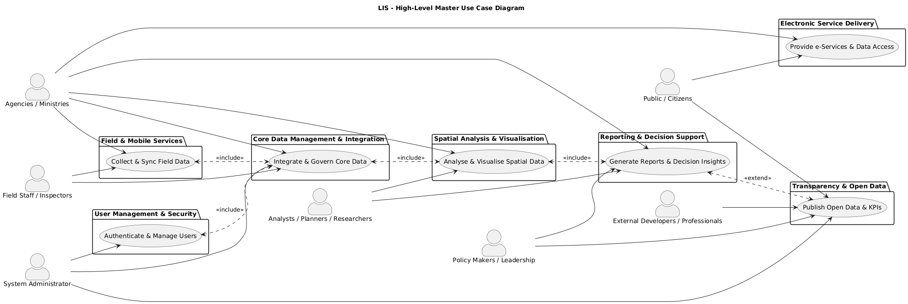

Figure: Master Use Case Diagram

### User Management and Security

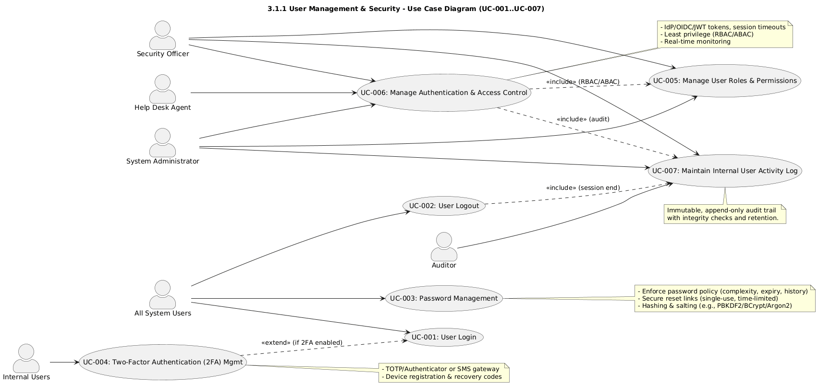

**Diagram: Use case diagram, User Management and Security**

#### UC-001: User Login

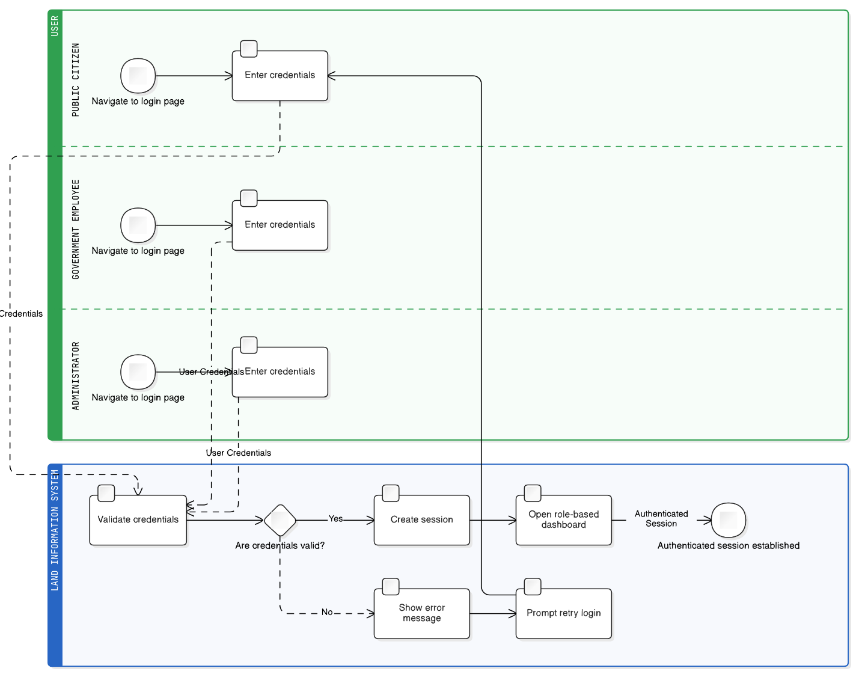

|  |  |
| --- | --- |
| **Field** | **Description** |
| **Description** | Authenticate users to grant access to the Land Information System based on their credentials. |
| **Priority** | Critical |
| **Actors** | All System Users (Public Citizen, Government Employee, Administrator etc.) |
| **Pre-Conditions** | User has an existing account with valid credentials. The system is online and accessible. |
| **Inputs** | Username / Email, Password |
| **Flow of Events** | 1. User navigates to the LIS login page. 2. User enters credentials. 3. System validates them against the user database. 4. If valid, the session is created and the user dashboard is opened. 5. If invalid, an error message is displayed. |
| **Post-Conditions** | User is logged in with access appropriate to their role; a secure session is established. |
| **Outputs** | Authenticated session; access to user-specific dashboard. |
| **Constraints** | Secure password handling (hashing and salting) is required; it must prevent brute-force attacks. |
| **Related Use Cases** | UC-002, UC-003, UC-004 |

#### UC-002: User Logout

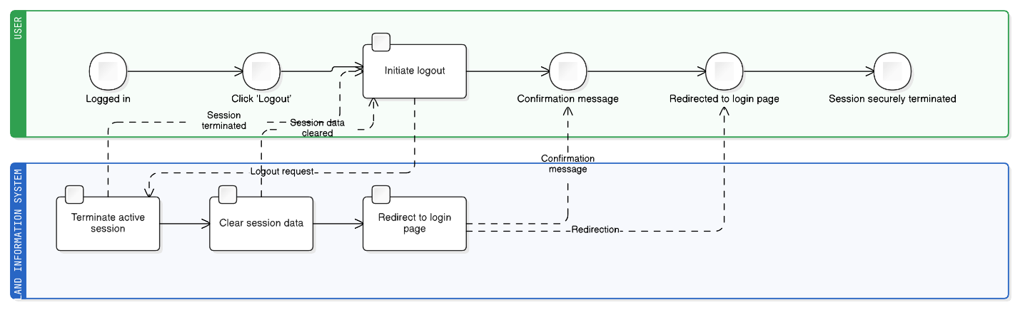

|  |  |
| --- | --- |
| **Field** | **Description** |
| **Description** | Securely terminate a user session and log the user out of the system. |
| **Priority** | Critical |
| **Actors** | All System Users |
| **Pre-Conditions** | User is currently logged into the system. |
| **Inputs** | User action to log out (e.g., clicking a “Logout” button). |
| **Flow of Events** | 1. User initiates logout. 2. System terminates active session. 3. All session data cleared. 4. User redirected to login page. |
| **Post-Conditions** | Session securely terminated; user logged out. |
| **Outputs** | Confirmation message; redirection to login page. |
| **Constraints** | Must ensure session tokens cannot be hijacked or reused. |
| **Related Use Cases** | UC-001 |

#### UC-003: Password Management

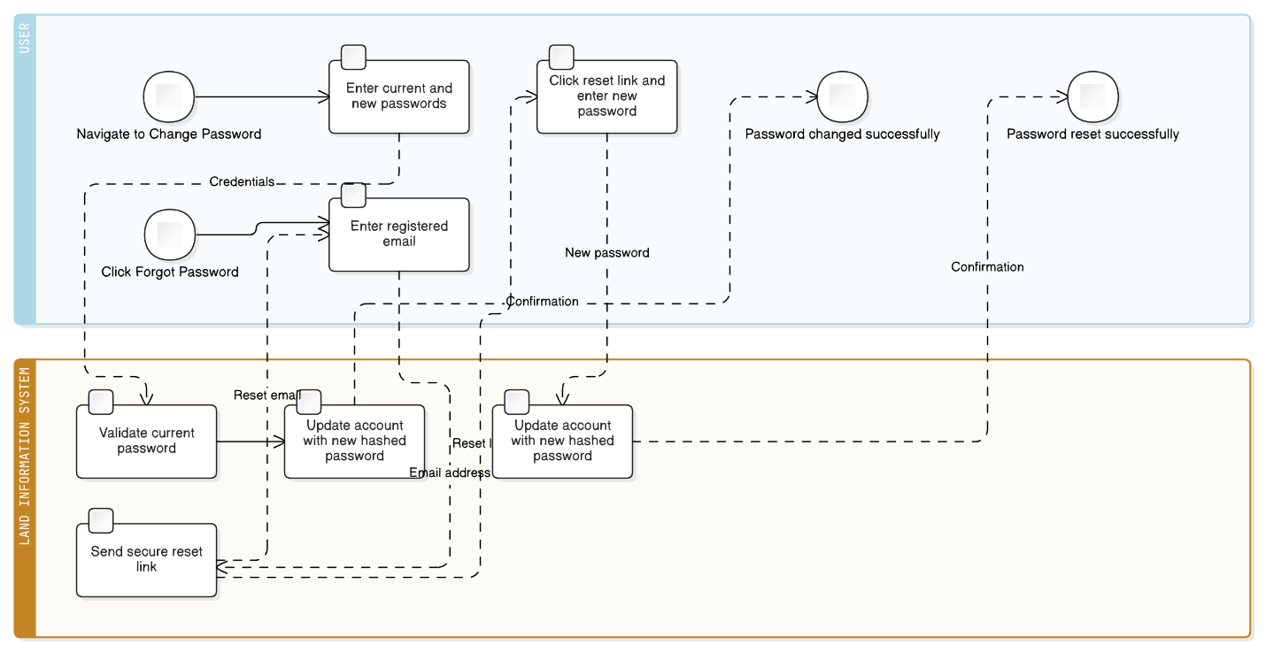

|  |  |
| --- | --- |
| **Field** | **Description** |
| **Description** | Allow users to securely change or reset passwords. |
| **Priority** | High |
| **Actors** | All System Users |
| **Pre-Conditions** | User has an existing account. For password reset, user must have access to their registered email. |
| **Inputs** | Current password, new password, email address. |
| **Flow of Events** | **Password Change** – 1. Navigate to “Change Password”. 2. Enter current and new passwords. 3. System validates current password. 4. System updates account with securely hashed password. **Password Reset** – 1. Click “Forgot Password”. 2. Enter registered email. 3. System sends secure reset link. 4. User enters new password via link. 5. System updates account. |
| **Post-Conditions** | Password changed or reset successfully. |
| **Outputs** | Confirmation notice; reset email. |
| **Constraints** | New passwords must meet complexity rules; reset links single-use and time-limited. |
| **Related Use Cases** | UC-001 |

#### UC-004: Two-Factor Authentication (2FA) Management

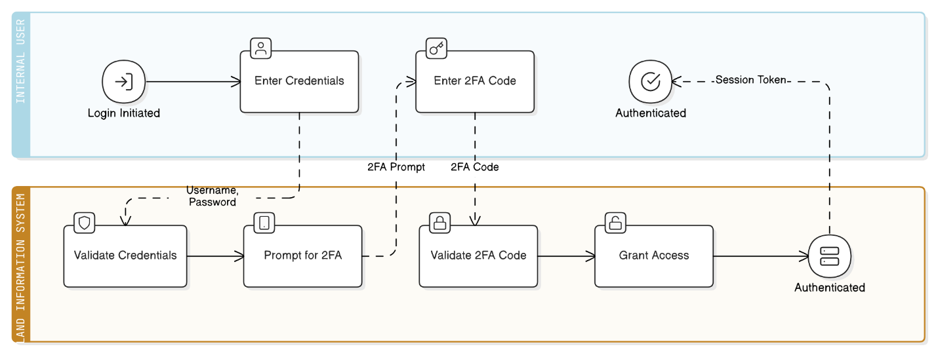

|  |  |
| --- | --- |
| **Field** | **Description** |
| **Description** | Enforce additional verification for internal users via one-time codes or authenticator apps. |
| **Priority** | High |
| **Actors** | Internal Users, System Administrator |
| **Pre-Conditions** | User has a registered device for 2FA (e.g. authenticator app or SMS). |
| **Inputs** | Username, Password, 2FA Code. |
| **Flow of Events** | 1. User enters username and password. 2. System prompts for 2FA code. 3. User provides code from device. 4. System validates code. 5. On success, access is granted. |
| **Post-Conditions** | Secure authenticated session established. |
| **Outputs** | Authenticated session token. |
| **Constraints** | Requires TOTP or SMS gateway integration. |
| **Related Use Cases** | UC-001, UC-005 |

#### UC-005: Manage User Roles and Permissions

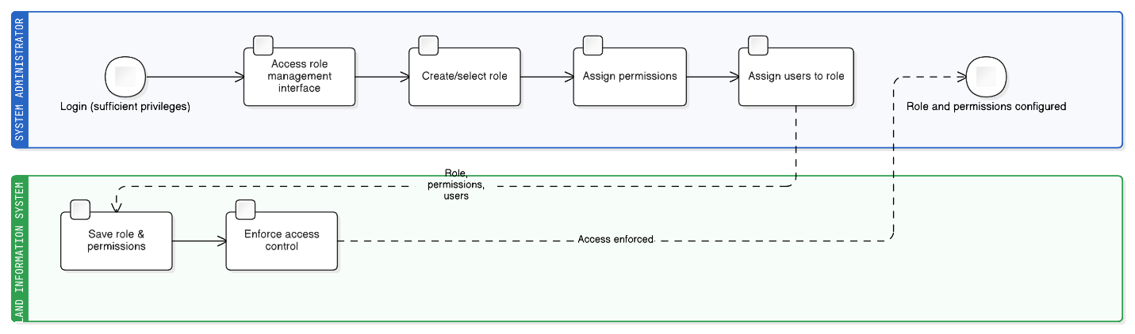

|  |  |
| --- | --- |
| **Field** | **Description** |
| **Description** | Allow System Administrators to create, define, and assign user roles with specific permissions for accessing data layers and system functions. |
| **Priority** | Critical |
| **Actors** | System Administrator, Security Officer |
| **Pre-Conditions** | Administrator is logged in with sufficient privileges. |
| **Inputs** | Role definitions (e.g. “NFA Analyst”), permission assignments (e.g. “Read-only on Cadastral Parcels,” “Edit access to Forest Management Plans”). |
| **Flow of Events** | 1. Administrator accesses the role management interface. 2. Administrator creates a new role or selects an existing one. 3. Administrator assigns specific permissions such as view, edit, create, delete, or execute on designated datasets or functions. 4. Administrator assigns users to defined roles. |
| **Post-Conditions** | User access rights are configured and enforced in accordance with the principle of least privilege. |
| **Outputs** | Configured user roles and permissions records. |
| **Constraints** | The permission model must be granular enough to control access down to the datasets and workflow action levels. |
| **Related Use Cases** | UC-004, UC-006, UC-033 |

#### UC-006: Manage User Authentication and Access Control

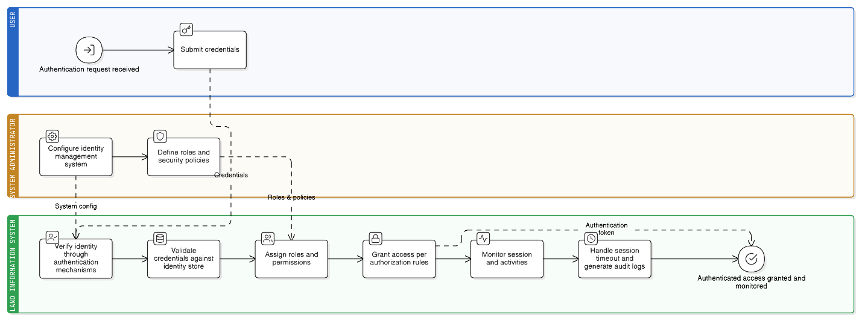

|  |  |
| --- | --- |
| **Field** | **Description** |
| **Description** | Provide secure user authentication, role-based access control, and authorisation management for all system users and services. |
| **Priority** | Critical |
| **Actors** | System Administrator, User, Security Officer, Help Desk Agent |
| **Pre-Conditions** | Identity management system configured; roles and security policies defined. |
| **Inputs** | User credentials, authentication requests, role assignments, access permissions. |
| **Flow of Events** | 1. Verify user identity through authentication mechanisms. 2. Validate credentials against identity store. 3. Assign appropriate roles and permissions. 4. Grant access per authorisation rules. 5. Monitor activities and sessions. 6. Manage timeouts and audits. |
| **Post-Conditions** | User authenticated; appropriate access granted; activities monitored. |
| **Outputs** | Authentication tokens, access permissions, audit logs. |
| **Constraints** | Must meet security compliance and performance requirements. |
| **Related Use Cases** | UC-005, UC-007, UC-023, UC-033 |

#### UC-007: Maintain Internal User Activity Log

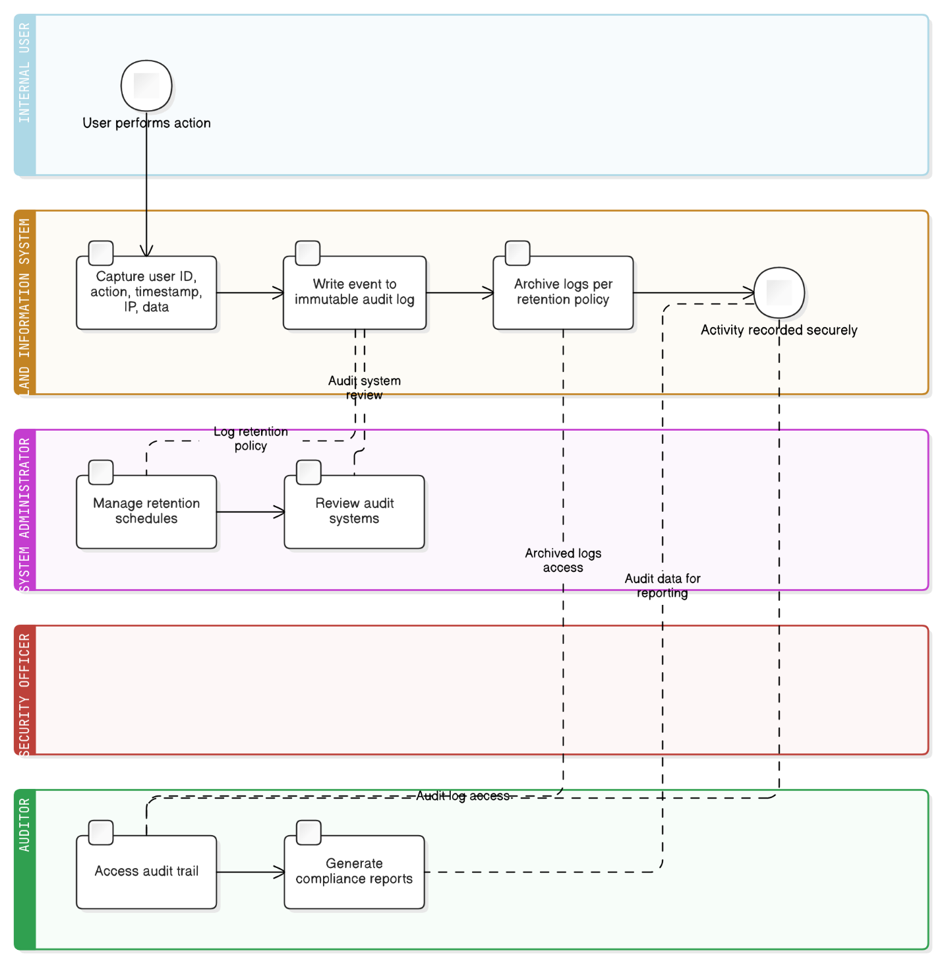

|  |  |
| --- | --- |
| **Field** | **Description** |
| **Description** | Systematically record and archive all significant actions performed by internal users for auditing, security, and accountability purposes. |
| **Priority** | Critical |
| **Actors** | System Administrator, Security Officer, Auditor |
| **Pre-Conditions** | User authenticated as internal; logging mechanisms active. |
| **Inputs** | User actions (e.g. data access, modification of Soil Condition Data), timestamps, user IDs. |
| **Flow of Events** | 1. Internal user performs an action. 2. System captures user ID, action, data affected, timestamp, IP address. 3. Event written to secure, immutable audit log. 4. Logs archived periodically per retention policy. |
| **Post-Conditions** | Detailed unalterable record of user activity stored securely. |
| **Outputs** | Immutable audit trail, activity reports for security and compliance audits. |
| **Constraints** | Log integrity and security must be ensured without performance degradation. |
| **Related Use Cases** | UC-006, UC-033 |

### Core Data Management and Integration

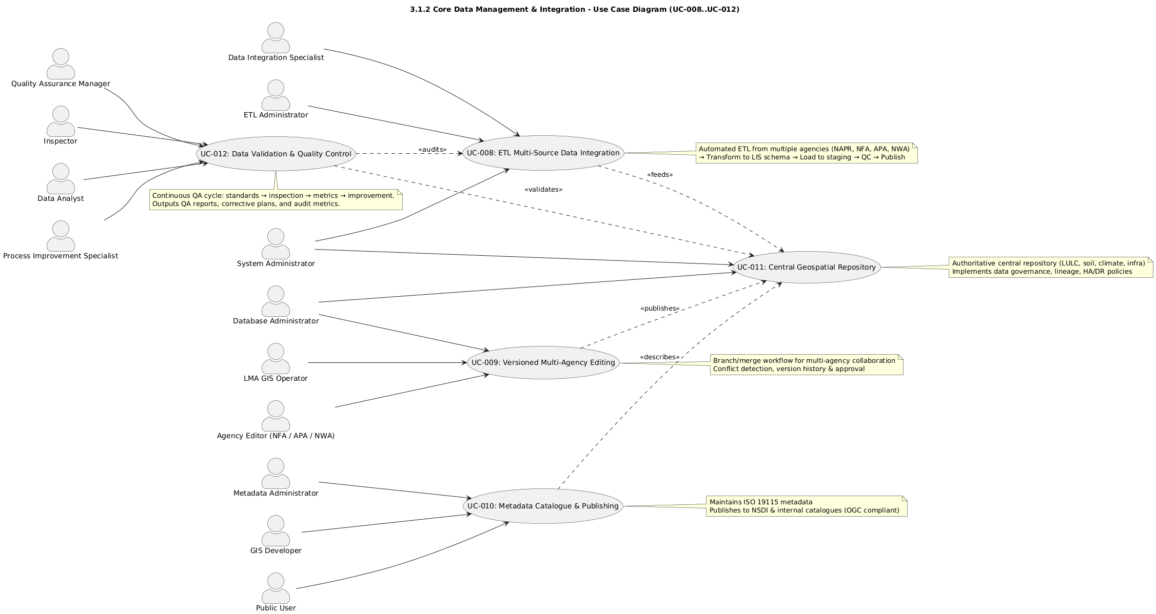

**Diagram: Use case diagram, Data Management and Integration**

#### UC-008: Extract, Transform, Load (ETL) Multi-Source Data Integration

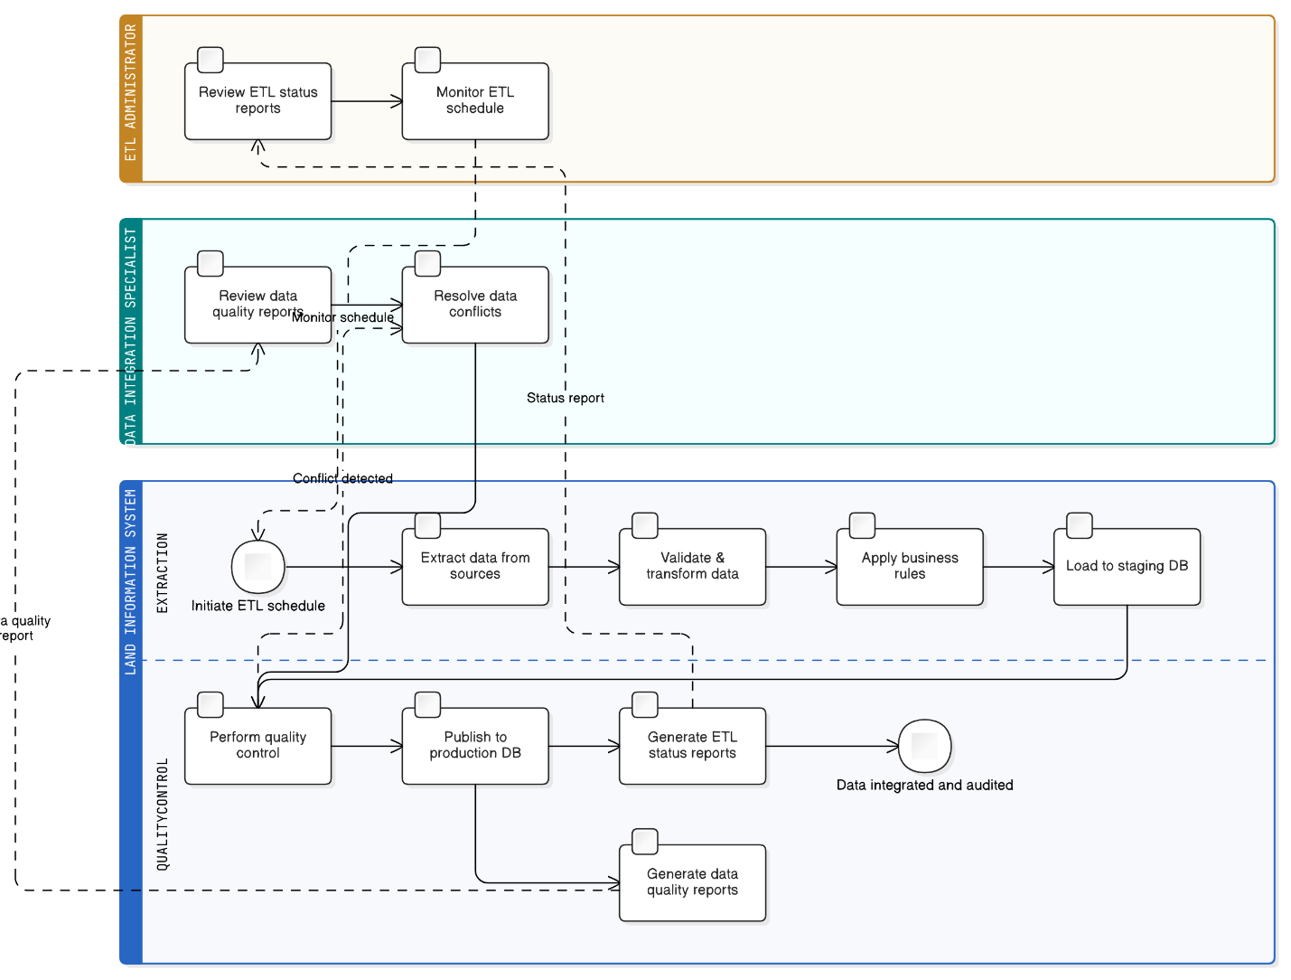

|  |  |
| --- | --- |
| **Field** | **Description** |
| **Description** | Automated processing to extract data from multiple government agencies (NAPR, NFA, APA, NWA), transform to common standards, and load into the centralised LIS database. |
| **Priority** | High |
| **Actors** | ETL Administrator, Data Integration Specialist, System Administrator |
| **Pre-Conditions** | Source systems accessible; integration APIs configured; mapping rules defined. |
| **Inputs** | NAPR land records (Cadastral Parcels), NFA agricultural data (Forest Management Plans), NWA data (Wine Cadastre), SRCA data (Soil Condition), tax authority data. |
| **Flow of Events** | 1. Schedule automated data extraction from source systems. 2. Validate and transform data to LIS standards. 3. Apply business rules for consistency. 4. Load transformed data into staging. 5. Perform QC and conflict resolution. 6. Publish verified data to production. 7. Generate status reports. |
| **Post-Conditions** | All current data is integrated and audited for consistency. |
| **Outputs** | Integrated records (Unified Land-Use Layer), ETL logs, and quality reports. |
| **Constraints** | Real-time processing limits and data privacy requirements. |
| **Related Use Cases** | UC-009, UC-010, UC-023 |

#### UC-009 Versioned Multi-Agency Editing

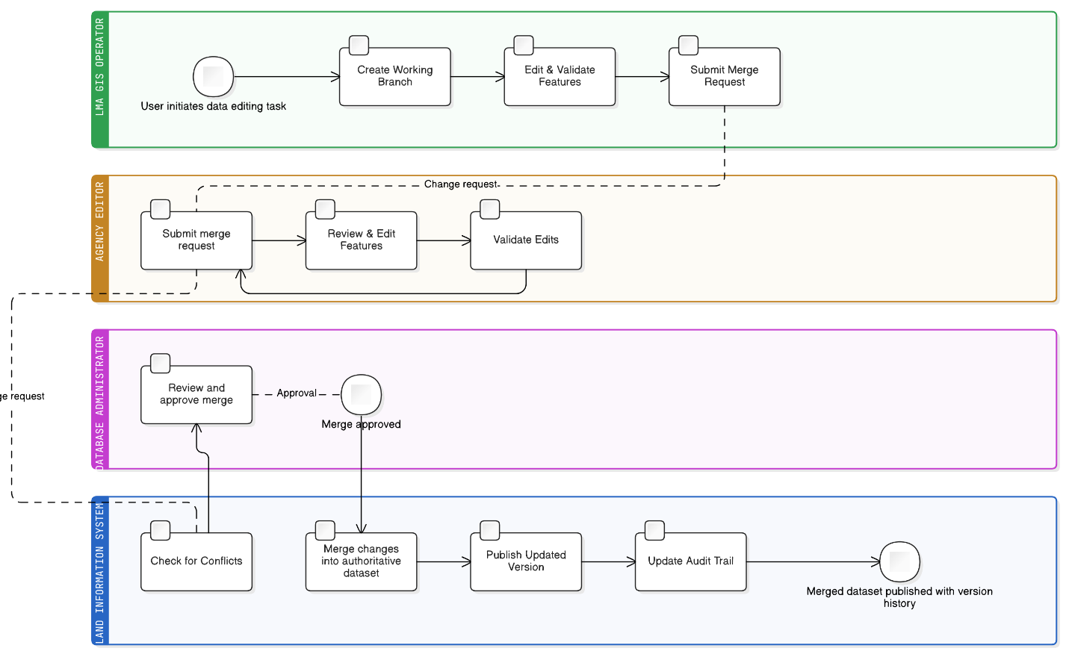

|  |  |
| --- | --- |
| **Field** | **Description** |
| **Description** | Support check-in/ check-out and branch/merge workflows for collaborative data management across multiple agencies. |
| **Priority** | High |
| **Actors** | LMA GIS Operator, Agency Editor (NFA / APA / NWA), Database Administrator |
| **Pre-Conditions** | Repository configured with version-control policies and branch access rules. |
| **Inputs** | Edited spatial features, change requests, and metadata. |
| **Flow of Events** | 1. User creates a working branch. 2. Performs edits and validations. 3. Submits a merge request; the system checks for conflicts. 4. Administrator approves the merge and publishes the version. 5. Audit trail updated. |
| **Post-Conditions** | Updated authoritative dataset published; conflicts resolved and documented. |
| **Outputs** | Merged datasets, version history, merge reports. |
| **Constraints** | Requires transaction rollback and multi-user locking mechanisms. |
| **Related Use Cases** | UC-008, UC-010 |

#### UC-010 Metadata Catalogue and Publishing

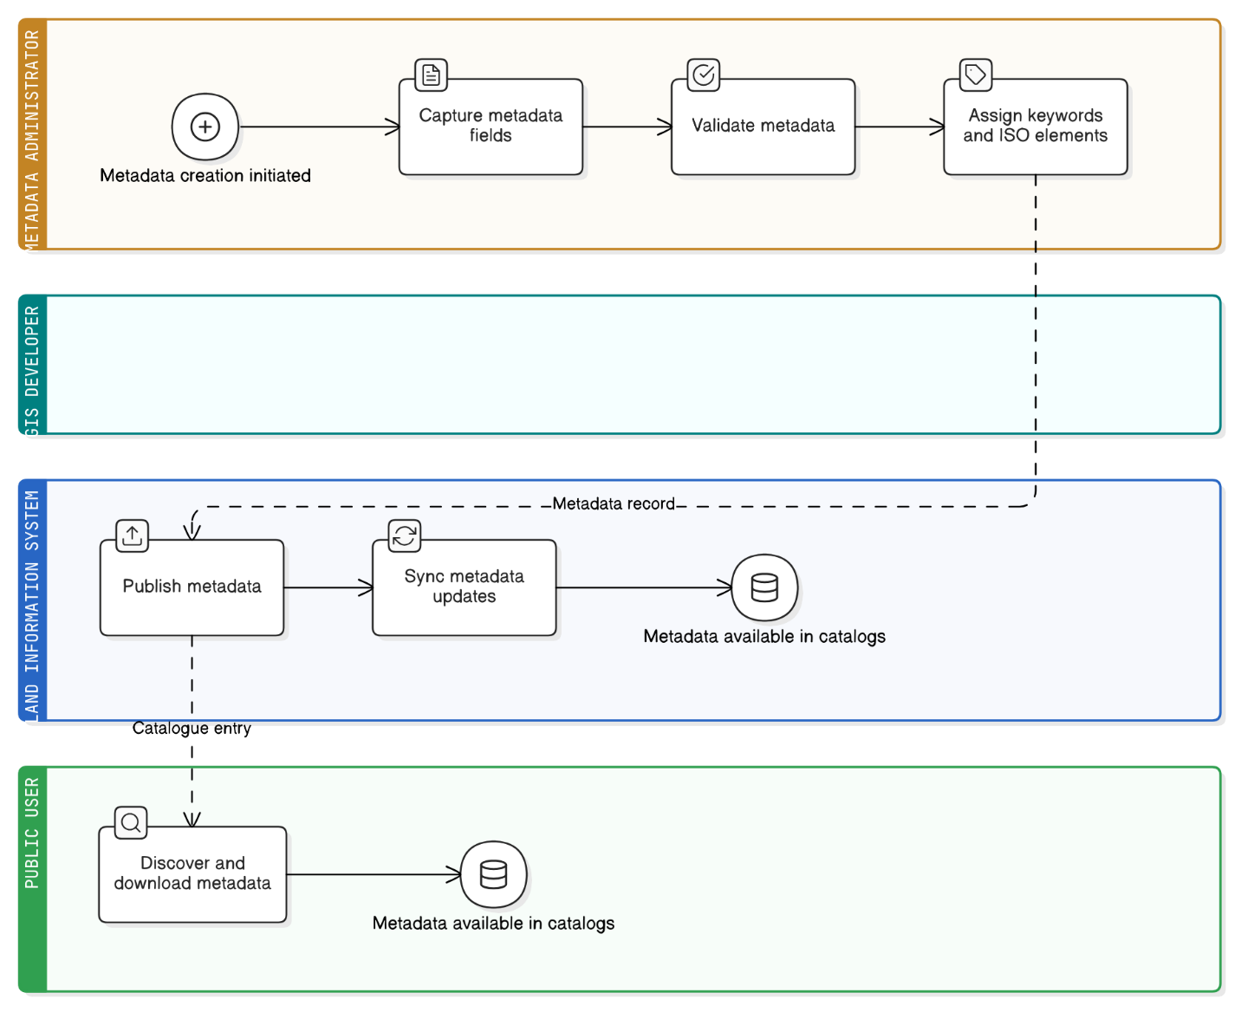

|  |  |
| --- | --- |
| **Field** | **Description** |
| **Description** | Maintain ISO 19115-compliant metadata and publish records to NSDI catalogues and internal portals. |
| **Priority** | Medium |
| **Actors** | Metadata Administrator, GIS Developer, Public User |
| **Pre-Conditions** | Metadata registry and templates configured. |
| **Inputs** | Dataset descriptors, keywords, service details. |
| **Flow of Events** | 1. Capture and validate metadata fields. 2. Assign keywords and ISO elements. 3. Publish records internally and to NSDI catalogues. 4. Synchronise updates periodically. |
| **Post-Conditions** | Metadata discoverable and downloadable through catalogues. |
| **Outputs** | ISO metadata records, catalogue entries, sync logs. |
| **Constraints** | Must conform to OGC and NSDI interoperability standards. |
| **Related Use Cases** | UC-011, UC-027 |

#### UC-011 Central Geospatial Repository

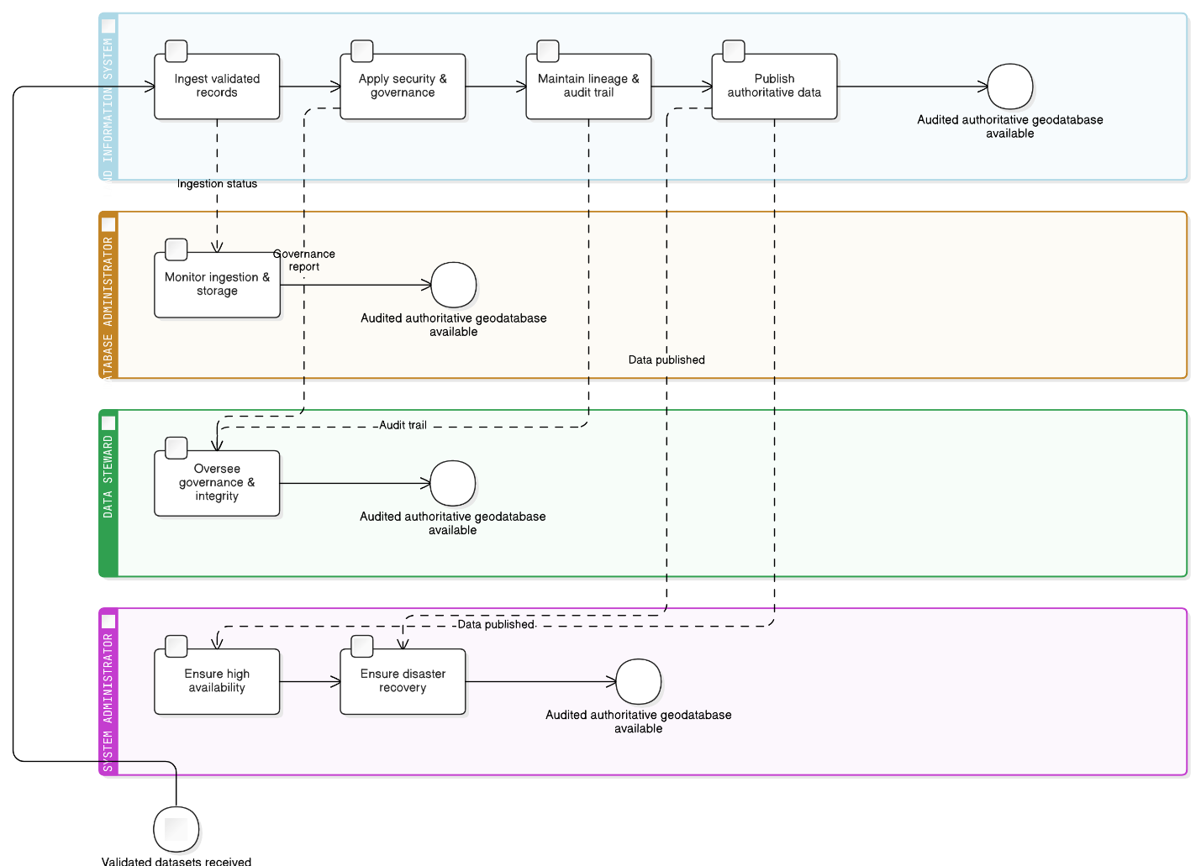

|  |  |
| --- | --- |
| **Field** | **Description** |
| **Description** | Host an authoritative repository of land parcels, LULC, soil, climate, infrastructure and environmental layers with controlled access and data governance. |
| **Priority** | Critical |
| **Actors** | Database Administrator, Data Steward, System Administrator |
| **Pre-Conditions** | Approved database schema and governance policies in place. |
| **Inputs** | Validated datasets from UC-008 to UC-009. |
| **Flow of Events** | 1. Ingest validated records into the repository. 2. Apply security and governance rules. 3. Maintain data lineage and audit trail. 4. Publish authoritative data to users and APIs. |
| **Post-Conditions** | Single source of truth maintained and audited. |
| **Outputs** | Central geodatabase, audit logs, access reports. |
| **Constraints** | Must support high availability and disaster recovery. |
| **Related Use Cases** | UC-008, UC-009 |

#### UC-012 Data Validation and Quality Control

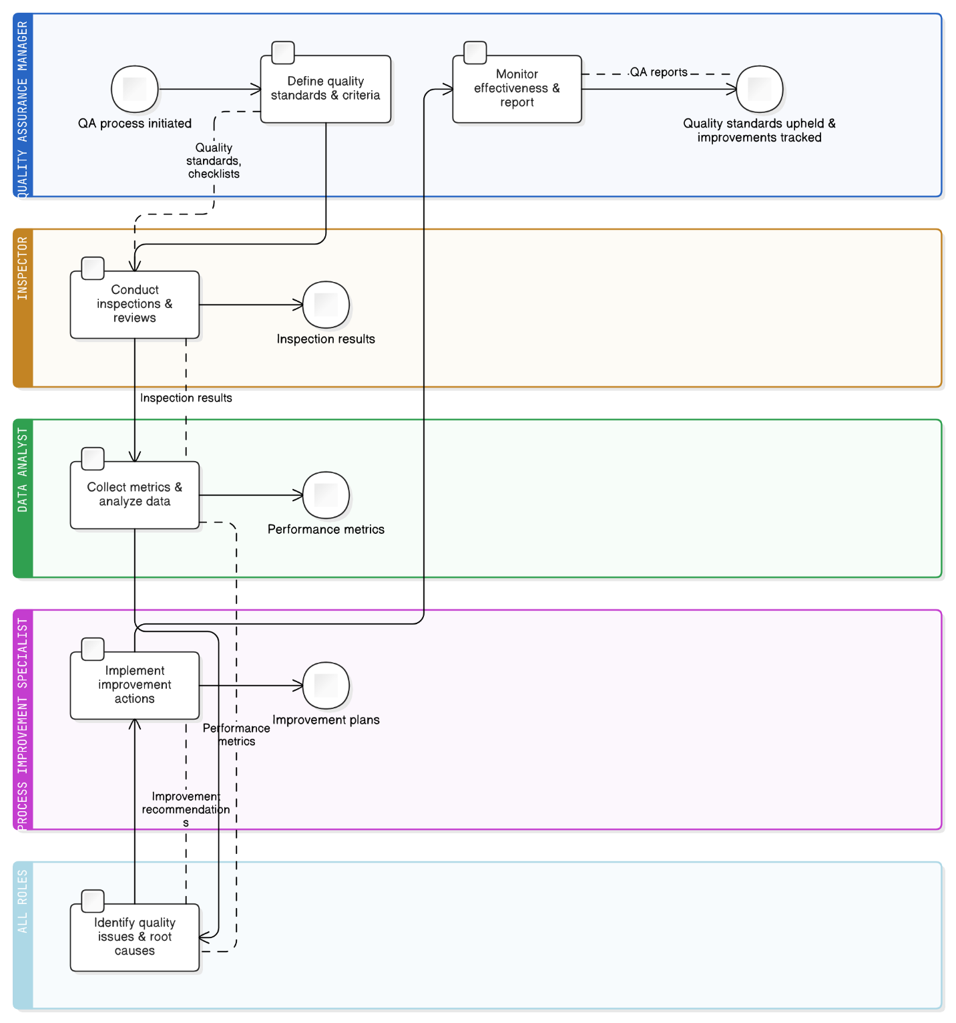

|  |  |
| --- | --- |
| **Field** | **Description** |
| **Description** | Establish and maintain quality assurance processes for data, methods, and system outputs with continuous improvement. |
| **Priority** | High |
| **Actors** | Quality Assurance Manager, Inspector, Data Analyst, Process Improvement Specialist |
| **Pre-Conditions** | Quality standards defined, inspection procedures established, measurement criteria configured. |
| **Inputs** | Quality standards, inspection checklists, performance metrics, improvement recommendations. |
| **Flow of Events** | 1. Define quality standards and measurement criteria. 2. Conduct regular inspections and reviews. 3. Collect performance metrics and data. 4. Identify quality issues and root causes. 5. Implement improvement actions. 6. Monitor effectiveness and report results. |
| **Post-Conditions** | Quality standards upheld; improvements implemented and tracked. |
| **Outputs** | QA reports, inspection results, improvement plans, performance metrics. |
| **Constraints** | Resource requirements and measurement accuracy must meet LIS standards. |
| **Related Use Cases** | UC-008 |

### Spatial Analysis and Visualisation

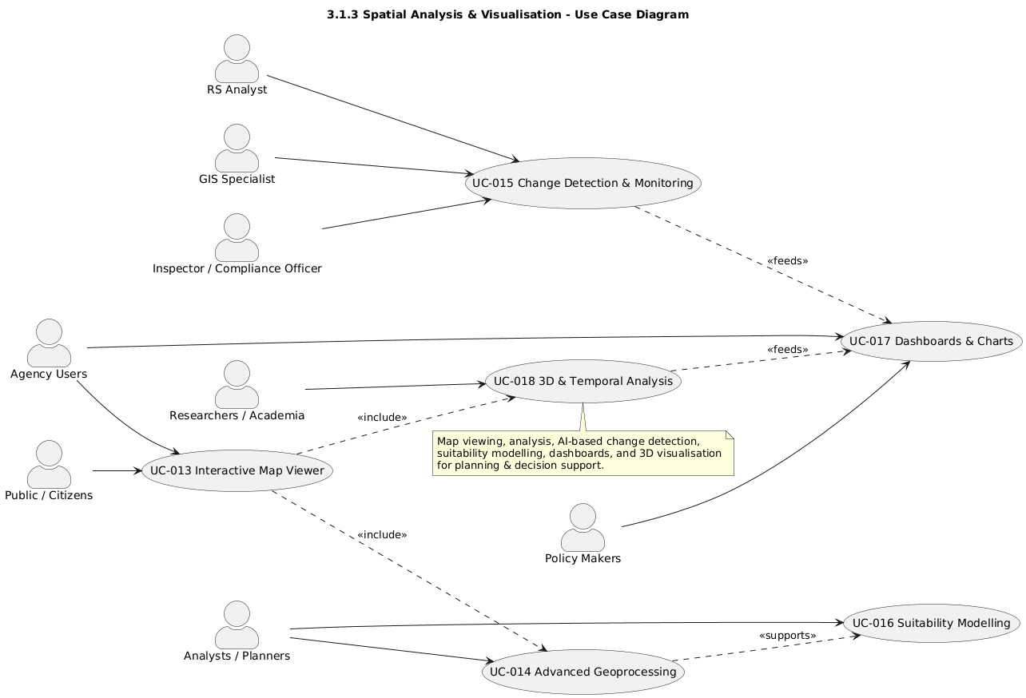

**Use case diagram: Spatial Analysis and Visualisation**

#### UC-013 Interactive Map Viewer / Queries

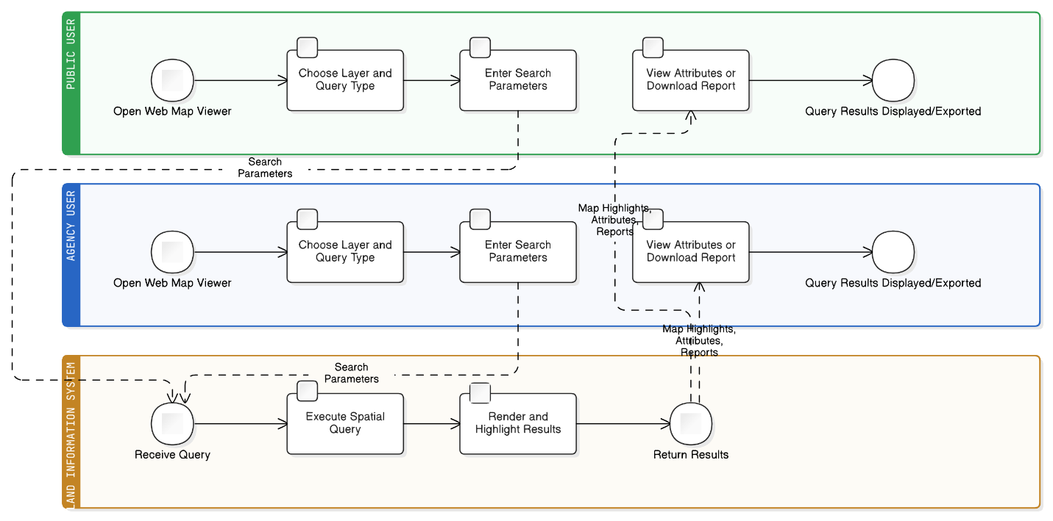

|  |  |
| --- | --- |
| **Field** | **Description** |
| **Description** | Provide interactive public + internal web map viewer supporting parcel search, identify, buffer, and polygon selection, returning highlighted results or tabular reports. |
| **Priority** | High |
| **Actors** | Citizens, Farmers, Businesses, Agency Users |
| **Pre-Conditions** | Map services and basemap configured. |
| **Inputs** | Search parameters (parcels, coordinates, owner ID), spatial selection tools. |
| **Flow of Events** | 1. User opens map viewer.2. Chooses layer and query type.3. System executes query and renders results.4. User views attributes or downloads report. |
| **Post-Conditions** | Query results displayed and exportable. |
| **Outputs** | Map highlights, attribute table, PDF/CSV report. |
| **Constraints** | Performance depends on data volume and network speed. |
| **Related Use Cases** | UC-014, UC-018 |

#### UC-014 Advanced Geoprocessing

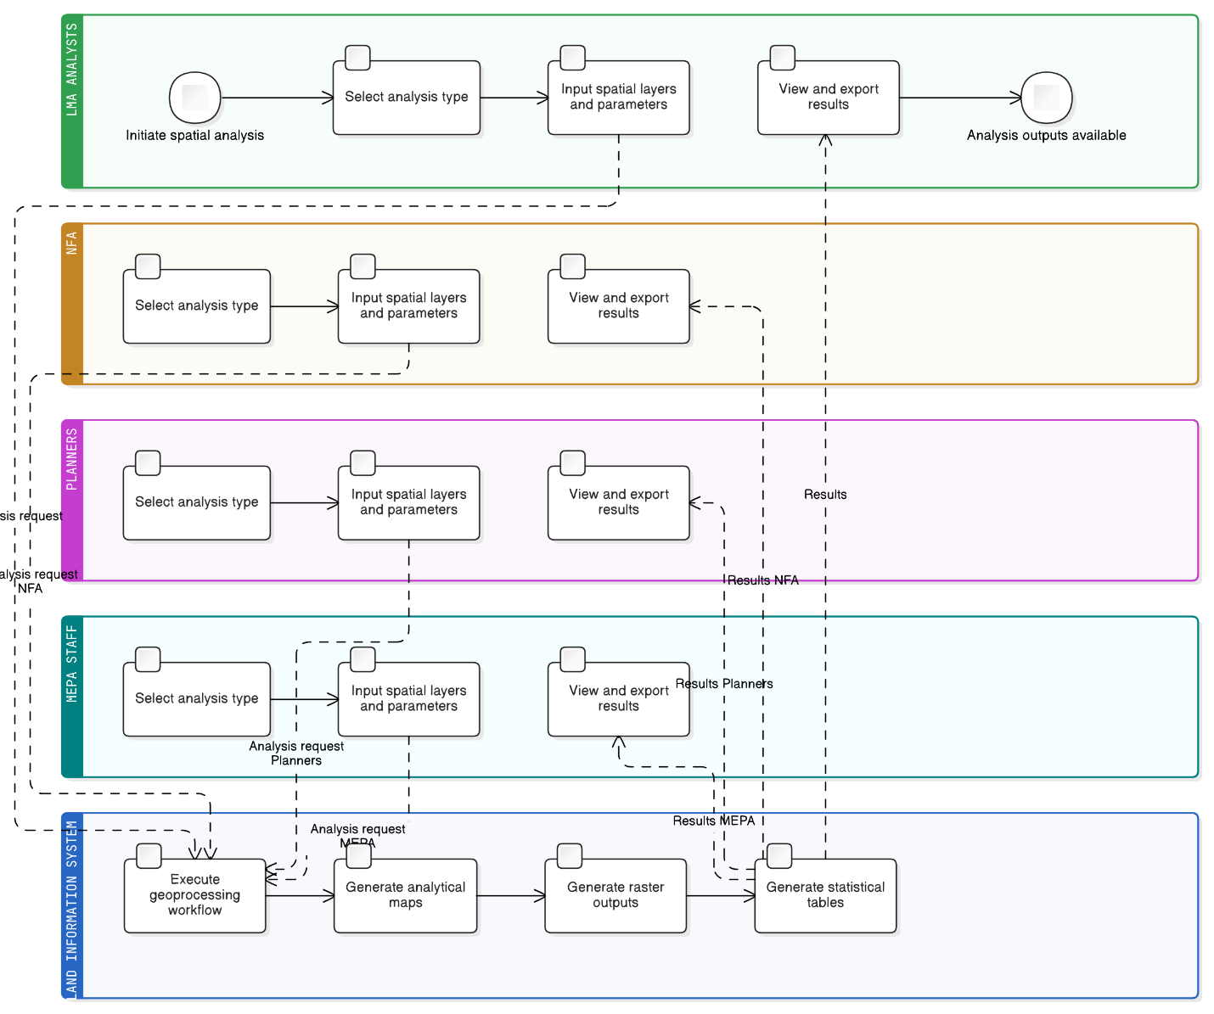

|  |  |
| --- | --- |
| **Field** | **Description** |
| **Description** | Perform spatial analyses (buffer, overlay, proximity, network, terrain/slope, vector & raster processing) for multi-criteria evaluation and suitability modelling. |
| **Priority** | High |
| **Actors** | LMA Analysts, NFA, Planners, MEPA Staff |
| **Pre-Conditions** | Analytical datasets and tools configured. |
| **Inputs** | Spatial layers, parameters (distance, weights, criteria). |
| **Flow of Events** | 1. Select analysis type.2. Input layers & parameters.3. System executes geoprocessing workflow.4. View and export results. |
| **Post-Conditions** | Analysis outputs available for further modelling or reporting. |
| **Outputs** | Analytical maps, raster outputs, statistical tables. |
| **Constraints** | Requires sufficient server resources for large raster jobs. |
| **Related Use Cases** | UC-013, UC-015 |

#### UC-015 Change Detection and Monitoring

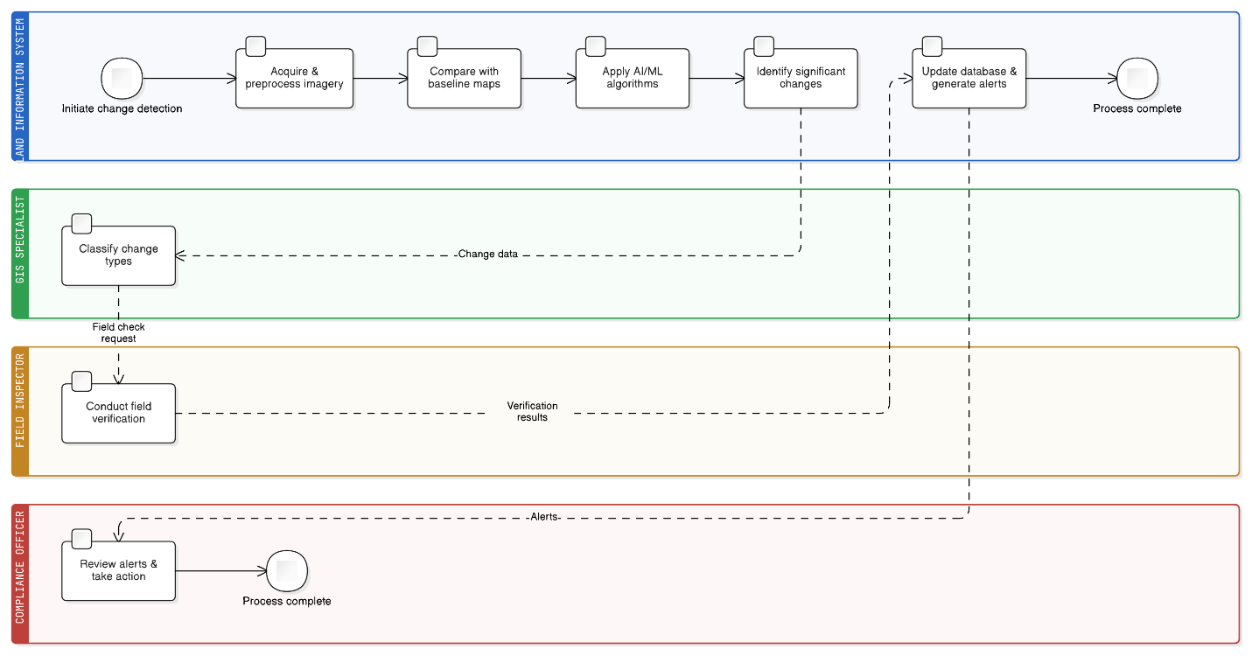

|  |  |
| --- | --- |
| **Field** | **Description** |
| **Description** | Detect temporal LULC changes (deforestation, urban expansion, crop rotation) using automated imagery analysis and AI/ML anomaly detection. |
| **Priority** | High |
| **Actors** | Remote Sensing Analyst, GIS Specialist, Field Inspector, Compliance Officer |
| **Pre-Conditions** | Baseline land use maps established, satellite data access configured, change detection algorithms calibrated. |
| **Inputs** | Satellite imagery (current and historical), aerial photography, field survey data, Land Use/Land Cover maps. |
| **Flow of Events** | 1. Acquire and preprocess current satellite imagery. 2. Compare with baseline land use maps. 3. Apply automated change detection algorithms. 4. Identify significant land use changes. 5. Classify types of changes detected. 6. Validate changes through field verification. 7. Update land use database and generate alerts. |
| **Post-Conditions** | Land use changes identified and validated, databases updated, stakeholders notified. |
| **Outputs** | Change Detection Maps, analysis reports, database updates, alert notifications. |
| **Constraints** | Satellite imagery availability, weather conditions, processing time requirements. |
| **Related Use Cases** | UC-014, UC-018, UC-024 |

#### UC-016 Suitability Modelling

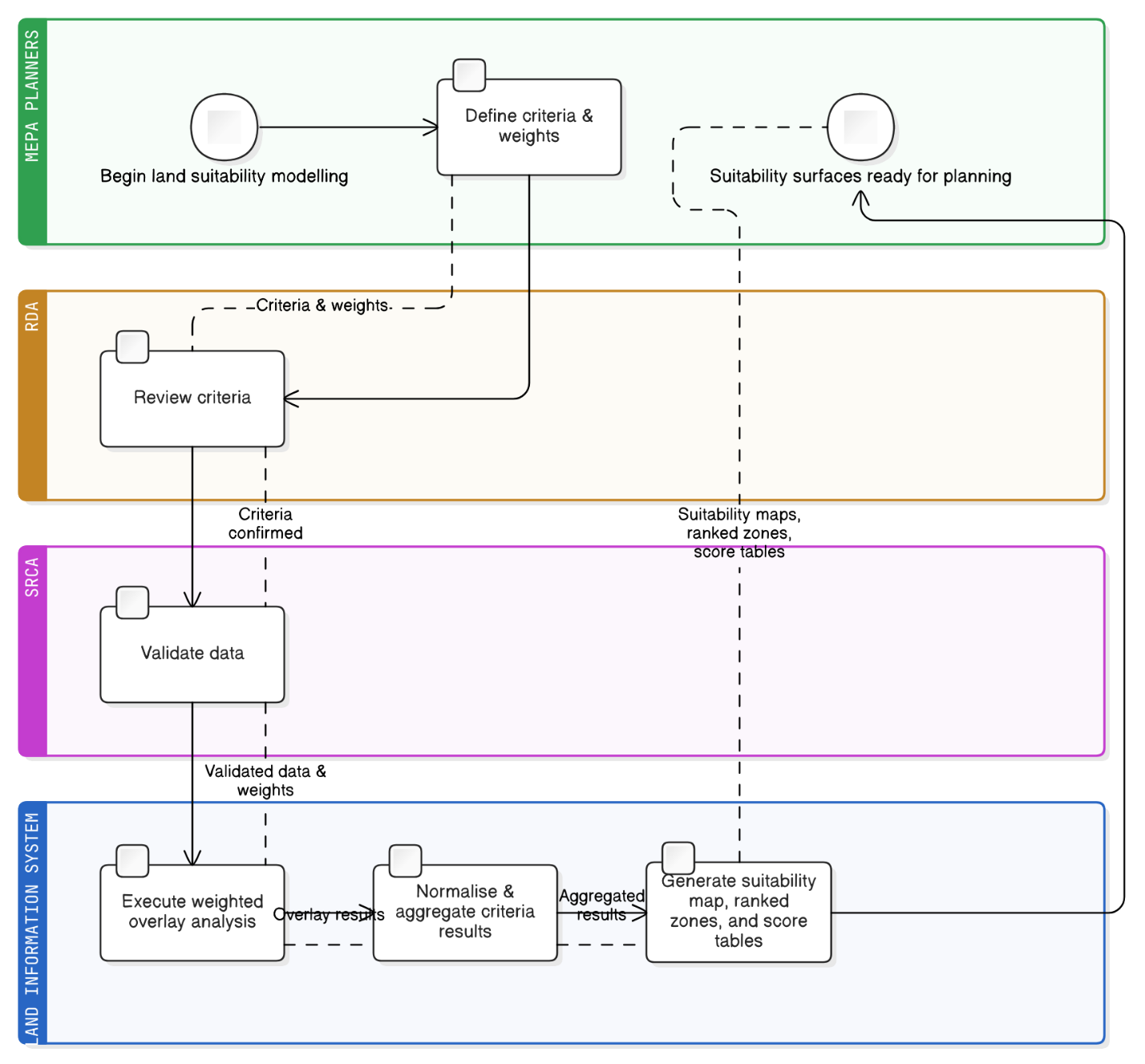

|  |  |
| --- | --- |
| **Field** | **Description** |
| **Description** | Provide multi-criteria land suitability modelling for agriculture, zoning, and planning using configurable weights and criteria layers. |
| **Priority** | High |
| **Actors** | MEPA Planners, RDA, SRCA |
| **Pre-Conditions** | Weighted overlay criteria defined. |
| **Inputs** | Raster layers (soil, slope, climate, accessibility), weights. |
| **Flow of Events** | 1. Define criteria and weights.2. Execute overlay.3. System normalises and aggregates results.4. Generate suitability map. |
| **Post-Conditions** | Suitability surfaces available for scenario planning. |
| **Outputs** | Suitability maps, ranked zones, score tables. |
| **Constraints** | Requires consistent data resolution and projection. |
| **Related Use Cases** | UC-014, UC-021 |

#### UC-017 Dashboards and Charts

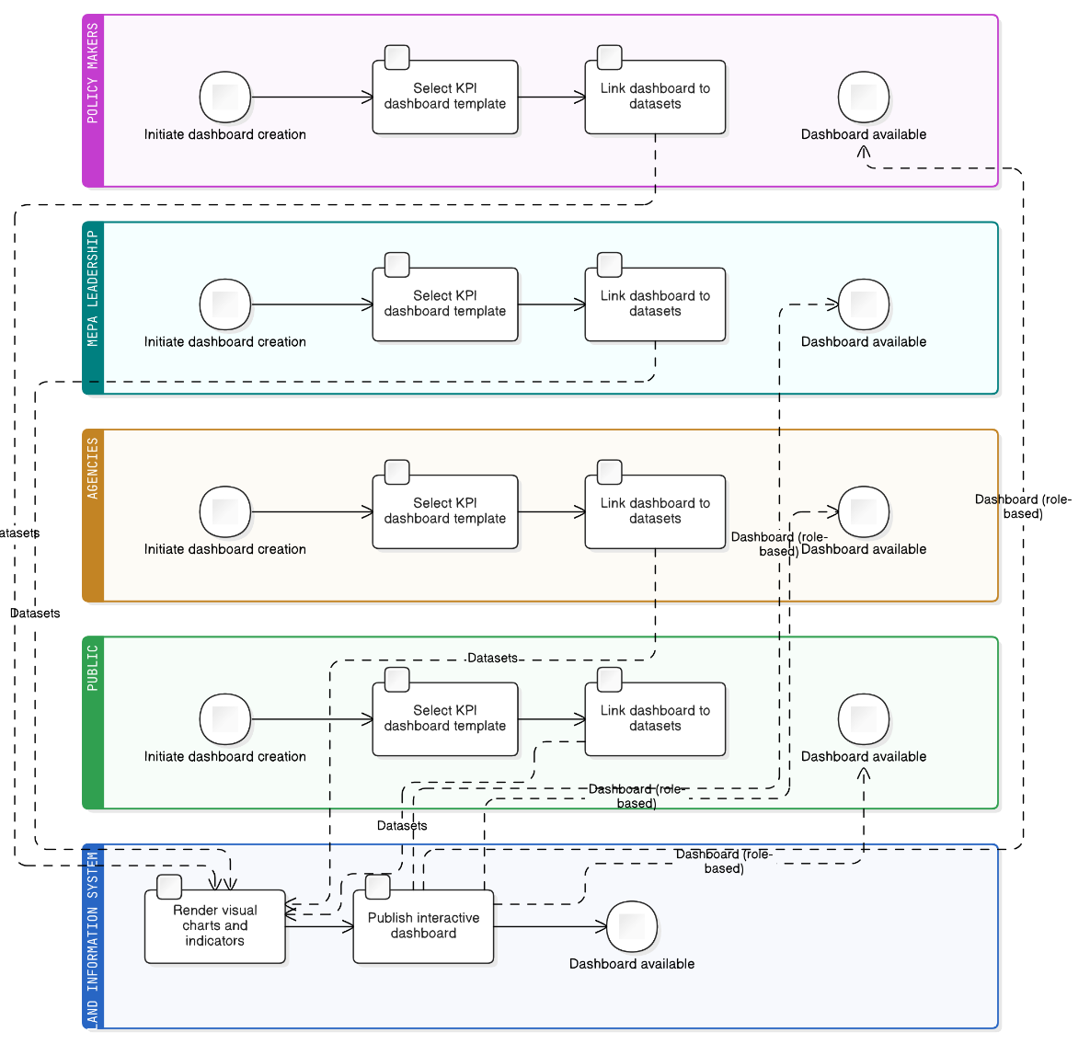

|  |  |
| --- | --- |
| **Field** | **Description** |
| **Description** | Generate role-based dashboards showing KPIs, land statistics, application status, and land distribution with real-time updates. |
| **Priority** | Medium |
| **Actors** | Policy Makers, MEPA Leadership, Agencies, Public |
| **Pre-Conditions** | Dashboard engine configured and linked to databases. |
| **Inputs** | Operational and analytical datasets. |
| **Flow of Events** | 1. Select KPI template.2. Link to data source.3. System renders charts.4. Publish dashboard. |
| **Post-Conditions** | Visual dashboards available for stakeholders. |
| **Outputs** | Interactive dashboards, exportable charts. |
| **Constraints** | Depends on data refresh frequency and user role. |
| **Related Use Cases** | UC-015, UC-018, UC-028 |

#### UC-018 3D and Temporal Analysis

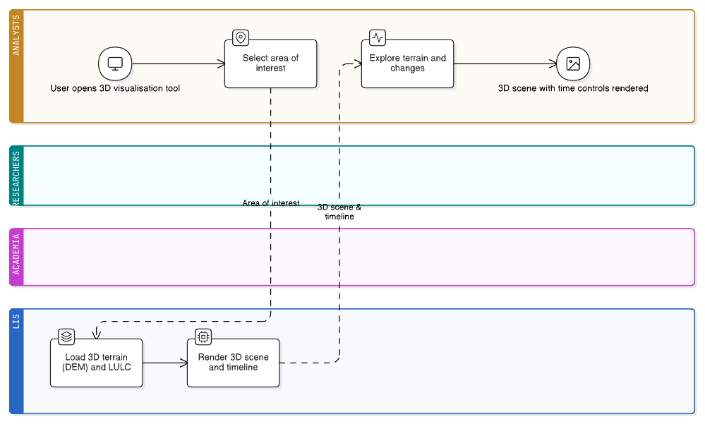

|  |  |
| --- | --- |
| **Field** | **Description** |
| **Description** | Provide browser-based 3D terrain visualisation and temporal analysis for slope assessment, infrastructure planning, and LULC change review. |
| **Priority** | Medium |
| **Actors** | Analysts, Researchers, Academia |
| **Pre-Conditions** | 3D engine and DEM datasets available. |
| **Inputs** | DEM, LULC layers, time-series imagery. |
| **Flow of Events** | 1. Select area of interest.2. Load 3D and time layers.3. Visualise terrain and changes over time. |
| **Post-Conditions** | 3D scene rendered with temporal controls. |
| **Outputs** | 3D views, animated temporal plots, screenshots. |
| **Constraints** | Browser GPU and data volume limits. |
| **Related Use Cases** | UC-013, UC-015, UC-017 |

### Electronic Service Delivery

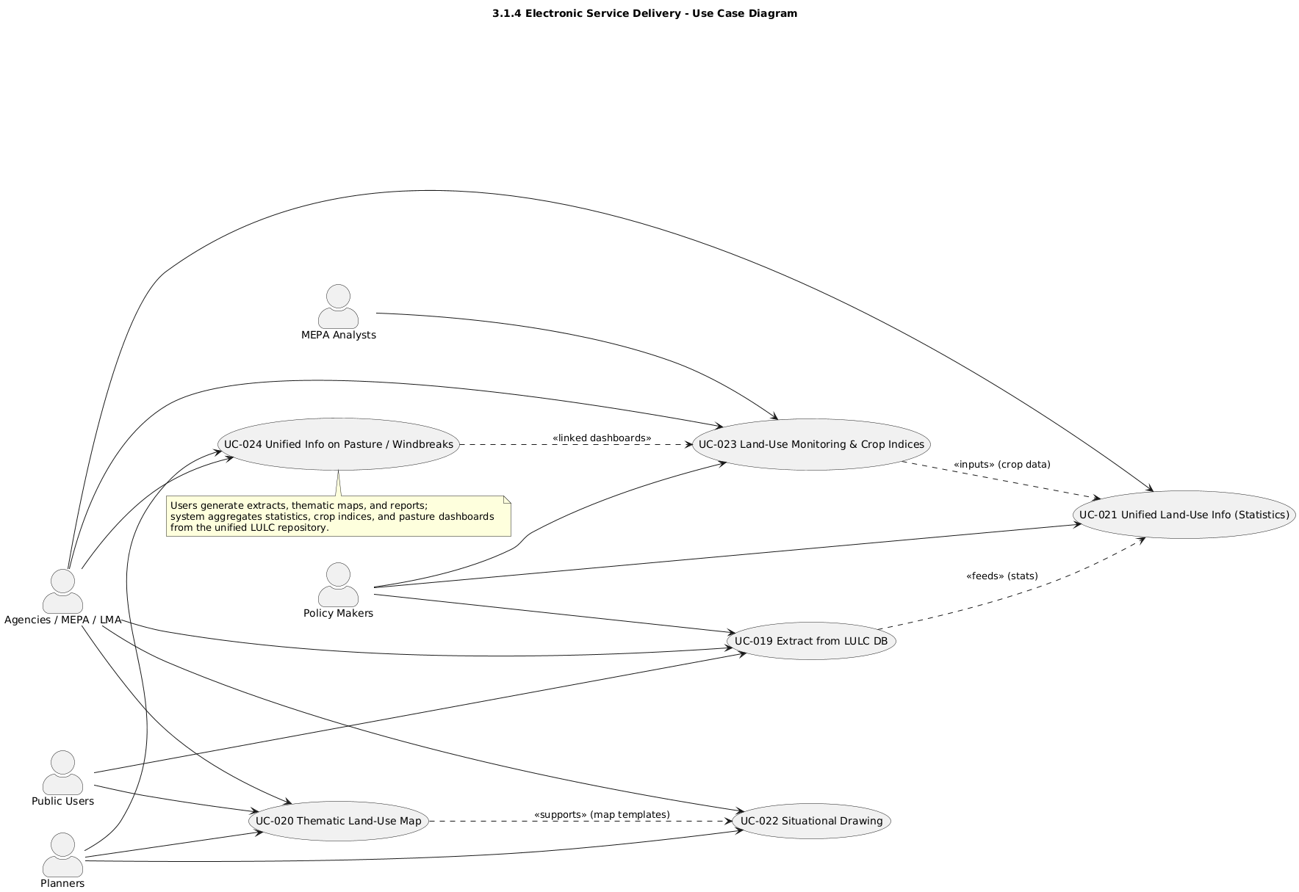

**Use case diagram : Electronic Service Delivery**

#### UC-019 Extract from Unified LULC Database

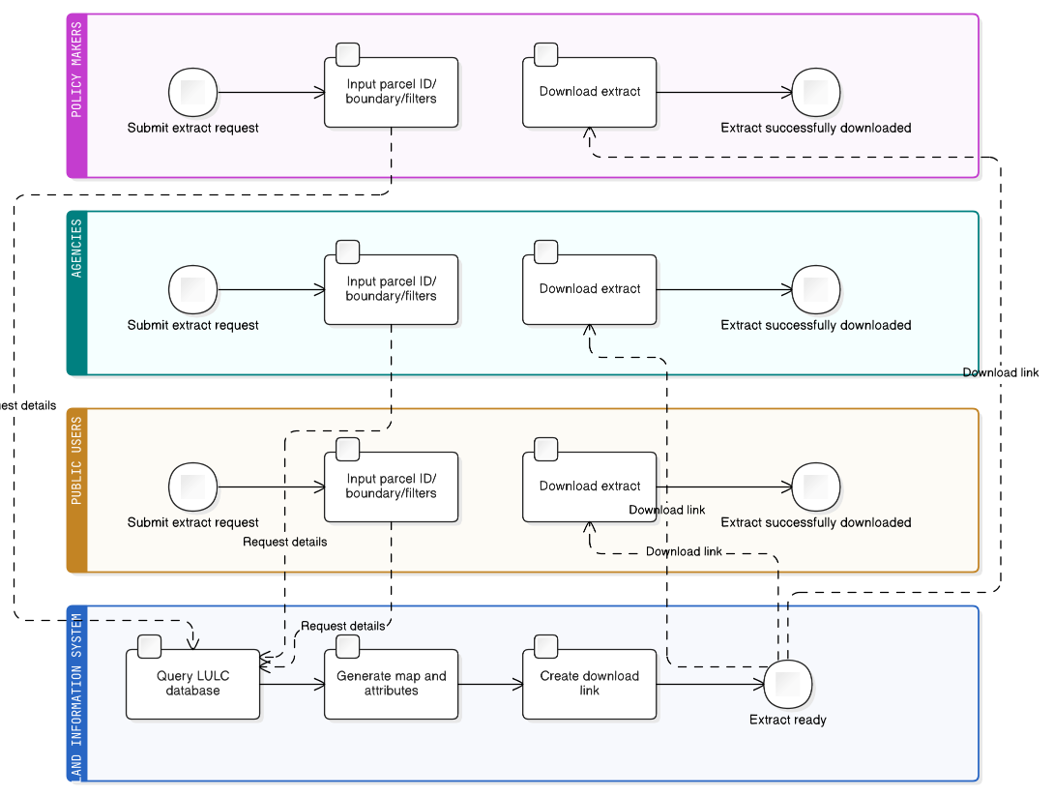

|  |  |
| --- | --- |
| **Field** | **Description** |
| **Description** | Allow users to generate on-demand parcel or LULC extracts from the authoritative repository. |
| **Priority** | High |
| **Actors** | Policy Makers, Agencies, Public Users |
| **Pre-Conditions** | LULC database configured and queryable. |
| **Inputs** | Parcel ID, boundary, query filters. |
| **Flow of Events** | 1. User submits extract request.2. System generates map and attributes.3. Provides download link. |
| **Post-Conditions** | Extract available for download. |
| **Outputs** | PDF/CSV extracts, metadata record. |
| **Constraints** | Access depends on user permissions. |
| **Related Use Cases** | UC-013, UC-027 |

#### UC-020 Thematic Land-Use Map

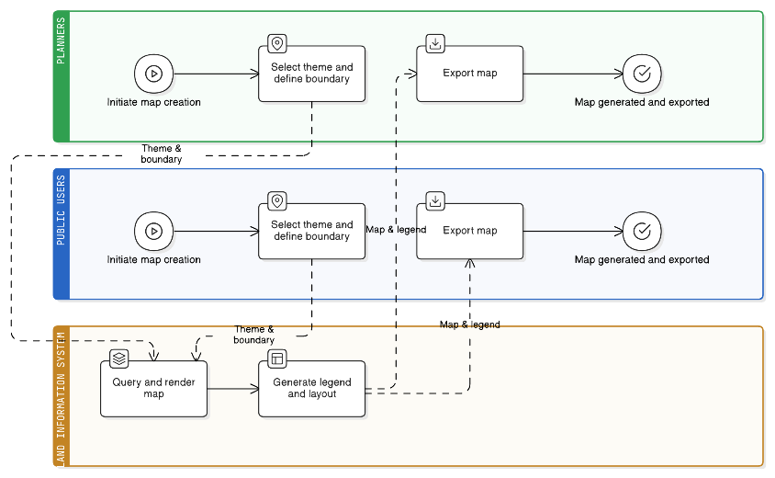

|  |  |
| --- | --- |
| **Field** | **Description** |
| **Description** | Allow users to generate user-defined boundary maps based on selected themes or attributes. |
| **Priority** | High |
| **Actors** | Planners, Public Users |
| **Pre-Conditions** | Dataset available; map templates defined. |
| **Inputs** | Boundary geometry, theme parameters. |
| **Flow of Events** | 1. Select theme and boundary.2. System renders map.3. Export as image or PDF. |
| **Post-Conditions** | Map generated for selected theme and area. |
| **Outputs** | Thematic maps, legends, reports. |
| **Constraints** | Depends on data availability and rendering speed. |
| **Related Use Cases** | UC-019, UC-025 |

#### UC-021 Unified Land-Use Information (Statistics)

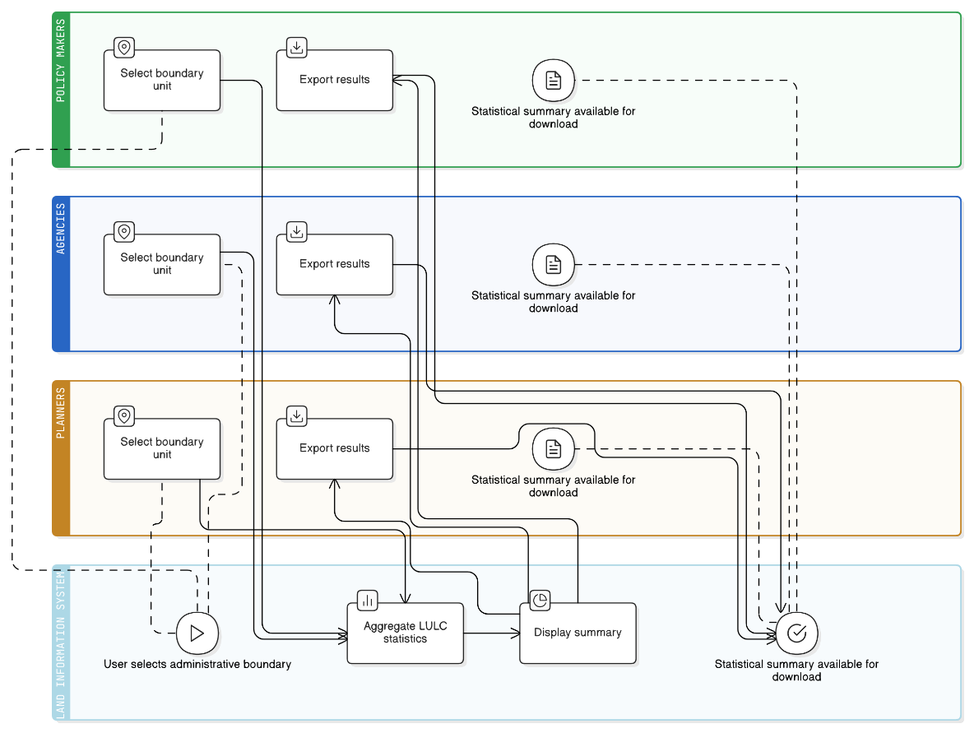

|  |  |
| --- | --- |
| **Field** | **Description** |
| **Description** | Provide statistical land-use information per administrative boundary (parcel, municipal, national) aggregated from the LULC database. |
| **Priority** | High |
| **Actors** | Policy Makers, Agencies, Planners |
| **Pre-Conditions** | Validated LULC database available. |
| **Inputs** | Boundary definitions, classification codes. |
| **Flow of Events** | 1. Select administrative unit.2. System aggregates LULC statistics.3. Displays and exports summary. |
| **Post-Conditions** | Statistical summary ready for download. |
| **Outputs** | Tables, graphs, Excel/PDF reports. |
| **Constraints** | Aggregation accuracy depends on base data. |
| **Related Use Cases** | UC-019, UC-022 |

#### UC-022 Situational Drawing (Current / Archival)

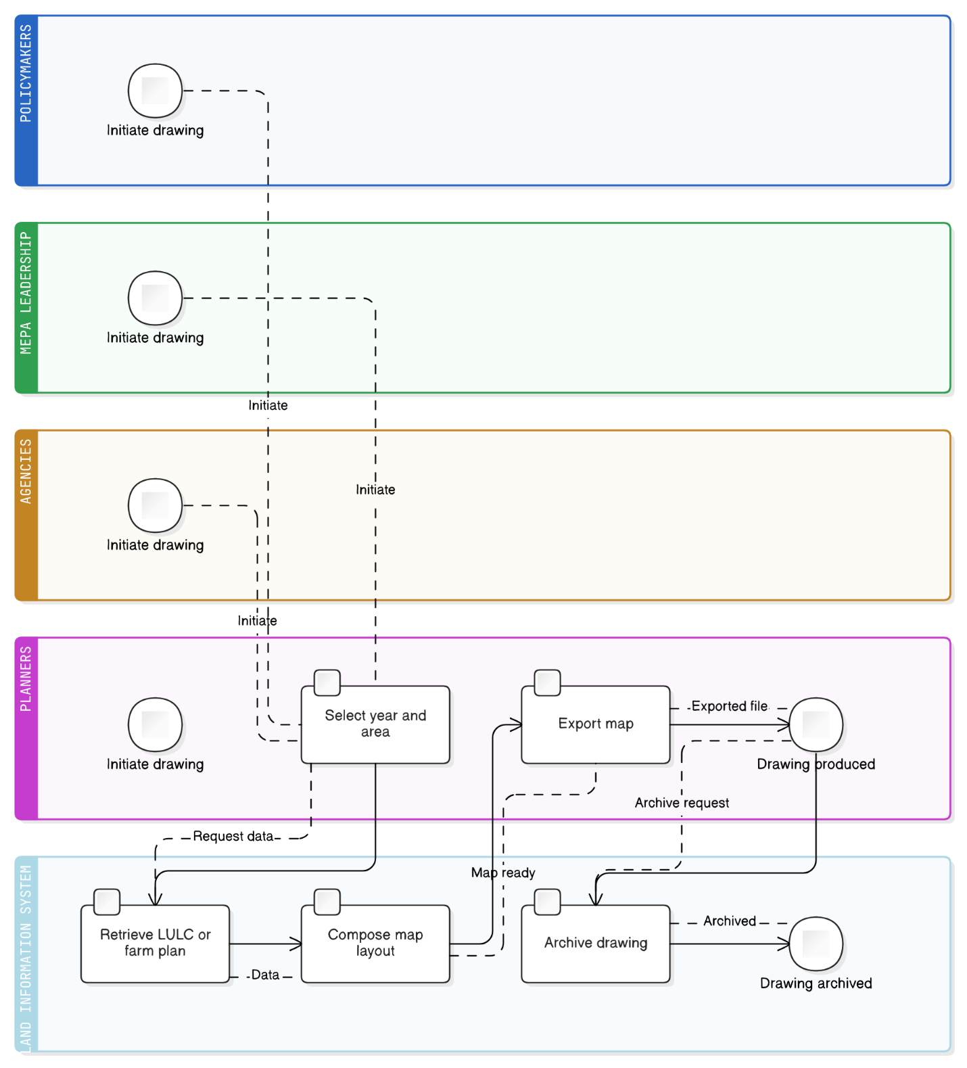

|  |  |
| --- | --- |
| **Field** | **Description** |
| **Description** | Generate land-use situational drawings for the current year or from archival farm plans, allowing users to compare historical land-use configurations. |
| **Priority** | Medium |
| **Actors** | Policymakers, MEPA Leadership, Agencies, Planners |
| **Pre-Conditions** | Historical and current datasets (LULC, farm plans) loaded in repository; map templates defined. |
| **Inputs** | Year, area of interest, layer selection. |
| **Flow of Events** | 1. User selects year and area.2. System retrieves corresponding LULC data or archival plan.3. Map composed with standard layout.4. Export in PDF or image format. |
| **Post-Conditions** | Situational drawing produced and archived for comparison or reporting. |
| **Outputs** | Year-wise map sheets, comparative graphics, metadata entries. |
| **Constraints** | Automation depends on availability of historical digital layers; may require manual intervention. |
| **Related Use Cases** | UC-019, UC-020, UC-025 |

#### UC-023 Land-Use Monitoring and Crop Indices

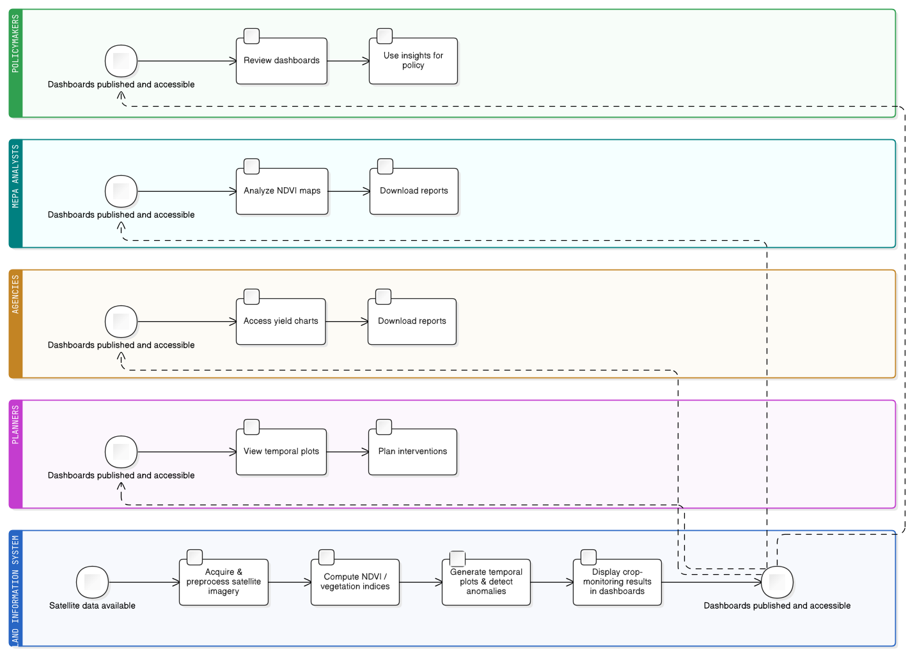

|  |  |
| --- | --- |
| **Field** | **Description** |
| **Description** | Provide crop-monitoring dashboards and indicators (e.g., NDVI, yield indices) for tracking vegetation health and seasonal trends using satellite imagery. |
| **Priority** | High |
| **Actors** | Policymakers, MEPA Analysts, Agencies, Planners |
| **Pre-Conditions** | Satellite imagery and NDVI computation services configured. |
| **Inputs** | Time-series imagery, crop masks, region boundaries. |
| **Flow of Events** | 1. Acquire and preprocess imagery.2. Compute NDVI or other vegetation indices.3. Generate temporal plots and anomaly alerts.4. Display results in dashboards. |
| **Post-Conditions** | Crop-monitoring dashboards published and accessible for analysis. |
| **Outputs** | NDVI maps, yield-index charts, downloadable reports. |
| **Constraints** | Accuracy depends on imagery frequency and cloud cover; computation time may vary. |
| **Related Use Cases** | UC-015, UC-018, UC-024 |

#### UC-024 Unified Information on Pasture / Windbreaks

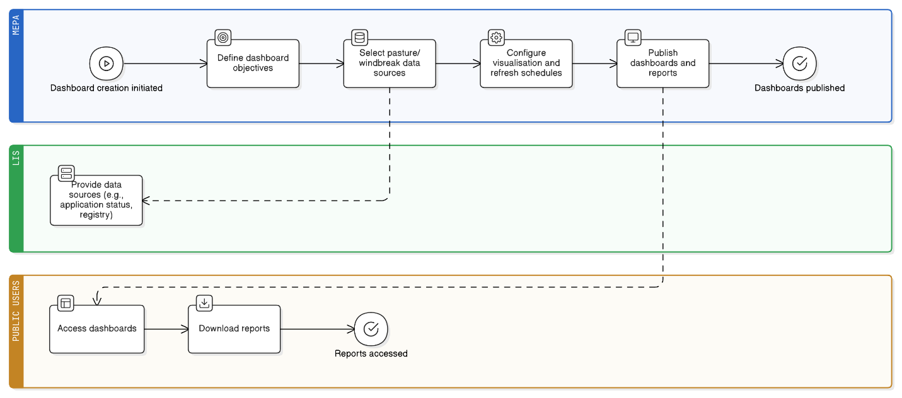

|  |  |
| --- | --- |
| **Field** | **Description** |
| **Description** | Provide unified access to pasture and windbreak information (registration, condition, management) through dashboards and reports integrated with land-use systems. |
| **Priority** | High |
| **Actors** | MEPA, LMA, APA, NFA, Planners, Public Users |
| **Pre-Conditions** | Datasets prepared and validated; access policies set. |
| **Inputs** | Data sources (e.g., pasture application status, windbreak registry), KPI definitions. |
| **Flow of Events** | 1. Define dashboard objectives.2. Select pasture/windbreak data sources.3. Configure visualisation and refresh schedules.4. Publish dashboards. |
| **Post-Conditions** | Unified dashboards and reports available for public and agency users. |
| **Outputs** | Interactive dashboards, tabular reports, downloadable files. |
| **Constraints** | Performance depends on data refresh intervals and API availability. |
| **Related Use Cases** | UC-018, UC-020, UC-027, UC-028 |

### Reporting & Decision Support

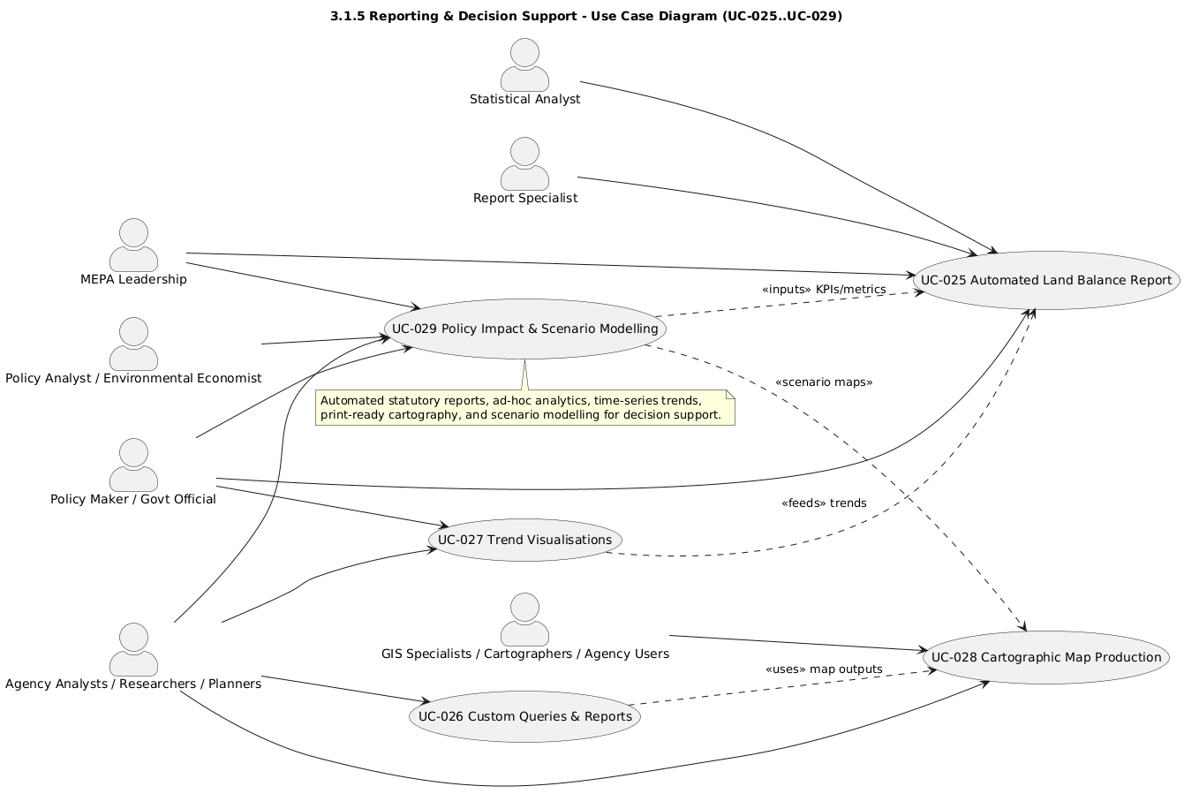

**Use Case Diagram: Reporting & Decision Support**

#### UC-025 Automated Land Balance Report

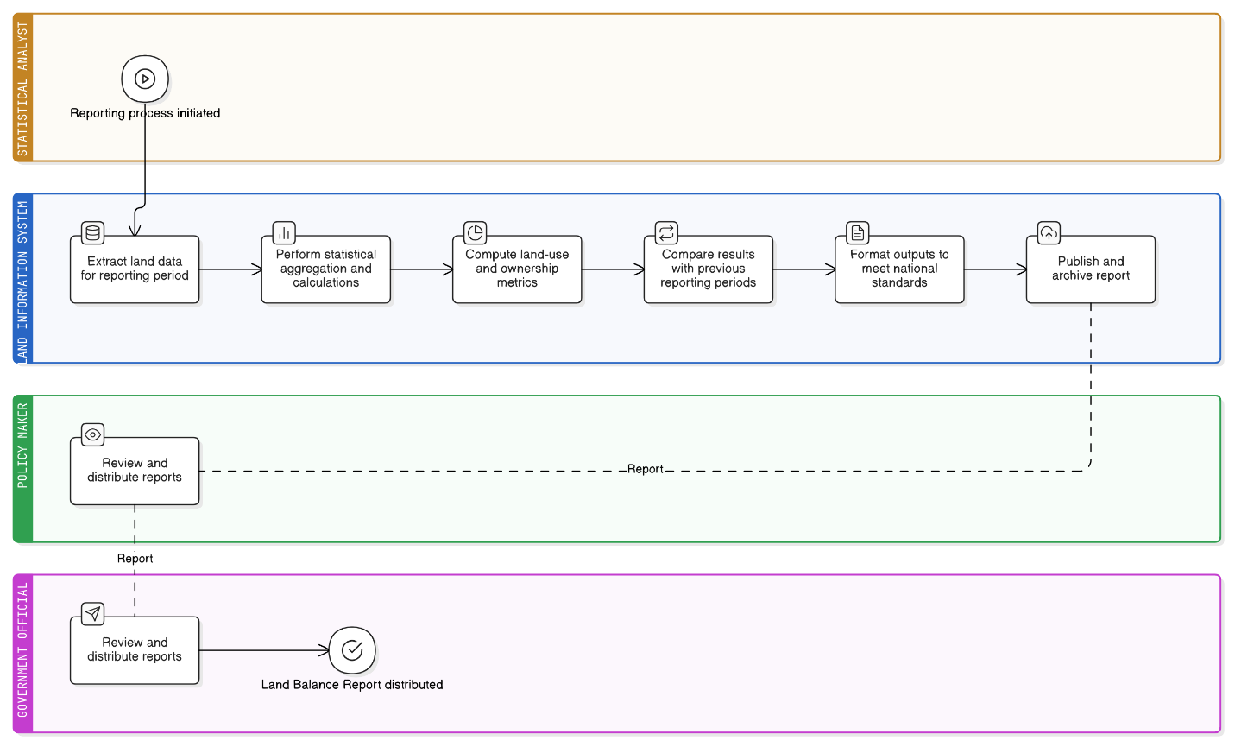

|  |  |
| --- | --- |
| **Field** | **Description** |
| **Description** | Produce statutory national and municipal Land Balance Reports automatically, including statistics on land use, ownership distribution, and temporal change analysis. |
| **Priority** | High |
| **Actors** | Statistical Analyst, Report Specialist, Policy Maker, Government Official |
| **Pre-Conditions** | Land data integrated and validated; statistical models and reporting templates configured. |
| **Inputs** | Land-use layers, cadastral parcels, forest boundaries, reporting parameters, time periods. |
| **Flow of Events** | 1. Extract data for the defined reporting period.2. Execute statistical aggregation and calculations.3. Compute land-use distribution and ownership metrics.4. Compare against prior periods.5. Format output per national standards.6. Publish and archive reports. |
| **Post-Conditions** | Official Land Balance Report produced and distributed to stakeholders. |
| **Outputs** | Excel/PDF reports, summary tables, policy dashboards. |
| **Constraints** | Must conform to national reporting standards; dependent on completeness and quality of datasets. |
| **Related Use Cases** | UC-018, UC-021 |

#### UC-026 Custom Queries and Reports

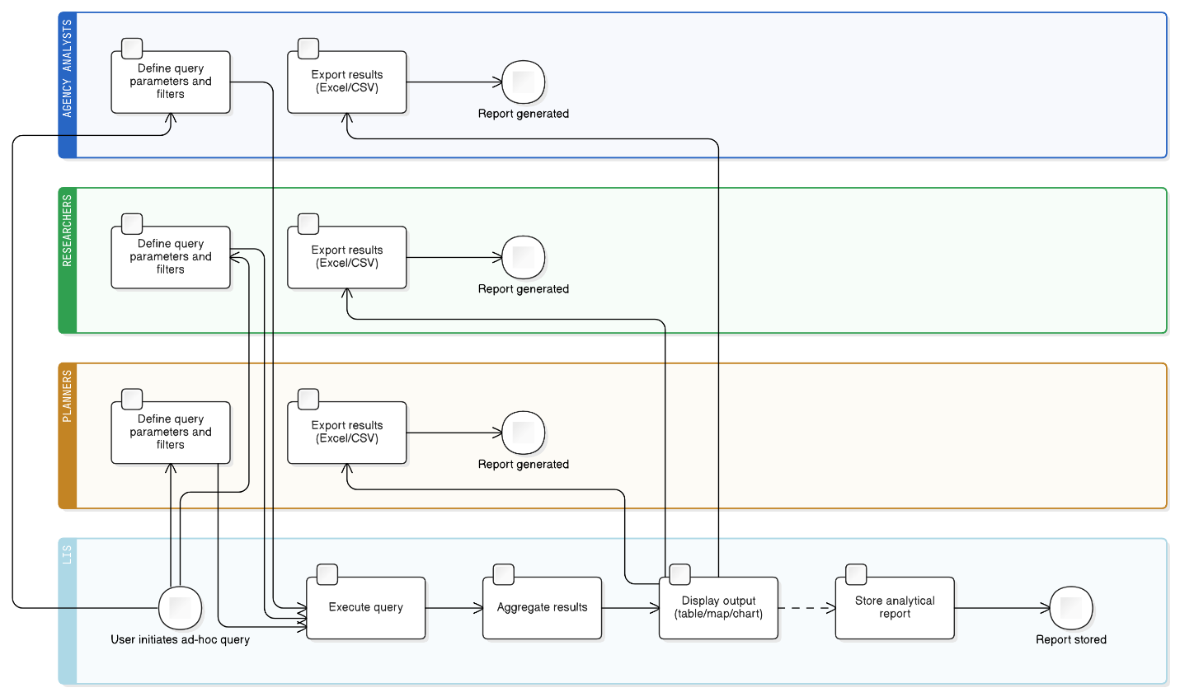

|  |  |
| --- | --- |
| Field | Description |
| Description | Enable users to create ad-hoc queries and reports to analyse data for specific themes (e.g. over-grazing, conflict analysis, water accessibility, agro-ecological zoning). |
| Priority | High |
| Actors | Agency Analysts, Researchers, Planners |
| Pre-Conditions | Data warehouse connected to reporting engine; user has query permissions. |
| Inputs | Query criteria, filters, spatial and tabular datasets. |
| Flow of Events | 1. User defines query parameters.2. System executes query and aggregates results.3. Display output as table, map, or chart.4. Allow export to Excel/CSV. |
| Post-Conditions | Analytical reports generated and stored. |
| Outputs | Dynamic tables, charts, CSV extracts. |
| Constraints | Response time depends on query complexity and dataset volume. |
| Related Use Cases | UC-013, UC-018, UC-022 |

#### UC-027 Trend Visualisations

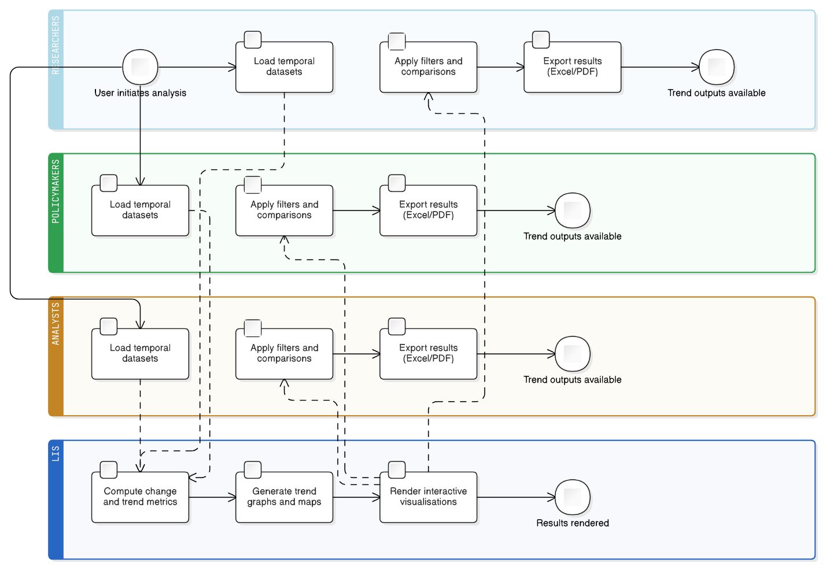

|  |  |
| --- | --- |
| **Field** | **Description** |
| **Description** | Display time-series and trend visualisations of land-use change, vegetation indices, and degradation metrics through interactive dashboards. |
| **Priority** | Medium |
| **Actors** | Researchers, Policy Makers, Analysts |
| **Pre-Conditions** | Time-series datasets indexed and accessible via LIS. |
| **Inputs** | Historical LULC data, vegetation indices, change detection results. |
| **Flow of Events** | 1. Load temporal datasets.2. Compute change and trend metrics.3. Generate trend graphs and maps.4. Enable filters and comparisons.5. Export outputs as reports or dashboards. |
| **Post-Conditions** | Temporal analysis results published for decision support. |
| **Outputs** | Dashboards, charts, PDF summaries, interactive graphs. |
| **Constraints** | Requires large-volume data storage and visual rendering capacity. |
| **Related Use Cases** | UC-015, UC-025, UC-026 |

#### UC-028 Cartographic Map Production

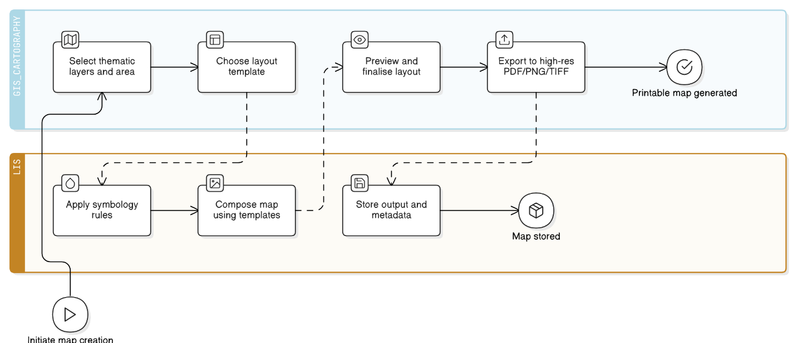

|  |  |
| --- | --- |
| **Field** | **Description** |
| **Description** | Generate high-quality printable cartographic maps with legends, scale bars, north arrows, and standard layouts for official reports and publications. |
| **Priority** | Medium |
| **Actors** | GIS Specialists, Cartographers, Agency Users, Planners |
| **Pre-Conditions** | Map templates, symbology rules, and data layers configured in LIS. |
| **Inputs** | Thematic layers, boundaries, title blocks, symbology definitions. |
| **Flow of Events** | 1. Select map theme and area of interest.2. Choose layout template.3. System composes map with standard legend and scale.4. Preview and finalise layout.5. Export to PDF or image. |
| **Post-Conditions** | Cartographically standard map stored and available for dissemination. |
| **Outputs** | Printable map files (PDF, PNG, TIFF), metadata records. |
| **Constraints** | Must comply with national cartographic and printing standards. |
| **Related Use Cases** | UC-016, UC-017, UC-018, UC-027 |

#### UC-029 Policy Impact and Scenario Modelling

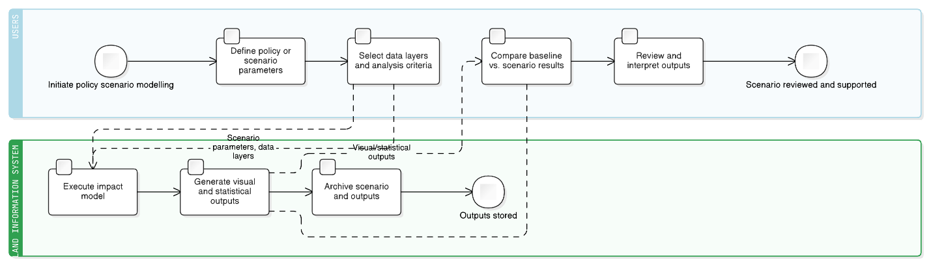

|  |  |
| --- | --- |
| **Field** | **Description** |
| **Description** | Provide decision-support models for evaluating policy impacts and scenarios (e.g., crop suitability, erosion risk, zoning, investment planning) using combined spatial, environmental, and socio-economic data. |
| **Priority** | High |
| **Actors** | Policy Analyst, Planner, Environmental Economist, MEPA Leadership, Researcher |
| **Pre-Conditions** | Integrated datasets (land use, forest, soil, climate, socio-economic) validated; model framework configured. |
| **Inputs** | Scenario parameters, data layers, model settings, policy variables. |
| **Flow of Events** | 1. Define policy or scenario parameters.2. Select data layers and analysis criteria.3. Execute impact model.4. Compare baseline vs. scenario results.5. Generate visual and statistical outputs. |
| **Post-Conditions** | Scenario outcomes available for review and decision support. |
| **Outputs** | Policy impact maps, comparative reports, recommendation summaries. |
| **Constraints** | Computational intensity depends on model complexity and data resolution; uncertainties must be documented. |
| **Related Use Cases** | UC-014, UC-016, UC-025, UC-026 |

### Field and Mobile Services

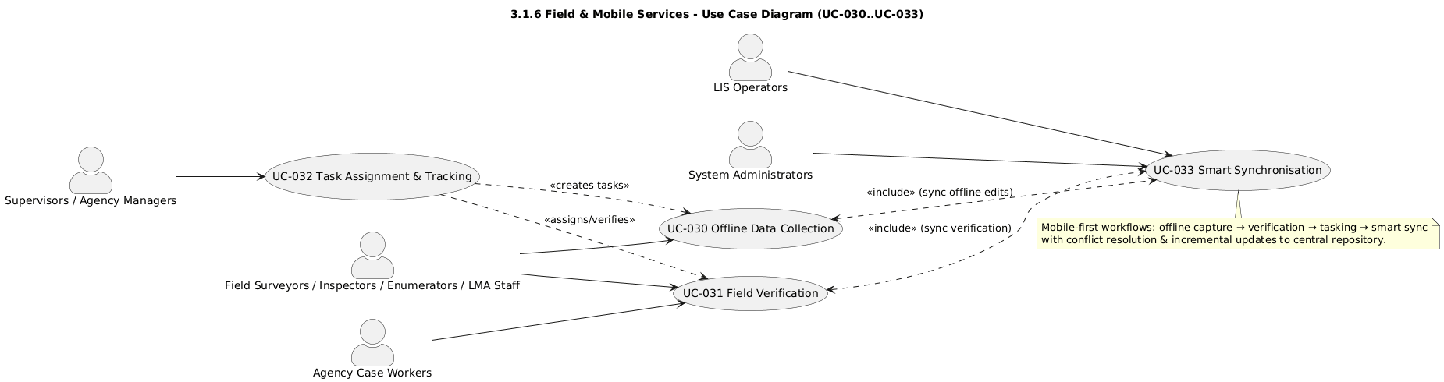

**Use Case Diagram: Field and Mobile Services**

#### UC-030 Offline Data Collection

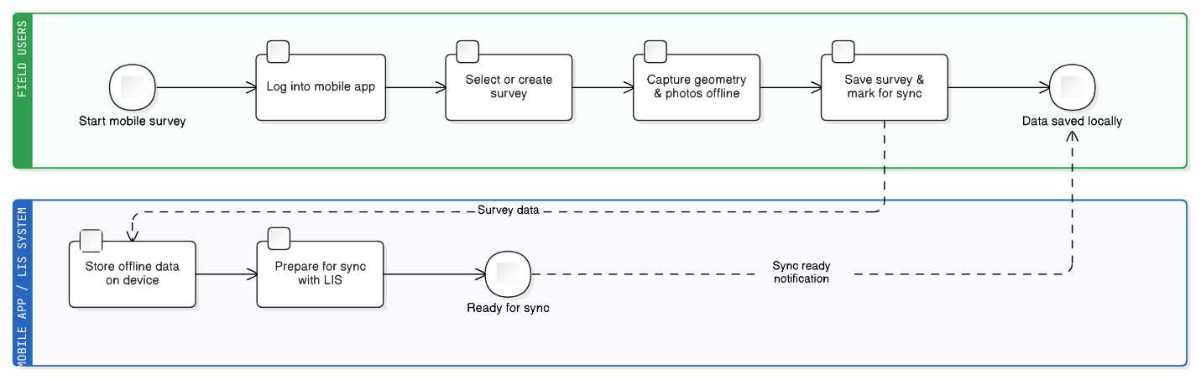

|  |  |
| --- | --- |
| **Field** | **Description** |
| **Description** | Provide GNSS-enabled mobile applications for capturing points, polygons, photos, and attribute forms in offline mode for subsequent synchronisation with the LIS centralised database. |
| **Priority** | High |
| **Actors** | Field Surveyors, Inspectors, LMA Staff, Agency Enumerators |
| **Pre-Conditions** | Mobile app installed and configured; survey tasks assigned. |
| **Inputs** | Spatial features (points/polygons), attribute forms, photographs. |
| **Flow of Events** | 1. Field user logs into mobile app.2. Select task or create new survey.3. Capture geometry and photos offline.4. Save and mark for sync. |
| **Post-Conditions** | Survey records stored locally for later upload. |
| **Outputs** | Offline geospatial datasets and forms. |
| **Constraints** | Device GNSS accuracy and battery dependence. |
| **Related Use Cases** | UC-031, UC-032 |

#### UC-031 Field Verification

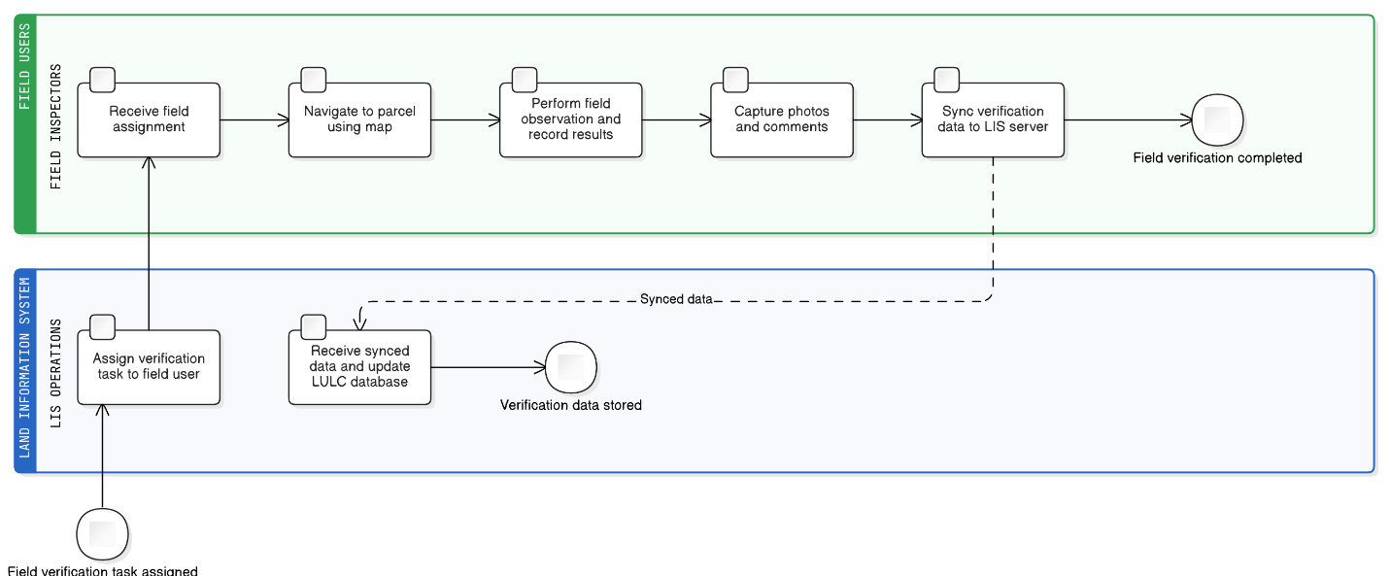

|  |  |
| --- | --- |
| **Field** | **Description** |
| **Description** | Support on-site verification of land-use and LULC features to validate data in the central repository. Tasks may include checking deforestation, crop types, and boundary accuracy. |
| **Priority** | High |
| **Actors** | Inspectors, LMA Staff, Agency Case Workers |
| **Pre-Conditions** | Verification tasks assigned via LIS workflow. |
| **Inputs** | Target parcel IDs, field form templates, reference imagery. |
| **Flow of Events** | 1. Receive field assignment.2. Navigate to parcel using map.3. Perform observation and record results.4. Capture photos and comments.5. Sync to LIS server. |
| **Post-Conditions** | Verification results updated in LULC database. |
| **Outputs** | Verification forms, GPS points, photos. |
| **Constraints** | Network availability may delay synchronisation. |
| **Related Use Cases** | UC-030, UC-032, UC-033 |

#### UC-032 Task Assignment and Tracking

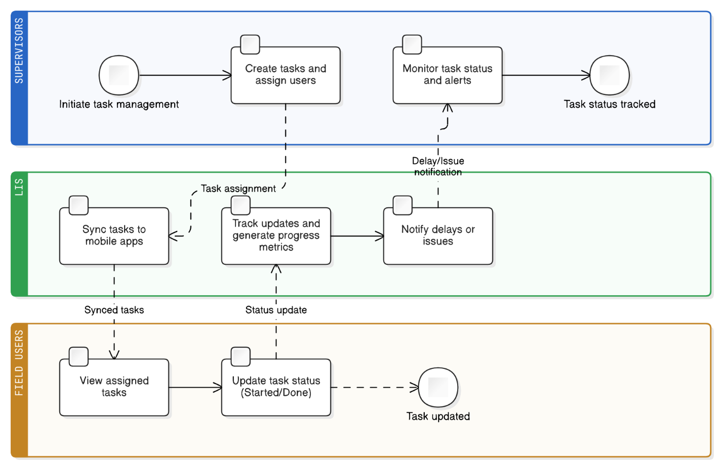

|  |  |
| --- | --- |
| **Field** | **Description** |
| **Description** | Enable supervisors to assign, track, and monitor field tasks linked to workflows (e.g., data collection or verification) through LIS dashboard and mobile apps. |
| **Priority** | Medium |
| **Actors** | Supervisors, Field Inspectors, Agency Managers |
| **Pre-Conditions** | Workflow module active and staff registered. |
| **Inputs** | Task parameters (location, deadline, staff), status updates. |
| **Flow of Events** | 1. Manager creates tasks and assigns users.2. Tasks synced to mobile apps.3. Field users update status (Started/Done).4. System tracks progress and alerts delays. |
| **Post-Conditions** | Task status visible on dashboard; progress metrics updated. |
| **Outputs** | Task lists, progress reports, notifications. |
| **Constraints** | Dependent on network sync and user compliance. |
| **Related Use Cases** | UC-030, UC-031, UC-033 |

#### UC-033 Smart Synchronisation

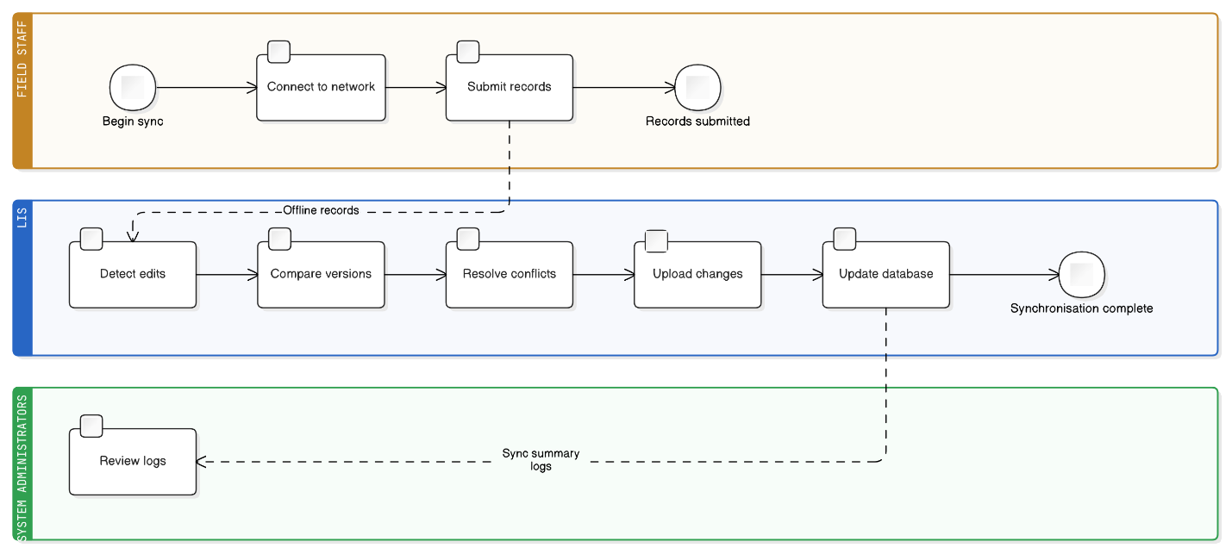

|  |  |
| --- | --- |
| **Field** | **Description** |
| **Description** | Synchronise offline and online edits from field devices with conflict resolution and incremental updates to ensure data integrity. |
| **Priority** | High |
| **Actors** | Field Staff, System Administrators, LIS Operators |
| **Pre-Conditions** | Offline data collected and device connected to network. |
| **Inputs** | Offline records, local transaction logs. |
| **Flow of Events** | 1. System detects pending edits.2. Compares server and local versions.3. Resolves conflicts using timestamps and user rules.4. Uploads confirmed changes to centralised database. |
| **Post-Conditions** | All datasets synchronised and version logs updated. |
| **Outputs** | Sync summary logs, updated records. |
| **Constraints** | Large datasets may increase sync time; requires stable connection. |
| **Related Use Cases** | UC-030, UC-031, UC-032 |

### Transparency and Open Data

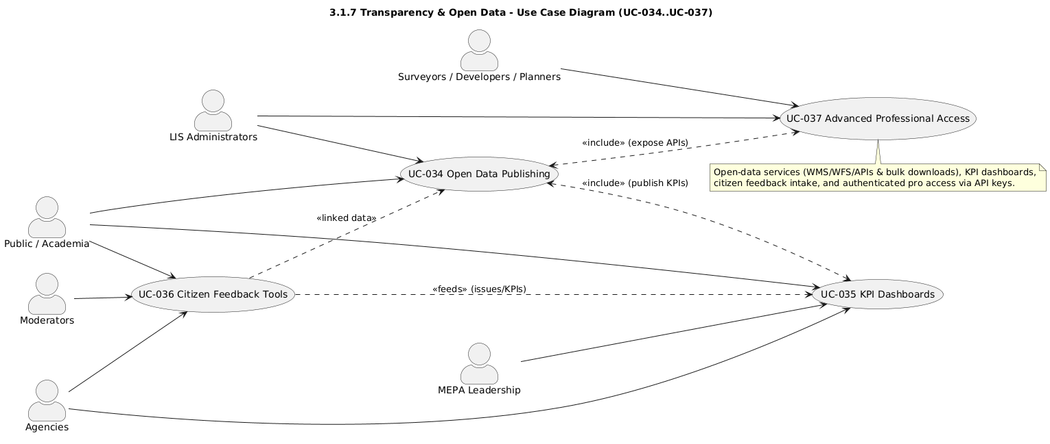

**User Case Diagram: Transparency and Open Data**

#### UC-034 Open Data Publishing

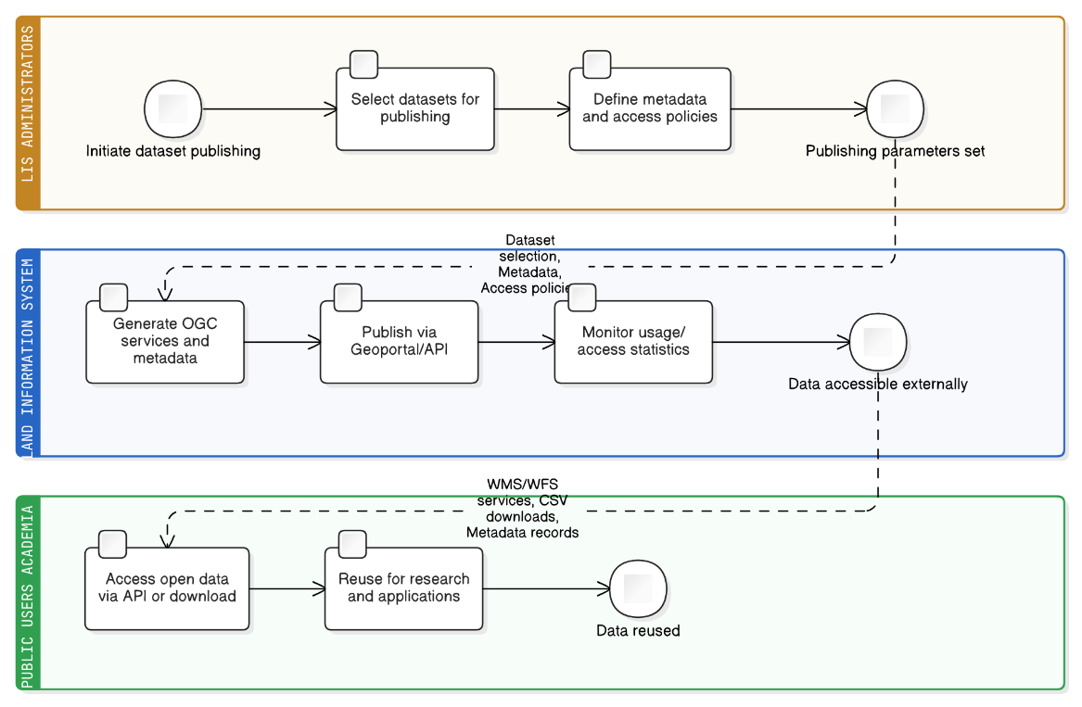

|  |  |
| --- | --- |
| **Field** | **Description** |
| **Description** | Publish OGC services, API endpoints, and bulk downloads integrated with the NSDI Geoportal to promote data transparency and reuse. |
| **Priority** | High |
| **Actors** | LIS Administrators, Public Users, Academia |
| **Pre-Conditions** | Data validated and approved for public release. |
| **Inputs** | Dataset selection, metadata, access policies. |
| **Flow of Events** | 1. Select datasets for publishing.2. Generate metadata and OGC services.3. Publish via Geoportal/API.4. Monitor access statistics. |
| **Post-Conditions** | Datasets available for external access via API and downloads. |
| **Outputs** | WMS/WFS services, CSV downloads, metadata records. |
| **Constraints** | Must comply with NSDI and open-data licensing policies. |
| **Related Use Cases** | UC-028, UC-035 |

#### UC-035 KPI Dashboards

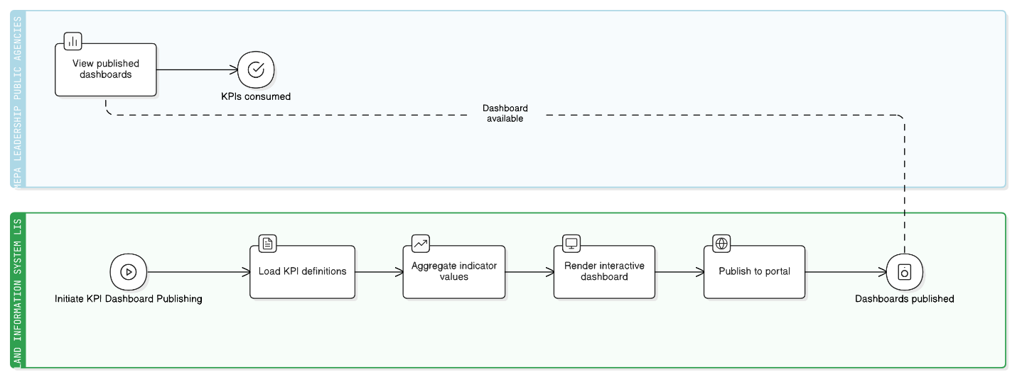

|  |  |
| --- | --- |
| **Field** | **Description** |
| **Description** | Present key performance indicators such as land-use percentages, degraded hectares, forest boundaries, and service cycle times through interactive dashboards. |
| **Priority** | Medium |
| **Actors** | MEPA Leadership, Public, Agencies |
| **Pre-Conditions** | KPI definitions configured and linked to data sources. |
| **Inputs** | Statistical datasets, API feeds. |
| **Flow of Events** | 1. Load KPI definitions.2. Aggregate indicator values.3. Render interactive dashboard.4. Publish to portal. |
| **Post-Conditions** | Dashboards available for stakeholder viewing. |
| **Outputs** | KPI charts, scorecards, exported PDFs. |
| **Constraints** | Real-time updates depend on API refresh intervals. |
| **Related Use Cases** | UC-034, UC-036 |

#### UC-036 Citizen Feedback Tools

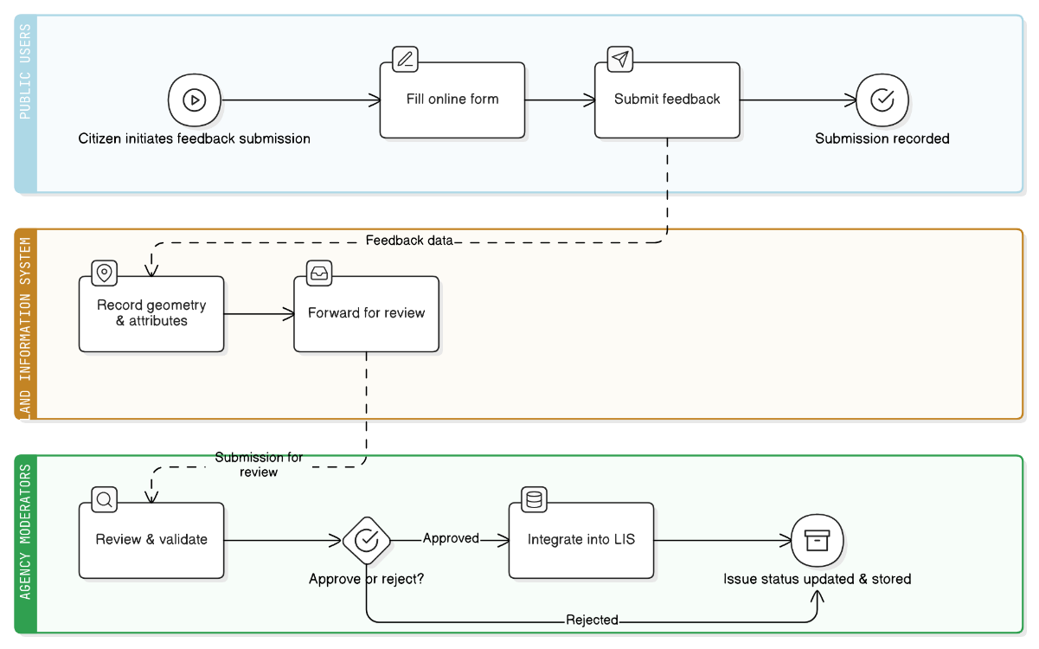

|  |  |
| --- | --- |
| **Field** | **Description** |
| **Description** | Enable citizens to submit and verify land-use issues or on-ground conditions via online forms and geo-tagged inputs. |
| **Priority** | High |
| **Actors** | Public Users, Agencies, Moderators |
| **Pre-Conditions** | Feedback portal active; verification workflow established. |
| **Inputs** | User ID, location, description, photo evidence. |
| **Flow of Events** | 1. Citizen submits feedback.2. System records geometry and attributes.3. Agency moderator reviews submission.4. Verified issue integrated into LIS. |
| **Post-Conditions** | Issue record stored and status tracked. |
| **Outputs** | Feedback entries, review logs, status dashboards. |
| **Constraints** | Requires moderation to avoid spam and duplicate entries. |
| **Related Use Cases** | UC-034, UC-035, UC-037 |

#### UC-037 Advanced Professional Access

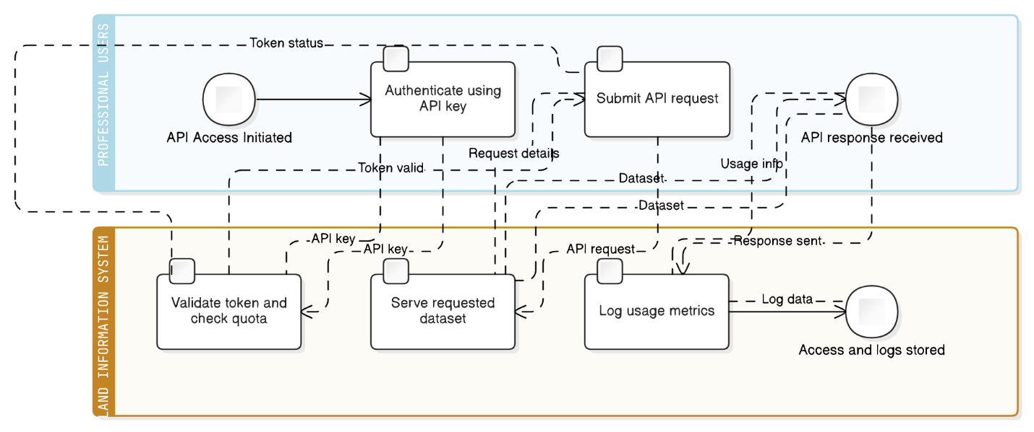

|  |  |
| --- | --- |
| **Field** | **Description** |
| **Description** | Provide advanced API and data-download access for professional users (surveyors, developers, planners) via API keys and authenticated tokens. |
| **Priority** | High |
| **Actors** | Surveyors, Developers, Planners |
| **Pre-Conditions** | User registered and API key issued; datasets tagged for professional access. |
| **Inputs** | API requests with token authentication. |
| **Flow of Events** | 1. User authenticates via API key.2. System validates token and usage quota.3. Serves requested dataset.4. Logs usage metrics. |
| **Post-Conditions** | Data delivered via secure API endpoint; access logged. |
| **Outputs** | API responses (JSON/XML), usage logs. |
| **Constraints** | Enforced rate limits and licensing rules. |
| **Related Use Cases** | UC-034, UC-035, UC-036 |

## External Interface Requirements

This section specifies requirements for how the LIS software will interface with users, other systems, and the hardware/environment. It is divided into: User Interfaces, Hardware Interfaces, Software Interfaces (to other systems), and Communication Interfaces.

### User Interfaces

* **[SRS-INT-001] General UI Design:** The LIS must provide intuitive, user-friendly interfaces tailored to the needs of each user group (internal staff, public users, field users). All interfaces shall have a consistent look and feel, adhere to the Government of Georgia branding guidelines (e.g., logo, colours), and maintain a consistent navigation structure across modules.
* **[SRS-INT-002] Internal Web Portal UI:** The internal portal shall be a web-based application accessible via standard browsers (Chrome, Firefox, Edge) without requiring any plugins or installations. It must present a **dashboard** upon login that gives an overview (e.g., pending tasks, relevant alerts, summary statistics).
* **[SRS-INT-003] GIS Map Viewer:** The internal portal shall include a GIS Map Viewer pane that allows users to view and overlay multiple layers of spatial data (parcels, land use, roads, imagery, etc.). Users must be able to pan/zoom smoothly, turn layers on/off, and see a legend.
* **[SRS-INT-004] Editing Tools:** The system shall provide editing tools for spatial data, allowing users with edit rights to create and modify features with visual feedback and rule enforcement.
* **[SRS-INT-005] Workflow (Task) Inbox:** The internal portal shall provide a clearly visible list of tasks assigned to the logged-in user.
* **[SRS-INT-006] Form Interfaces:** The system shall provide form interfaces for data entry and updates with appropriate controls and inline validation.
* **[SRS-INT-007] Public Portal UI:** The public portal must have a **clean, simple design** that is welcoming to non-technical users.
* **[SRS-INT-008] Public Map Viewer:** The public portal shall include a simplified map interface for searching and viewing basic public layers.
* **[SRS-INT-009] E-Service Application Forms:** The public portal shall present a multi-step form wizard for each e-service, guiding users through the process with clear instructions and validation.
* **[SRS-INT-010] Public Account Management:** The public portal shall provide pages for user login, registration, profile management, and a dashboard to track application status.
* **[SRS-INT-011] Help and Guidance:** The system shall include a Help/FAQ section and contextual help (e.g., tooltips) to assist users.
* **[SRS-INT-012] Mobile-Friendly Design:** The public portal’s pages must use responsive design to be fully functional on small screens.
* **[SRS-INT-013] Mobile App UI:** The mobile application shall have a streamlined UI optimised for touch and offline use, with large, clear buttons and minimal text entry.
* **[SRS-INT-014] Sync Status Indicator:** The mobile app must clearly indicate its online/offline status and what data is pending synchronisation.

### Hardware Interfaces

* **[SRS-INT-015] Server Hardware Interface:** Server Hardware Interface – LIS is deployable on a virtualised server environment (Microsoft Hyper-V or equivalent standards-compliant virtualisation platform) with the given resources.
* **[SRS-INT-016] Mobile Device Sensor Integration:** The LIS mobile app must interface with the device’s hardware, including the GNSS receiver for location and the camera for photo/video capture.

### Software Interfaces

The LIS employs a hybrid integration model: ETL pipelines handle scheduled bulk synchronisation (typically nightly), while REST/SOAP APIs support real-time transactions and two-way data exchange. ETL is used for large datasets and historical alignment; APIs for event-driven updates and service invocations.

* **[SRS-INT-017] NAPR Cadastre System Interface:** The LIS shall interface with NAPR’s cadastral and property registration system to exchange parcel and ownership data, preferably through a secure API.
* **[SRS-INT-018] NFA Forest Information System Interface:** The LIS shall interface with NFA’s systems to consume data on forests, compartments, and permits, and to provide feedback on detected changes or incidents.
* **[SRS-INT-019] APA Protected Areas DB Interface:** The LIS shall interface with APA’s database to consume boundaries and zoning of Protected Areas and to push alerts regarding incidents near these areas.
* **[SRS-INT-020] NWA Vineyard Cadastre System Interface:** The LIS shall serve as the primary system for the vineyard cadastre and provide an API for other NWA systems to fetch updated vineyard information.
* **[SRS-INT-021] RDA Farmer Registry Interface:** The system shall integrate with RDA’s Farmer Registry database to look up and verify farmer information.
* **[SRS-INT-023] NSDI Geoportal Interface:** The LIS shall publish metadata and share datasets via OGC services to the national geoportal.
* **[SRS-INT-024] External Notification Services Interface:** The LIS shall interface with an SMTP server for sending emails and an SMS gateway API for sending text messages.
* **[SRS-INT-025] API and Data Standards:** The system shall expose all external APIs only via a central API Gateway that enforces: (a) OAuth2/OIDC for delegated access; (b) mutual TLS or signed requests for system-to-system trust; (c) rate-limits per client (baseline 60 RPS; burst 120 RPS/10s with HTTP 429 and retry-after headers); (d) semantic versioning with ≥6 months deprecation notice for breaking changes; (e) OpenAPI (OAS) specs published to partner agencies; and (f) audit logging of all calls with client ID. (Traces: SyRS [External System Interfaces, API & Identity Governance] and [SYS-INT-010] API Gateway).

### Communication Interfaces

* **[SRS-INT-026] Web Communication (HTTPS):** All web/API communication uses HTTPS (TLS 1.3; TLS 1.2 permitted only for approved legacy endpoints); HSTS enabled; approved cipher suites; TLS scans clean.
* **[SRS-INT-027] Email (SMTP) Communication:** The LIS shall send emails via an SMTP server using TLS encryption (STARTTLS).
* **[SRS-INT-028] File Transfer (SFTP/FTPS):** For scheduled data imports/exports, the LIS shall use secure file transfer protocols like SFTP or FTPS.
* **[SRS-INT-029] Session Management:** For web user sessions, the LIS shall use secure cookies (with HttpOnly, Secure flags) or token-based authentication (JWTs).
* **[SRS-INT-030] Government SSO / Digital ID:** The public portal shall integrate with the national Single Sign-On / eID (when available) using OpenID Connect (OIDC) / OAuth 2.0 with PKCE; LIS shall also support username/password fallback.
* **[SRS-INT-031] Georgian Amelioration (GA) Interface:** LIS shall consume GA irrigation/amelioration assets and operational data via scheduled ETL (daily) and publish LIS-generated overlays (works, restrictions) back to GA weekly. Exchange formats: OGC WFS/WMS or CSV/GeoPackage over SFTP/HTTPS; character set UTF-8; coordinate reference system EPSG:32638/4326 as applicable.
* **[SRS-INT-032] SRCA Interface:** LIS shall consume SRCA soil and agro-climatic datasets (station observations, rasters, zonal statistics) quarterly or as published, and shall expose LIS land-unit identifiers for cross-reference. Exchange formats: OGC WCS/WMS for rasters, CSV/GeoTIFF for bulk; transport via HTTPS/SFTP.

## Non-Functional Requirements

This section details the quality attributes and constraints that the LIS software must satisfy, grouped by category.

### Performance Requirements

* **[SRS-PRF-001] Concurrent User Support:** Concurrent User Support — Support ≥150 internal and ≥1000 public concurrent authenticated sessions while meeting SRS-PRF-002/003/009/010 thresholds.
* **[SRS-PRF-002] UI Response Time:** Simple retrieval queries shall return results within 3 seconds.
* **[SRS-PRF-003] Map Navigation Performance:** Map navigation (pan/zoom) shall update the display within 1-2 seconds.
* **[SRS-PRF-004] E-Service Submission Time:** Submitting an e-service form shall provide a confirmation page within 5 seconds.
* **[SRS-PRF-005] Geoprocessing Performance:** Complex spatial queries shall complete within 30 seconds on average. Cumbersome tasks shall be handled asynchronously.
* **[SRS-PRF-006] Batch Import Performance:** Nightly ETL processes shall complete within scheduled maintenance windows (e.g., before 06:00 AM).
* **[SRS-PRF-007] API Throughput:** API Throughput – Public API shall sustain ≥100 requests/second with p95 server processing time ≤300 ms for simple GETs on the baseline VM sizing defined in Section 3.2.
* **[SRS-PRF-008] Scalability:** The architecture must allow horizontal scaling to at least double the baseline capacity without requiring redesign.
* **[SRS-PRF-009] Bandwidth Efficiency:** The system shall minimise bandwidth usage for low-connectivity users by using compressed data transfers and progressive/loading techniques (e.g. tiled map data, on-demand loading of large content). Users on slow networks shall experience graceful degradation rather than failure.

### Security Requirements

* **[SRS-SEC-001] Authentication:** All users must be authenticated before using non-public functions, with strong credentials. Administrative and other sensitive accesses shall require multi-factor authentication (e.g. one-time codes). Passwords must be stored securely (hashed)
* **[SRS-SEC-002] Role-Based Access Control (RBAC):** The system shall implement RBAC to ensure users only access data and functions they are permitted to.
* **[SRS-SEC-003] Data Confidentiality:** All communications must be encrypted. Sensitive data in storage shall be encrypted at rest if required by policy. TLS 1.3 required; TLS 1.2 permitted only for approved legacy endpoints; HSTS enabled; cipher suites audited; storage encryption; clean external scan.
* **[SRS-SEC-004] Audit Logging:** The system shall produce audit logs for security-relevant events, including user logins, data changes, and approval decisions.
* **[SRS-SEC-005] Input Validation and Hardening:** The system must be secure against common web vulnerabilities, including SQL Injection, XSS, and CSRF.
* **[SRS-SEC-006] Security Testing:** The system shall undergo security testing, such as vulnerability scanning and penetration testing, before production.
* **[SRS-PRI-001] PII Masking & Role-Based Disclosure** — Public outputs (maps, extracts, status pages) shall never expose personal owner identifiers; internal roles may view full PII per RBAC. Masking rules shall be configurable (e.g., last-4 digits, role-specific redactions).
* **[SRS-PRI-002] Retention & Purge Controls** — The system shall support policy-driven retention (archive/purge) of personal data and attachments by type and age, with legal holds and audit logs of purge actions.
* **[SRS-PRI-003] Subject Access/Export** — Administrators shall be able to locate and export all records related to a data subject on request, with an auditable report.
* **[SRS-PRI-004] Open-Data Anonymisation** — Datasets published for open data shall be anonymised or aggregated per policy before exposure. *(Traces: SyRS “Security and Privacy” incl. Personal Data Protection Law; SYS-PRI-001/002).*
* **[SRS-SEC-007] Attribute-Based Access Control:** The system shall support attribute-based access controls in addition to roles. Access to records or fields marked with specific attributes (e.g., confidentiality level, agency ownership) will be automatically restricted to users possessing the requisite qualities or clearance level.
* **[SRS-SEC-008] Data Loss Prevention:** The system shall limit mass export of data and include DLP safeguards. Sensitive reports will be watermarked, bulk data downloads by users will be logged and alert administrators if thresholds are exceeded, and only authorised users can export or print sensitive datasets.
* **[SRS-SEC-009] Security Monitoring and Alerts:** The system shall integrate with government security monitoring systems. It will provide real-time threat detection and logging, sending security event data to the centralised SIEM. An administrative security dashboard shall display alerts for unusual activities (e.g. multiple failed logins, bulk data downloads) to facilitate prompt response.

### Usability and Accessibility Requirements

* **[SRS-USA-001] Ease of Use:** The system shall have an intuitive user interface such that typical tasks can be accomplished with minimal training for internal users and no training for public users.
* **[SRS-USA-002] Accessibility (WCAG compliance):** The public portal must meet WCAG 2.1 AA guidelines.
* **[SRS-USA-003] Mobile Usability:** The public portal and mobile app must be easily usable on smartphone touch screens.
* **[SRS-USA-004] Internationalisation and Localisation:** The system shall be fully usable in Georgian and English, with all UI elements, messages, and help content available in both languages.
* **[SRS-USA-005] Consistent Terminology:** The system shall use consistent terminology across all interfaces and documentation.
* **[SRS-USA-006] Contextual Help & Tooltips:** The system shall provide contextual help for complex forms and key fields (inline tooltips/links) in Georgian and English; help links must resolve to relevant content.

### Software Quality Attributes

#### Reliability & Availability Requirements

* **[SRS-REL-001] System Uptime:** The system shall be available (operational) at least 99.9% of the time, excluding scheduled maintenance windows.
* **[SRS-REL-002] Recovery Time Objective (RTO):** In the event of a significant outage, the LIS must be restored to operational state within 24 hours at most.
* **[SRS-REL-003] Recovery Point Objective (RPO):** The system must not lose more than 4 hours of data in a worst-case scenario.
* **[SRS-REL-004] Redundancy:** The system components must be redundant to eliminate single points of failure.
* **[SRS-REL-005] Disaster Recovery:** The system shall have a Disaster Recovery (DR) plan and environment. Regular DR drills shall be conducted. Backups shall be encrypted in transit and at rest and stored in a geographically separate facility. Conduct two DR failover drills/year and a quarterly restore test for database point-in-time recovery. Acceptance requires: (i) documented DR runbook; (ii) drill reports proving RTO ≤ 24h and RPO ≤ 4h; (iii) restore-test artefacts.

#### Maintainability & Supportability Requirements

* **[SRS-MNT-001] Modular Architecture:** The system shall be designed in a modular way with separation of concerns and well-defined interfaces.
* **[SRS-MNT-002] Code Quality and Documentation:** The code shall follow standard coding conventions and be well-commented. Up-to-date technical documentation must be provided.
* **[SRS-MNT-003] Configurability:** The system shall use configuration rather than hard-coded values for business rules, UI elements, and workflow definitions.
* **[SRS-MNT-004] Logging and Diagnostics:** The system shall include detailed logging at appropriate levels (info, warning, error, debug) to help support personnel diagnose issues.

#### Scalability & Flexibility Requirements

* **[SRS-SCL-001] User Scalability:** The system shall scale to accommodate at least 2× the initially expected number of users and data volume without fundamental redesign.
* **[SRS-SCL-002] Data Scalability:** The LIS database and storage shall be able to handle growth in data volume from new datasets or historical records.
* **[SRS-SCL-003] Functional Flexibility:** The system shall be flexible to adapt to new requirements, such as adding new e-services or analysis tools, with minimal changes to the core system.

## Logical Database Requirements

The LIS database follows ISO 19152 (LADM) as a conceptual guideline to ensure semantic consistency. Only those classes necessary for land-management operations are implemented (e.g., Party, Spatial Unit, BAUnit, Source). Rights/Restrictions/Responsibilities (RRR) entities remain referenced through NAPR APIs rather than fully replicated.

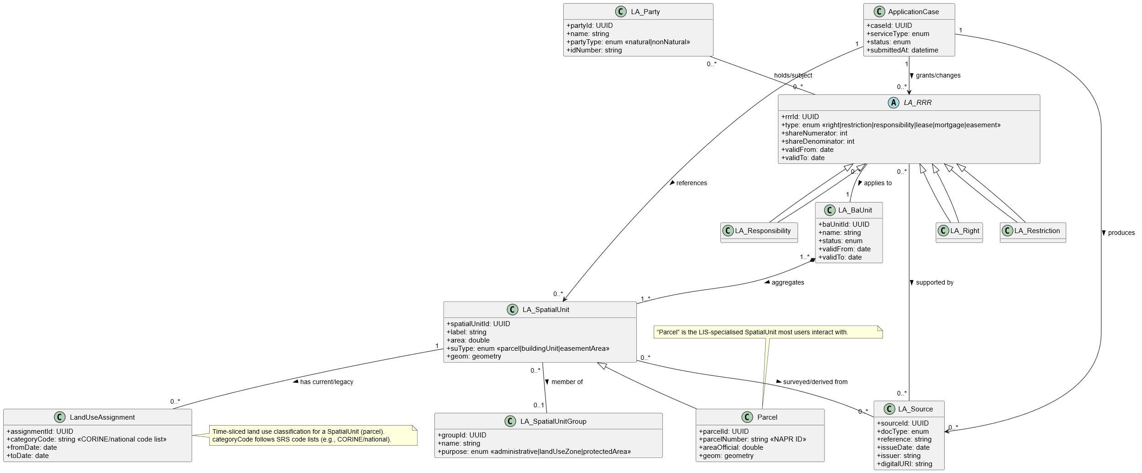

**Figure: UML Class Diagram**

* **[SRS-DB-001] Central Spatial Database:** The LIS shall use a centralised spatial database (RDBMS with GIS support) as the single source of truth.
* **[SRS-DB-002] Data Model Alignment with LADM:** The database schema shall align with the ISO 19152 Land Administration Domain Model (LADM) concepts.
* **[SRS-DB-003] Key Entity Definitions:** The database shall include tables for key entities such as Parcel, Land Use/Cover, Thematic Layers, Application/Case, Party, User Accounts & Roles, and Audit Logs.
* **[SRS-DB-004] Spatial Indexing:** All spatial tables must have spatial indexes for performance.
* **[SRS-DB-005] Data Integrity Constraints:** The database shall use primary keys, foreign keys, and other constraints to ensure referential integrity and data quality.
* **[SRS-DB-006] Historical Record Management:** The centralized spatial database shall maintain a complete valid-time history of parcels, rights, restrictions and responsibilities, supporting lawful back-dated corrections and audit. The LIS shall maintain valid-time history for all core land administration entities (Parcels, Rights, Restrictions, Responsibilities, and Parties) in accordance with LADM temporal schema.

For supplementary datasets (e.g., land use, zoning, LULC, administrative boundaries), the LIS shall support snapshot or event-based versioning sufficient for change analysis, but not require continuous valid-time tracking. (See SRS-DB-010/011).

Note: Historical records for NAPR cadastre data will not be duplicated within LIS. Where NAPR’s IPRS already maintains version history, LIS will retrieve it via API on demand; only management datasets originating within LIS (e.g., pasture leases, forest permits) will maintain local temporal versions.

* **[SRS-DB-007] Transactions and Concurrency:** The database must support concurrent edits safely using proper transaction isolation and locking mechanisms.
* **[SRS-DB-008] LADM Core Classes** – The logical data model shall implement LADM core concepts (LA_Party, LA_BAUnit, LA_RRR, LA_SpatialUnit) and their associations in the LIS schema or mapping layer; deviations shall be documented
* **[SRS-DB-009] Temporal Versioning:** The centralised spatial database shall maintain valid-time history for all authoritative land units and administrative records (create/modify/delete) with from/to timestamps, enabling historical queries (“as of” a date).

Note * A complete logical ER diagram conforming to the LADM-based schema shall be prepared by the LIS implementation contractor and submitted for client review and approval as a contractual deliverable before database development.

## UML Component Diagram

UML Component Diagram showing: UI Layer (Internal/Public/Mobile Portals), Application Services (BPM/ETL/API/GeoProcessing), Central DB & Metadata Repo, External Systems (NAPR, NFA, etc.).

|  |
| --- |
|  |
| **UML Component Diagram** |

The architecture follows a three-tier model with loosely coupled components to enable scalability and maintainability.

## Design Constraints

* **[SRS-CON-001] Use of Open Standards:** The LIS design shall adhere to open standards for data formats and interfaces (e.g., OGC, GML, GeoJSON).
* **[SRS-CON-002] Technology Stack Constraints:** The system must be built on technologies that meet government approval and avoid vendor lock-in, preferring open-source solutions where possible.
* **[SRS-CON-003] Regulatory Compliance:** The design must incorporate constraints imposed by Georgian laws, including those related to land governance and personal data protection, as well as supporting international environmental reporting obligations (e.g. climate change and sustainable development reports)
* **[SRS-CON-004] Non-duplication of External Systems Functions:** The LIS shall not replicate the authoritative functions of external systems like NAPR.
* **[SRS-CON-005] Data Sovereignty & Hosting Constraint:** The LIS will be hosted on government infrastructure within Georgia. The design will not require any external cloud service that would conflict with data sovereignty.
* **[SRS-CON-006] Accessibility as a Constraint:** The public-facing components of the system must be designed to meet WCAG 2.1 AA compliance as a mandatory constraint.

## Business Rules and Constraints

All business rules governing LIS operations (e.g., validation logic, eligibility criteria, calculation formulae) shall be catalogued in a Business Rules Register to be produced by the implementation contractor and approved by the Client before system acceptance.

# Appendices

## Appendix A — Effort & Cost Estimation (Multi‑Model, Self‑Contained)

This appendix provides a comprehensive estimation of development effort, cost, and schedule for the Georgia Land Information System (LIS), using multiple validated estimation models—Function Point Analysis (primary), COCOMO II, LOC back‑firing, Use Case Points (UCP), and heuristic cross‑checks. The figures reflect the updated hybrid implementation model, in which the core software development and testing activities are executed offshore, while key milestones (inception, elaboration, UAT, and go‑live) are carried out onsite in Georgia.

## Summary

|  |  |
| --- | --- |
| **Baseline Dimension** | **Final Agreed Baseline** |
| **Project** | National Land Information System (LIS) |
| **Primary Sizing Method** | Function Point Analysis (IFPUG) |
| **Adjusted Function Points (AFP)** | ≈ 1,101 FP |
| **Productivity Assumption** | 25 hours / FP (hybrid, seniorised delivery) |
| **Total Engineering Effort** | ≈ 27,525 hours |
| **Effort (Person-Months)** | ≈ 183.5 PM @ 150 h/PM | ≈ 172.0 PM @ 160 h/PM |
| **Delivery Model** | Hybrid (≈75% offshore development with targeted onsite presence in Georgia during key phases) |
| **Implementation Duration** | 8 months (accelerated schedule) |
| **Average Staffing** | ≈ 22–23 FTE |
| **Peak Staffing** | ≈ 28–32 FTE |
| **Development & Integration Cost** | USD 1.50 million |
| **Cost Basis** | Accelerated delivery, seniorised resources, enhanced non-functional assurance, multi-agency integration, data migration risk, governance and compliance overhead. |
| **Cross-Check Validation** | COCOMO II, Use Case Points (UCP), LOC back-firing, and expert heuristic — all converge around the USD 1.5M baseline |
| **Warranty** | 1 year post–go-live, included in implementation cost |
| **Warranty Coverage** | Corrective maintenance, security patches, stabilisation support |
| **Operations & Maintenance (O&M)** | 20 months following completion of the warranty period |
| **O&M Cost Basis** | ≈ 15% of development cost per year, pro-rated |
| **Total O&M (20 months)** | ≈ USD 375,000 |
| **Total Support Horizon** | ≈ 32 months (1-year warranty + 20-month O&M) |

### Function Point Analysis (Primary Method)

The LIS functional size is counted using IFPUG 4.x. Transactional functions (EI/EO/EQ) and data functions (ILF/EIF) are taken from the approved use-case inventory and interface set.

**Counting & Weights (IFPUG 4.x)**

|  |  |  |  |
| --- | --- | --- | --- |
| **Type** | **Count (S/A/C)** | **Weight (S/A/C)** | **UFP** |
| EI | 20 / 40 / 10 | 3 / 4 / 6 | 283 |
| EO | 20 / 40 / 14 | 4 / 5 / 7 | 378 |
| EQ | 8 / 15 / 4 | 3 / 4 / 6 | 108 |
| ILF | 6 / 6 / 4 | 7 / 10 / 15 | 162 |
| EIF | 5 / 5 / 1 | 5 / 7 / 10 | 70 |
| **Total UFP** |  |  | **1,001** |

#### Value Adjustment Factor (VAF)

General System Characteristics (GSC) reflect the LIS’s distributed nature, heavy online updates, multiple sites, performance sensitivity, complex processing, and change facilitation.

|  |  |
| --- | --- |
| **Parameter** | **Value** |
| Total Degree of Influence (TDI) | 45 |
| VAF | 1.10 |
| AFP = UFP × VAF | 1,001 × 1.10 ≈ 1,101 FP |

#### Effort from FP (Hours and Person-Months)

Productivity is held at 25 hours per FP under the hybrid delivery model (offshore execution with increased senior oversight, stronger QA/NFR engineering, and compressed schedule concurrency).

* Total Engineering Hours = AFP × 25 h/FP  
  = 1,101 × 25  
  = 27,525 hours
* Scenario A: PM @ 150 h/PM  
  = 27,525 ÷ 150  
  = 183.5 PM
* Scenario B: PM @ 160 h/PM  
  = 27,525 ÷ 160  
  = 172.0 PM

#### Baseline Blended Delivery Rate (Input Assumption)

For this estimate, a **baseline blended delivery rate of approximately USD 55 per hour** is assumed.

Established based on the following delivery characteristics:

|  |  |
| --- | --- |
| **Cost Driver** | **Impact on Rate** |
| **Accelerated 8-month schedule** | Higher concurrency, coordination overhead |
| **Seniorised delivery team** | Increased proportion of senior GIS, integration, and QA specialists |
| **National-scale LIS complexity** | High integration density, spatial processing, regulatory sensitivity |
| **Non-functional assurance** | Performance engineering, security hardening, HA validation |
| **World Bank compliance** | Governance, documentation, audit-ready evidence |
| **One-year warranty** | Corrective maintenance risk priced into delivery |

The resulting blended rate is consistent with observed benchmarks for hybrid offshore–onsite delivery of mission-critical GIS/LIS platforms under accelerated schedules.

#### Cost Computation from FP Baseline

Using the approved Function Point baseline:

* Adjusted Function Points (AFP): ≈ 1,101 FP
* Productivity: 25 hours per FP
* Total Engineering Effort:  
  1,101 × 25 = 27,525 hours

**Applying the baseline blended rate:**

* Total Implementation Cost:  
  27,525 hours × USD 55/hour  
  ≈ USD 1.51 million

For planning and contracting purposes, the figure is rounded and rebaselined to USD 1.50 million.

#### Workstream Distribution & Cost

|  |  |  |  |  |
| --- | --- | --- | --- | --- |
| **Workstream** | **Share** | **Hours (≈27,525h)** | **Cost Share** | **Cost (USD)** |
| Programme & Architecture Leadership | 15% | 4,129 | 15% | 225,000 |
| Business Analysis & Configuration | 8% | 2,202 | 8% | 120,000 |
| GIS & Core Back-end Engineering | 38% | 10,460 | 38% | 570,000 |
| Front-end, Mobile & UX | 12% | 3,303 | 12% | 180,000 |
| Data Integration & Migration (ETL) | 10% | 2,752 | 10% | 150,000 |
| QA, Security & Performance Assurance | 10% | 2,752 | 10% | 150,000 |
| DevOps, Installation & Deployment | 4% | 1,101 | 4% | 60,000 |
| Training & Change Management | 3% | 826 | 3% | 45,000 |
| **Total** | **100%** | **27,525** | **100%** | **1,500,000** |

**Included explicitly**

* Installation and deployment
* Performance and security testing
* One-year warranty support

### Warranty & Operations Support

|  |  |  |
| --- | --- | --- |
| **Period** | **Coverage** | **Cost** |
| Warranty (Year 1) | Corrective maintenance, security fixes, stabilisation support | Included |
| O&M Phase 1 (Months 1–12 post-warranty) | Application Management Services (AMS), adaptive changes, minor enhancements | ≈ USD 225,000 |
| O&M Phase 2 (Months 13–20 post-warranty) | Same scope (pro-rated for 8 months) | ≈ USD 150,000 |
| **Total O&M (20 months)** |  | ≈ USD 375,000 |

### Basis of Cost Estimate

The implementation cost of approximately **USD 1.5 million** is derived from a structured assessment of delivery risk, schedule compression, quality obligations, and lifecycle support commitments. The following factors substantially influence the estimate:

1. **Accelerated Delivery Schedule (8 Months):** Reducing the implementation window requires a significant increase in concurrent staffing, parallel development streams, and additional coordination overhead. Peak staffing increases to over 30 FTE during construction and transition phases, necessitating enhanced technical leadership and integration management.
2. **Seniorisation of Delivery Resources:** Given the national importance of the LIS, the delivery model assumes a higher proportion of senior GIS, integration, data, and security specialists compared to a standard offshore delivery. This approach reduces execution risk under a compressed timeline but increases the blended cost rate.
3. **Enhanced Non-Functional Assurance:** The estimate explicitly includes effort for performance engineering, load testing, security hardening, audit logging, and high-availability validation to meet the SyRS non-functional requirements (e.g., 99.9% availability, response-time SLAs).
4. **Multi-Agency Integration and Data Migration Risk:** The LIS integrates with numerous external systems (NAPR, NFA, APA, NWA, RDA, SRCA), each with varying data quality and interface maturity. The cost baseline includes engineering contingency for integration variability, rehearsal migrations, and parallel data validation.
5. **One-Year Warranty Included in Implementation Cost:** The implementation cost internalises the effort and risk associated with a one-year post–go-live warranty period. During this period, corrective maintenance and stabilisation support are provided at no additional charge, transferring early operational risk from the Client to the Implementer.
6. **Governance, Quality Assurance, and Compliance Overhead:** World Bank–funded national systems require enhanced documentation, traceability, acceptance evidence, and formal quality controls. The estimate includes dedicated programme governance, QA leadership, and compliance support.

### Cross‑Check Models (Not for Pricing; for Sanity)

Function Point Analysis (FPA) is used as the primary sizing and pricing anchor for the LIS. Additional estimation models—COCOMO II, LOC back-firing, Use Case Points (UCP), and expert heuristics—are applied solely as independent cross-checks to validate the reasonableness of the baseline effort and cost.

Based on the re-baselined implementation cost of approximately USD 1.5 million and the FP-derived engineering effort of ≈ 27,525 hours, the estimate implies a blended delivery rate of approximately USD 54–55 per hour. This blended rate reflects the hybrid delivery model, increased seniorisation of resources, enhanced quality assurance, and the acceleration premium associated with the eight-month implementation window.

**COCOMO II Alignment**

When the FP size is converted to Source Lines of Code using a conservative back-firing ratio of approximately 55 SLOC per FP (resulting in ~60 KSLOC), and processed through the COCOMO II Post-Architecture model with effort multipliers representative of:

* high integration complexity,
* elevated reliability and security requirements,
* schedule compression, and
* strong toolchain and process maturity,

The resulting effort band lies in the range of approximately 190–210 person-months. When translated using the implied blended rate, this corresponds to a cost-equivalent range that encloses and slightly exceeds the USD 1.5M baseline, which is expected for accelerated, integration-heavy national systems. This confirms that the USD 1.5M baseline is risk-adjusted but not under-estimated.

**Use Case Points (UCP) Alignment**

Application of the Karner/Ribu Use Case Points method, using LIS-appropriate actor weights, technical complexity factors, and environmental factors, yields an estimated size of approximately 950–1,100 UCP. At observed productivity levels of 25–28 hours per UCP for GIS- and integration-heavy systems, the resulting effort range is approximately 24,000–31,000 hours. When valued at the implied blended delivery rate, this produces a cost band of approximately USD 1.3–1.7 million, cleanly bracketing the USD 1.5M implementation cost.

**Consultant Heuristic Alignment**

As a further reasonableness check, the accelerated eight-month delivery requires an average staffing level of approximately 22–23 full-time equivalents, with peak staffing reaching 28–32 FTE during construction and transition phases. This staffing profile corresponds to approximately 175–185 person-months, which, when monetised at the implied blended rate, aligns closely with the USD 1.5M baseline.

**Conclusion**

All independent cross-check methods—COCOMO II, UCP, and expert heuristic—converge around a cost-equivalent range that encloses or centres on USD 1.5 million when translated using the project’s implied blended delivery rate. This convergence provides strong validation that the re-baselined implementation cost appropriately reflects the LIS scope, accelerated schedule, integration complexity, non-functional requirements, and warranty obligations, while avoiding reliance on any single estimation method.

### Assumptions & Risks

**Assumptions**

* Scope stability based on the approved Service Catalogue and SRS baseline.
* Integration partners (NAPR, NFA, APA, etc.) to provide sandbox APIs by Month 3.
* Data migration strategy fixed by mid-Elaboration.
* Non‑functional targets: 99.9% uptime, ≤ 5s response time for 95% of requests.

**Risks & Mitigations**

* Integration delays: mitigate via mock APIs and simulators.
* Data quality variance: mitigate with profiling and rehearsal migrations.
* Timezone coordination issues: establish joint agile ceremonies and overlapping core hours.
* Resource constraints: deploy cross-trained multi-role staff.
* Scope creep: controlled through MoSCoW prioritisation and Steering Committee approvals.

### Final Baseline Summary

**Cost:** ≈ **USD 1.50 million**  
(Development & Integration, inclusive of 1-year post–go-live warranty)

**Effort:** ≈ **27,525 hours**  
(≈ 172–184 person-months, depending on productive hours per month)

**Duration:** **8 months**  
(Accelerated implementation under a hybrid delivery model)

**O&M:** **20 months post-warranty**, budgeted at ≈ 15% of development cost per year,  
(≈ USD 375,000 total, pro-rated for 20 months)

**Total lifecycle cost:** **≈ USD 1.875 million**

## Appendix B: Requirements Traceability Matrix (RTM)

This section provides a comprehensive bi-directional requirements traceability matrix for the Land Information System (LIS) project. Each software requirement (SRS) is traced back to its source system requirements (SyRS) and stakeholder requirements (StRS). Conversely, every stakeholder and system requirement is traced forward to one or more software requirements, ensuring complete coverage. The matrix is organised by requirement category as in the SRS (Functional, External Interface, and various Non-Functional quality categories).

Legend:  
- SRS ID – Unique software requirement ID (from SRS document).  
- Description – Summary of the software requirement.  
- Category – Requirement type (Functional, Interface, Performance, Security, etc.).  
- Priority – Implementation priority (C = Critical, H = High, M = Medium, L = Low).  
- SyRS ID – Linked system requirement ID(s) (from SyRS document).  
- StRS ID – Linked stakeholder requirement ID(s) (from StRS document).

### SRS to SyRS/StRS Traceability

#### Functional Requirements (Use Cases)

The LIS functional requirements are captured as use cases in the SRS. Each use case represents a major service or function and is derived from specific SyRS and StRS needs (ensuring real-world stakeholder goals are met). The table below lists each use case from the SRS, with its priority and links to source requirements:

|  |  |  |  |  |  |  |
| --- | --- | --- | --- | --- | --- | --- |
| **SRS ID (Use Case)** | **Description / Service Function** | **Category** | **Priority** | **SyRS ID(s)** | **StRS ID(s)** | **Verification** |
| UC-001 | User Login (authenticate users to grant access) | Security / Functional | C | SYS-SEC-001; SYS-INT-013 | REQ-USR-001 | D, T |
| UC-002 | User Logout (terminate session securely) | Security / Functional | C | SYS-SEC-001; SYS-SEC-004 | REQ-USR-001 | D, T |
| UC-003 | Password Management (change/reset) | Security / Functional | H | SYS-INT-013 | REQ-SEC-003; REQ-USR-001 | D, T, I |
| UC-004 | Two-Factor Authentication (OTP/TOTP) | Security / Functional | H | SYS-INT-013; SYS-SEC-002 | REQ-SEC-002 | D, T |
| UC-005 | Manage User Roles & Permissions (RBAC) | Security / Functional | C | SYS-SEC-002 | REQ-USR-002 | I, D, T |
| UC-006 | Authentication & Access Control (end-to-end) | Security / Functional | C | SYS-SEC-001/002/004; SYS-INT-013 | REQ-SEC-001/003; REQ-USR-001 | I, D, T |
| UC-007 | Internal User Activity Log (audit trail) | Security | C | SYS-SEC-004 | REQ-BUS-001 | I, A |
| UC-008 | ETL Multi-Source Data Integration | Functional | H | SYS-INT-015; SYS-INT-012 | REQ-BUS-001 | D, T, A |
| UC-009 | Versioned Multi-Agency Editing (branch/merge) | Functional | H | SYS-FUN-004/011 | REQ-BUS-001 | D, I |
| UC-010 | Metadata Catalogue & Publishing (ISO 19115/NSDI) | Functional | M | SYS-INT-011 | REQ-INT-007 | D, I |
| UC-011 | Central Geospatial Repository (authoritative store) | Functional | C | SYS-REL-001; SYS-PER-004 | REQ-BUS-001 | A, I |
| UC-012 | Data Validation & Quality Control (DQ rules, QC) | Functional | H | SYS-FUN-003 | REQ-BUS-001 | T, A |
| UC-013 | Interactive Map Viewer / Queries | Functional | H | SYS-INT-011; SYS-PER-002 | REQ-BUS-002 | T |
| UC-014 | Advanced Geoprocessing (raster/vector/MCDA) | Functional | H | SYS-FUN-009 | REQ-BUS-002 | T, A |
| UC-015 | Change Detection & Monitoring (AI/ML) | Functional | H | SYS-FUN-010 | REQ-BUS-002 | D, T |
| UC-016 | Suitability Modelling (weighted overlay) | Functional | H | SYS-FUN-011 | REQ-BUS-002 | T, A |
| UC-017 | Dashboards & Charts (role-based) | Usability / Functional | M | SYS-PER-004; SYS-UI-003 | REQ-BUS-002 | D, T |
| UC-018 | 3D & Temporal Analysis (terrain/time series) | Functional | M | SYS-PER-003/004 | REQ-BUS-002 | D, A |
| UC-019 | Extract from Unified LULC Database | Functional | H | SYS-INT-017; SYS-INT-011 | REQ-BUS-003 | D, T |
| UC-020 | Thematic Land-Use Map (boundary-based) | Functional | H | SYS-INT-011; SYS-PER-002 | REQ-BUS-003 | D, T |
| UC-021 | Unified Land-Use Information (statistics) | Functional | H | SYS-FUN-037 | REQ-BUS-013 | A, T |
| UC-022 | Situational Drawing (current/archival) | Functional | M | SYS-INT-015; SYS-INT-011 | REQ-BUS-003 | D, T |
| UC-023 | Land-Use Monitoring & Crop Indices (NDVI, etc.) | Functional | H | SYS-FUN-038 | REQ-BUS-010 | D, T |
| UC-024 | Unified Information on Pasture / Windbreaks | Functional | H | SYS-FUN-021/022 | REQ-BUS-005/006 | D, T |
| UC-025 | Automated Land Balance Report (statutory) | Functional | H | SYS-FUN-037 | REQ-BUS-013 | A, T |
| UC-026 | Custom Queries & Reports (ad-hoc) | Functional | H | SYS-FUN-030 | REQ-BUS-002 | D, T |
| UC-027 | Trend Visualisations (time-series) | Functional | M | SYS-PER-004; SYS-UI-003 | REQ-BUS-002 | D, T |
| UC-028 | Cartographic Map Production (print layouts) | Functional | M | SYS-INT-011 | REQ-BUS-003 | I, D |
| UC-029 | Policy Impact & Scenario Modelling | Functional | H | SYS-FUN-011; SYS-FUN-009 | REQ-BUS-002 | A, T |
| UC-030 | Offline Data Collection (GNSS, forms, photos) | Functional | H | SYS-FUN-049; SYS-PER-010 | REQ-USR-009 | D, T |
| UC-031 | Field Verification (on-site checks) | Functional | H | SYS-FUN-049; SYS-PER-010 | REQ-USR-009 | D, T |
| UC-032 | Task Assignment & Tracking (field/workflow) | Functional | M | SYS-FUN-036 | REQ-BUS-028/031 | D, T |
| UC-033 | Smart Synchronisation (conflict-aware) | Reliability / Functional | H | SYS-PER-010; SYS-REL-001 | REQ-NFR-010 | D, A, T |
| UC-034 | Open Data Publishing (OGC/API/downloads) | Interface / Functional | H | SYS-INT-011; SYS-INT-012 | REQ-INT-007; REQ-BUS-003 | I, D |
| UC-035 | KPI Dashboards (public/internal) | Functional / Usability | M | SYS-PER-004; SYS-UI-003 | REQ-BUS-033 | D, T |
| UC-036 | Citizen Feedback Tools (geo-tagged) | Functional | H | SYS-FUN-019 | REQ-BUS-029/030 | D, T |
| UC-037 | Advanced Professional Access (API keys/tokens) | Interface / Security | H | SYS-INT-010; SYS-INT-013 | REQ-INT-010 | I, D, T |

#### External Interface Requirements

These are the LIS requirements for user interfaces, hardware interfaces, and integration with other systems. They ensure the software meets usability standards and can exchange data with external systems:

|  |  |  |  |  |  |
| --- | --- | --- | --- | --- | --- |
| **SRS ID** | **Description (External Interface Requirement)** | **Category** | **Priority** | **SyRS ID(s)** | **StRS ID(s)** |
| SRS-INT-001 | General User Interface Design – LIS must have intuitive, user-friendly and consistent UIs for all user groups. | Interface (UI) | C | SYS-INT-004, SYS-INT-001 | REQ-INT-001 (Consistent UI), REQ-INT-004 (User-Centric UI) |
| SRS-INT-002 | Internal Web Portal UI – a web-based internal portal accessible via standard browsers, featuring a dashboard upon login. | Interface (UI) | C | SYS-INT-001, SYS-INT-003 | REQ-INT-001 (Consistent UI), REQ-INT-003 (Bilingual Support) |
| SRS-INT-003 | GIS Map Viewer (Internal) – interactive map pane for internal portal (pan/zoom, layer control, legend). | Interface (UI) | C | SYS-INT-008, SYS-INT-006 | REQ-INT-005 (Multiple Views), REQ-PRF-001 (Map Performance) |
| SRS-INT-004 | Editing Tools – internal portal must provide spatial editing tools for users with edit rights. | Interface (UI) | C | SYS-INT-009, SYS-FUN-011 | REQ-INT-004 (Pro/User Interfaces), REQ-FUN-012 (Versioned Editing) |
| SRS-INT-005 | Workflow Inbox – the internal portal displays each logged-in user with a list of their assigned tasks. | Interface (UI) | C | SYS-INT-009, SYS-FUN-030 | REQ-BUS-027 (SLA Monitoring) |
| SRS-INT-006 | Form Interfaces – the system provides web forms for data entry/updates with validation feedback. | Interface (UI) | C | SYS-INT-007 | REQ-INT-007 (Simplified Public UI), REQ-SEC-006 (Input Validation) |
| SRS-INT-007 | Public Portal UI – clean, simple interface for public users (no training required). | Interface (UI) | C | SYS-INT-001, SYS-INT-003 | REQ-INT-007 (Simplified Public UI), REQ-INT-002 (Accessibility) |
| SRS-INT-008 | Public Map Viewer – a simplified map interface on the public portal for viewing and searching basic layers. | Interface (UI) | H | SYS-INT-008 | REQ-INT-009 (Public Map Interface) |
| SRS-INT-009 | E-Service Application Forms – multi-step form wizard guiding users through online applications. | Interface (UI) | C | SYS-INT-005 | REQ-INT-008 (Public Service Wizards), REQ-BUS-024 (Digital Service Delivery) |
| SRS-INT-010 | Public Account Management – pages for user registration, login, profile, and application dashboard. | Interface (UI) | C | SYS-INT-010 | REQ-BUS-007 (Foreign Access / English UI), REQ-INT-003 (Bilingual Support) |
| SRS-INT-011 | Help and Guidance – help/FAQ section and contextual help (tooltips, etc.) in the system. | Interface (UI) | H | SYS-INT-005 | REQ-INT-006 (Contextual Help) |
| SRS-INT-012 | Mobile-Friendly Design – public portal pages use responsive design for mobile devices. | Interface (UI) | C | SYS-INT-001 | REQ-INT-001 (Consistent UI), REQ-INT-005 (Multiple Views/Responsive) |
| SRS-INT-013 | Mobile App UI – a streamlined, touch-optimised interface designed for field use. | Interface (UI) | H | SYS-INT-001 | REQ-INT-019 (Advanced GPS/GNSS Integration), REQ-INT-021 (Mobile Sensors) |
| SRS-INT-014 | Sync Status Indicator – mobile app clearly shows online/offline status and pending sync data. | Interface (UI) | H | SYS-INT-014 | REQ-ENV-004 (Offline Functionality) |
| SRS-INT-015 | Server Hardware Interface – LIS is deployable on a virtualised server environment (Microsoft Hyper-V or equivalent) with the given resources. | Hardware Interface | C | SYS-ENV-001 | REQ-ENV-001 (Infrastructure Compatibility) |
| SRS-INT-016 | Mobile Device Sensor Integration – mobile app interfaces with device GPS and camera for field data capture. | Hardware Interface | H | SYS-INT-019 | REQ-INT-019 (Advanced GPS Integration), REQ-INT-020 (GPS Data Management) |
| SRS-INT-017 | NAPR Cadastre System Interface – interface with NAPR’s cadastre system to exchange parcel/ownership data (secure API). | Software Interface | C | SYS-INT-014 | REQ-INT-010 (Real-time NAPR Integration) |
| SRS-INT-018 | NFA Forest System Interface – import forest maps/compartment data and share alerts. | Software Interface | H | SYS-INT-014 | REQ-INT-013 (Agency System Integration) |
| SRS-INT-019 | APA Protected Areas DB Interface – consume Protected Area boundaries/zones and provide incident alerts. | Software Interface | H | SYS-INT-014 | REQ-INT-013 (Agency System Integration) |
| SRS-INT-020 | NWA Vineyard Cadastre Interface – LIS serves as the primary vineyard cadastre; API for NWA systems to fetch vineyard data. | Software Interface | C | SYS-INT-014 | REQ-BUS-017 (Public Viticulture Services), REQ-INT-013 (Agency System Integration) |
| SRS-INT-021 | RDA Farmer Registry Interface – integrate with RDA’s Farmer Registry to verify farmer identities and data. | Software Interface | H | SYS-INT-014 | REQ-BUS-015 (Mobile Field Operations for RDA), REQ-INT-013 (Agency System Integration) |
| SRS-INT-023 | NSDI Geoportal Interface – publish data/metadata via OGC-compliant services to Georgia’s NSDI geoportal. | Software Interface | H | SYS-INT-011 | REQ-INT-016 (OGC-Compliant Services) |
| SRS-INT-024 | External Notification Services – integrate with email (SMTP) server and SMS gateway for sending notifications. | Software Interface | H | SYS-INT-013 | REQ-SEC-008 (Security Monitoring/Alerts) |
| SRS-INT-025 | API and Data Standards – all LIS APIs employ standard formats (REST/JSON, SOAP/XML, OGC Web Services). | Software Interface | C | SYS-INT-011 | REQ-INT-015 (OGC Service Performance), REQ-INT-017 (Consume External OGC) |
| SRS-INT-026 | Communication – All web/API communication shall use HTTPS with TLS 1.3. TLS 1.2 is permitted only for approved legacy endpoints with documented exceptions. HTTP Strict Transport Security (HSTS) must be enabled; weak protocols/cipher suites (e.g., TLS 1.0/1.1, RC4, 3DES) disabled. | Communication Interface | C | SYS-SEC-002 | REQ-SEC-004 (Data Encryption) |
| SRS-INT-027 | Email Communication – system sends emails via secure SMTP (TLS) for notifications. | Communication Interface | H | SYS-SEC-008 | REQ-INT-024 (Scanning/Digitisation) |
| SRS-INT-028 | File Transfer – for bulk data exchange, use secure file transfer (SFTP/FTPS) for imports/exports. | Communication Interface | H | SYS-INT-015 | REQ-INT-015 (Event-Driven Integration) |
| SRS-INT-029 | Session Management – web user sessions use secure cookies or tokens (JWT) with proper flags (HttpOnly, Secure, etc.). | Communication Interface | C | SYS-SEC-005 | REQ-SEC-005 (Data at Rest Protection) |
| SRS-INT-030 | Government SSO / Digital ID | Communication Interface | H | SYS-INT-011; SYS-INT- | REQ-SEC-001; REQ-INT-026 |
| SRS-INT-031 | Georgian Amelioration (GA) Interface | Communication Interface | H | SYS-INT-011; SYS-INT-013 | REQ-INT-016; REQ-INT-017 |
| SRS-INT-032 | SRCA Interface | Communication Interface | H | SYS-INT-011; SYS-PER-006 | REQ-PRF-006 |

* **[SRS-INT-030] Government SSO / Digital ID:** The public portal shall integrate with the national Single Sign-On / eID (when available) using OpenID Connect (OIDC) / OAuth 2.0 with PKCE; LIS shall also support username/password fallback.
* **[SRS-INT-031] Georgian Amelioration (GA) Interface:** LIS shall consume GA irrigation/amelioration assets and operational data via scheduled ETL (daily) and publish LIS-generated overlays (works, restrictions) back to GA weekly. Exchange formats: OGC WFS/WMS or CSV/GeoPackage over SFTP/HTTPS; character set UTF-8; coordinate reference system EPSG:32638/4326 as applicable.
* **[SRS-INT-032] SRCA Interface:** LIS shall consume SRCA soil and agro-climatic datasets (station observations, rasters, zonal statistics) quarterly or as published, and shall expose LIS land-unit identifiers for cross-reference. Exchange formats: OGC WCS/WMS for rasters, CSV/GeoTIFF for bulk; transport via HTTPS/SFTP.

Notes: The interface requirements ensure that user interfaces meet design standards (e.g., consistent look & feel, accessibility), that hardware interfaces support deployment on MEPA’s infrastructure, and that software interfaces support integration with external agencies. For example, SRS-INT-017 (NAPR Cadastre Interface) traces to SYS-INT-014 (Real-Time Integration) originating from REQ-INT-010 (secure real-time integration with NAPR). Similarly, SRS-INT-023 (NSDI Geoportal) aligns with SYS-INT-011 (Standards Compliance: OGC services) and the stakeholder mandate to publish data via standard OGC web services.

#### Non-Functional Requirements (Quality Attributes)

The following tables trace each quality attribute requirement in the SRS (performance, security, usability, etc.) to its source system and stakeholder requirements. These ensure that all stakeholder expectations for system quality (as detailed in StRS) are met in the software design.

**Performance Requirements: (System capacity and response targets)**

|  |  |  |  |  |  |
| --- | --- | --- | --- | --- | --- |
| **SRS ID** | **Description (Performance Requirement)** | **Category** | **Priority** | **SyRS ID(s)** | **StRS ID(s)** |
| SRS-PRF-001 | Concurrent User Support — Support ≥150 internal and ≥1000 public concurrent authenticated sessions while meeting SRS-PRF-002/003/009/010 thresholds. | Performance | C | SYS-PER-001 | REQ-PRF-004 (Concurrency & Scale) |
| SRS-PRF-002 | UI Response Time – simple queries respond within 3 seconds under normal load. | Performance | C | SYS-PER-002 | REQ-PRF-001 (Response Time) |
| SRS-PRF-003 | Map Navigation Performance – pan/zoom updates within 1–2 seconds. | Performance | C | SYS-PER-002 | REQ-PRF-001 (Map Rendering Speed) |
| SRS-PRF-004 | E-Service Submission Time – confirmation within 5 seconds. | Performance | H | SYS-PER-002 | REQ-PRF-002 (Performance Under Load) |
| SRS-PRF-005 | Geoprocessing Performance – complex spatial queries complete within ~30 seconds on average (long jobs async). | Performance | H | SYS-PER-005 | REQ-PRF-003 (Optimised Bandwidth) |
| SRS-PRF-006 | Batch Import Performance – nightly ETL jobs complete within maintenance windows (e.g., by 06:00). | Performance | C | SYS-PER-006 | REQ-PRF-006 (Efficient Batch Processing) |
| SRS-PRF-007 | API Throughput – Public APIs shall sustain ≥100 requests/second for simply GETs with p95 server processing time ≤300 ms on the “commodity” VM class defined in §3.2 | Performance | H | SYS-PER-003 | REQ-PRF-002 (Performance Under Load) |
| SRS-PRF-008 | Scalability – architecture supports horizontal scaling to double capacity without redesign. | Performance | C | SYS-PER-004 | REQ-PRF-007 (Horizontal/Elastic Scaling) |
| SRS-PRF-009 | Bandwidth efficiency / graceful degradation | Performance | H | SYS-PER-004 | REQ-PER-003 |
| SRS-PRF-010 | Low-bandwidth/Offline (mobile) | Performance | H | SYS-PER-004; SYS-INT-014 | REQ-ENV-004 |

**Security Requirements: (Security controls and compliance)**

|  |  |  |  |  |  |
| --- | --- | --- | --- | --- | --- |
| **SRS ID** | **Description (Security Requirement)** | **Category** | **Priority** | **SyRS ID(s)** | **StRS ID(s)** |
| SRS-SEC-001 | Authentication – all users must authenticate before using non-public functions; passwords are stored hashed. | Security | C | SYS-SEC-001 | REQ-SEC-002 (Strong Authentication) |
| SRS-SEC-002 | Role-Based Access Control (RBAC) – restrict users to permitted data/functions. | Security | C | SYS-SEC-001 | REQ-SEC-001 (RBAC) |
| SRS-SEC-003 | Data Confidentiality – all communications encrypted (TLS); sensitive data encrypted at rest per policy. | Security | C | SYS-SEC-002 | REQ-SEC-004 (Data Encryption), REQ-SEC-005 (Data at Rest Protection) |
| SRS-SEC-004 | Audit Logging – produce audit logs for security events (logins, data changes, approvals). | Security | C | SYS-SEC-003 | REQ-SEC-007 (Comprehensive Auditing) |
| SRS-SEC-005 | Input Validation & Hardening – protect against OWASP Top 10 (validate inputs, prevent SQLi, XSS, CSRF). | Security | C | SYS-SEC-006 | REQ-SEC-006 (Data Loss Prevention / DLP) |
| SRS-SEC-006 | Security Testing – vulnerability scanning & penetration testing before production rollout. | Security | H | SYS-SEC-009 | REQ-SEC-009 (Security Compliance & Testing) |

**Usability & Accessibility Requirements: (Ease of use and accessibility standards)**

|  |  |  |  |  |  |
| --- | --- | --- | --- | --- | --- |
| **SRS ID** | **Description** | **Category** | **Priority** | **SyRS ID(s)** | **StRS ID(s)** |
| SRS-USA-001 | Ease of Use – intuitive UI such that typical tasks require minimal training (no training for public users). | Usability | C | SYS-HFE-001 (Intuitive Design) | REQ-INT-004 (User-Centric UI), REQ-USR-047 (95% satisfaction UAT) |
| SRS-USA-002 | Accessibility (WCAG 2.1 AA) – public portal complies with WCAG 2.1 AA. | Accessibility | C | SYS-INT-003 | REQ-INT-002 (Accessibility Compliance) |
| SRS-USA-003 | Mobile Usability – public portal and mobile app are easily usable on smartphone touch screens. | Usability | H | SYS-INT-001 | REQ-INT-005 (Responsive Design) |
| SRS-USA-004 | Internationalisation/Localisation – fully usable in Georgian and English. | Usability | C | SYS-INT-002 | REQ-BUS-007 (English-Language Access), REQ-INT-003 (Bilingual Support) |
| SRS-USA-005 | Consistent Terminology – Use consistent terms across all interfaces and documentation. | Usability | H | SYS-HFE-005 (Language Clarity) | REQ-CON-005 (Standards & Interoperability – terminology) |

**Reliability & Availability Requirements: (System uptime, backup, recovery)**

|  |  |  |  |  |  |
| --- | --- | --- | --- | --- | --- |
| **SRS ID** | **Description** | **Category** | **Priority** | **SyRS ID(s)** | **StRS ID(s)** |
| SRS-REL-001 | System Uptime – operational ≥99.9% (excluding scheduled maintenance). | Reliability | C | SYS-AVL-001 (High Availability) | REQ-ENV-002 (Disaster Recovery & BC) |
| SRS-REL-002 | Recovery Time Objective (RTO) – restore operations within 24 hours. | Reliability | C | SYS-ENV-002 | REQ-ENV-002 (DR RTO ≤ 24h) |
| SRS-REL-003 | Recovery Point Objective (RPO) – at most 4 hours of data loss (backup frequency). | Reliability | C | SYS-ENV-002 | REQ-ENV-002 (DR RPO ≤ 4h) |
| SRS-REL-004 | Redundancy – no single points of failure (cluster, failover). | Availability | C | SYS-AVL-001 (High Availability) | REQ-ENV-001 (Infrastructure Scalability) |
| SRS-REL-005 | Disaster Recovery – DR environment and plan; regular failover drills. | Reliability | C | SYS-ENV-002 | REQ-ENV-002 (DR Strategy) |

Maintainability & Supportability Requirements: (Design for maintenance, support tools)

|  |  |  |  |  |  |
| --- | --- | --- | --- | --- | --- |
| **SRS ID** | **Description** | **Category** | **Priority** | **SyRS ID(s)** | **StRS ID(s)** |
| SRS-MNT-001 | Modular Architecture – separation of concerns, well-defined interfaces. | Maintainability | C | SYS-SUP-004 (Phased Modularity) | REQ-CON-003 (Client Tech Limitations – modular) |
| SRS-MNT-002 | Code Quality & Documentation – standards-compliant code; up-to-date technical docs. | Maintainability | H | SYS-SUP-004 (Documentation) | REQ-CON-007 (Security Architecture compliance) |
| SRS-MNT-003 | Configurability – configurable parameters (no hard-coded business rules). | Maintainability | H | SYS-AVL-003 (Configurability) | REQ-BUS-013 (Efficient Data Mgmt for Non-Experts) |
| SRS-MNT-004 | Logging & Diagnostics – log levels (info/warn/error/debug) for troubleshooting/support. | Supportability | H | SYS-OPE-005 (Monitoring & Logging) | REQ-SEC-007 (Audit Logging), REQ-BUS-033 (Performance Mgmt/KPIs) |

**Scalability & Flexibility Requirements: (Growth and adaptability)**

|  |  |  |  |  |  |
| --- | --- | --- | --- | --- | --- |
| **SRS ID** | **Description** | **Category** | **Priority** | **SyRS ID(s)** | **StRS ID(s)** |
| SRS-SCL-001 | User Scalability – scale to 2× initial user count and data volume without major redesign. | Scalability | C | SYS-PER-001 | REQ-PRF-007 (Horizontal Scaling) |
| SRS-SCL-002 | Data Scalability – DB/storage can handle growth from new datasets and historical records. | Scalability | C | SYS-PER-004 | REQ-PRF-005 (Data Volume Handling) |
| SRS-SCL-003 | Functional Flexibility – accommodate new e-services/analysis tools with minimal core changes. | Flexibility | H | SYS-CON-005 (Standards & Interop.) | REQ-BUS-028 (Automated Workflows – adaptability) |

Notes: The non-functional requirements in SRS are directly traceable to quality expectations in the stakeholder and system specifications. For instance, SRS-PRF-001 aligns with SYS-PER-001 (performance capacity) and the stakeholder requirement to handle at least ≥150 internal and ≥1,000 public concurrent authenticated sessions. SRS-SEC-001/002 map to SYS-SEC-001 and the stakeholder requirements for strong authentication and RBAC.

## Appendix C: Verification Traceability Matrix (VTM)

This appendix links every software requirement to a concrete, auditable verification activity and acceptance criteria. It complements (not replaces) the existing RTM by specifying how each requirement will be verified (inspection, test, analysis, demonstration, security assessment) and where (unit, integration, system/SIT, UAT, performance, security).

**Legend.**  
**Methods:** I = Inspection/review, D = Demonstration, T = Test, A = Analysis, S = Security evaluation.  
**Levels:** DEV = Developer/unit, INT = Integration, SIT = System integration, UAT = User acceptance, PERF = Performance/scalability, SEC = Security.  
**Artefacts:** TC-UC-xxx (use-case tests), IT-INT-xxx (interface tests), PT-PRF-xxx (performance), SR-SEC-xxx (security/VA/PT), PT-REL-xxx (reliability/DR), TC-USA-xxx (usability/accessibility).

### Performance Requirements — Verification

|  |  |  |  |  |  |
| --- | --- | --- | --- | --- | --- |
| **SRS ID** | **Requirement (abridged)** | **Source Trace** | **Method & Level** | **Acceptance Criteria** | **Artefacts** |
| SRS-PRF-001 | ≥150 internal and ≥1,000 public concurrent authenticated sessions. | SYS-PER-001; REQ-PRF-004 | A/T · PERF/SIT | 60-min soak; <1% error; p95 key APIs within PRF-002/003 | PT-PRF-001 |
| SRS-PRF-002 | UI response ≤3s (normal load) | SYS-PER-001 | T · PERF | p95 ≤3s for top 10 read journeys | PT-PRF-002 |
| SRS-PRF-003 | Map pan/zoom 1–2s | SYS-PER-002 | T · PERF | p95 redraw ≤2s (warm); ≤3s (cold) | PT-PRF-003 |
| SRS-PRF-004 | E-service submit confirm ≤5s | SYS-PER-002 | T · PERF | p95 confirmation ≤5s incl. server validation | PT-PRF-004 |
| SRS-PRF-005 | Geoprocessing ≈≤30s (sync) / async for long jobs | SYS-PER-005 | T/A · PERF/SIT | p95 sync ≤30s; async queued & callback | PT-PRF-005 |
| SRS-PRF-006 | Nightly ETL done by 06:00 | SYS-PER-006 | A · SIT | All ETL tasks finish before 06:00; 0 critical errors | PT-PRF-006 |
| SRS-PRF-007 | Public API throughput | SYS-PER-003 | A/T · PERF | ≥100 requests/second for simple GETs with p95 server processing time ≤300 ms with 0 data loss | PT-PRF-007 |
| SRS-PRF-008 | Horizontal scaling to ~2× capacity | SYS-PER-004 | D/A · SIT | Near-linear scale after adding replicas | PT-PRF-008 |
| SRS-PRF-009 | Bandwidth Efficiency / Graceful Degradation |  | Browser devtools + network shaper; capture HAR; verify payload budgets; confirm no hard failures. | Under throttled links of 256 kbps, 128 kbps, and 64 kbps (traffic-shaped), the internal portal remains usable. Log in, open the dashboard, and open a parcel detail complete in ≤ 10s, < 15s, and < 25s, respectively. Map viewport initial payload is ≤250 KB, and subsequent tile requests are ≤150 KB. Non-essential assets are deferred. | PT-PRF-009 |
| SRS-PRF-010 | Low-Bandwidth / Offline Mode (Mobile) |  | Throttle on device/emulator; instrument sync timers and record conflict-resolution flows; evidence via logs and test video.throttle on device/emulator; instrument sync timers and record conflict-resolution flows; evidence via logs and test video. | With the device online at 128 kbps, a field sync of ≤500 features (geometry + basic attrs) is complete in ≤2 min; when fully offline, feature capture/edit queueing works; upon reconnection, conflict resolution prompts and sync finalisation complete without data loss. | PT-PRF-009 |

### Security Requirements — Verification

|  |  |  |  |  |  |
| --- | --- | --- | --- | --- | --- |
| **SRS ID** | **Requirement (abridged)** | **Source Trace** | **Method & Level** | **Acceptance Criteria** | **Artefacts** |
| SRS-SEC-001 | Authentication; salted & hashed passwords | SYS-SEC-001; REQ-SEC-002 | I/T · SIT/SEC | Argon2/bcrypt; lockout policy; negative tests blocked | TC-SEC-001 |
| SRS-SEC-002 | Role-based access control | SYS-SEC-001; REQ-SEC-001 | T · SIT/UAT | Role matrix enforced across UI/API; least privilege | TC-SEC-002 |
| SRS-SEC-003 | TLS in transit; encryption at rest | SYS-SEC-002; REQ-SEC-004/005 | I/A/S · SEC | TLS 1.3 required; TLS 1.2 permitted only for approved legacy endpoints; HSTS enabled; cipher suites audited; storage encryption; clean external scan. | SR-SEC-003 |
| SRS-SEC-004 | Audit logging | SYS-SEC-003; REQ-SEC-007 | T/I · SIT | Immutable, time-synced entries; admin cannot alter | TC-SEC-004 |
| SRS-SEC-005 | OWASP Top-10 hardening | SYS-SEC-006; REQ-SEC-006 | T/S · SEC | ZAP/Burp/PT: 0 high/critical | SR-SEC-005 |
| SRS-SEC-006 | VA + Penetration testing | SYS-SEC-009; REQ-SEC-009 | S · SEC | Formal PT report; accepted remediations; sign-off | SR-SEC-006 |

### Usability & Accessibility — Verification

|  |  |  |  |  |  |
| --- | --- | --- | --- | --- | --- |
| **SRS ID** | **Requirement** | **Source Trace** | **Method & Level** | **Acceptance Criteria** | **Artefacts** |
| SRS-USA-001 | Intuitive UI; minimal training | SYS-HFE-001; REQ-INT-004/USR-047 | D/UAT | 95% of UAT tasks completed first time; SUS ≥80 | TC-USA-001 |
| SRS-USA-002 | WCAG 2.1 AA compliance | SYS-INT-003; REQ-INT-002 | I/T · SIT/UAT | AXE/WAVE scans: 0 critical; manual checks pass | TC-USA-002 |
| SRS-USA-003 | Mobile usability (touch) | SYS-INT-001; REQ-INT-005 | D/T · UAT | Tasks pass on 5″–10″ touch devices; hit-target ≥44px | TC-USA-003 |
| SRS-USA-004 | Georgian & English | SYS-INT-002; REQ-BUS-007/INT-003 | I/D · SIT/UAT | All UI/outputs bilingual; locale toggles persist | TC-USA-004 |
| SRS-USA-005 | Consistent terminology | SYS-HFE-005; REQ-CON-005 | I · SIT | Glossary enforced; no conflicting labels in UI/help | TC-USA-005 |
| SRS-USA-006 | Contextual Help & Tooltips | SRS-INT-011 | I/T · UAT | 20 complex forms sampled; ≥95% fields with contextual help present; links resolve; bilingual text present. | TC-USA-006 |

### Reliability & Availability — Verification

|  |  |  |  |  |  |
| --- | --- | --- | --- | --- | --- |
| **SRS ID** | **Requirement** | **Source Trace** | **Method & Level** | **Acceptance Criteria** | **Artefacts** |
| SRS-REL-001 | Uptime ≥99.9% | SYS-AVL-001; REQ-ENV-002 | A · SIT | 30-day SLI shows ≥99.9% excl. maintenance | PT-REL-001 (SLI/SLO report) |
| SRS-REL-002 | RTO ≤24h | SYS-ENV-002; REQ-ENV-002 | D · SIT | DR drill restores critical services ≤24h | PT-REL-002 (DR runbook & log) |
| SRS-REL-003 | RPO ≤4h | SYS-ENV-002; REQ-ENV-002 | A/D · SIT | Backup schedule + restore test shows ≤4h data loss | PT-REL-003 |

### External Interface & Communication — Verification

|  |  |  |  |  |  |
| --- | --- | --- | --- | --- | --- |
| **SRS ID** | **Interface Requirement** | **Source Trace** | **Method & Level** | **Acceptance Criteria** | **Artefacts** |
| SRS-INT-001 | Consistent UI guidelines | SYS-INT-004/001; REQ-INT-001/004 | I/D · SIT | UI kit applied; heuristic review pass | IT-INT-001 |
| SRS-INT-002 | Internal portal (browser-based) | SYS-INT-001/003 | D/T · SIT | Role-dashboard loads; smoke tests pass | IT-INT-002 |
| SRS-INT-003 | Internal GIS map viewer | SYS-INT-008/006; REQ-INT-005/PRF-001 | D/T · SIT | Pan/zoom/layers OK; see PRF-003/001 | IT-INT-003 |
| SRS-INT-004 | Editing tools (web GIS) | SYS-INT-009/ SYS-FUN-011 | D/T · SIT | Create/split/merge w/ topology rules | IT-INT-004 |
| SRS-INT-005 | Workflow inbox | SYS-INT-009/ SYS-FUN-030 | D/T · SIT | Task assignment & transitions work | IT-INT-005 |
| SRS-INT-006 | Validated forms | SYS-INT-007; REQ-SEC-006 | T · SIT | Client+server validation; no bypass | IT-INT-006 |
| SRS-INT-007 | Public portal UI | SYS-INT-001/003 | D/T · UAT | Top 10 journeys succeed first attempt | IT-INT-007 |
| SRS-INT-023 | NSDI geoportal (OGC publish) | SYS-INT-011; REQ-INT-016 | D/T · SIT | WMS/WFS validate via OGC checks | IT-INT-023 |
| SRS-INT-024 | Email/SMS notifications | SYS-INT-013; REQ-SEC-008 | D/T · SIT | SMTP(S)/SMS deliveries & retries OK | IT-INT-024 |
| SRS-INT-025 | API and data standards | SYS-INT-011; REQ-INT-015/017 | I/T · SIT | REST/JSON, SOAP/XML, OGC enforced | IT-INT-025 |
| SRS-INT-026 | HTTPS (TLS 1.3; TLS 1.2 permitted only for approved legacy endpoints); TLS scans clean; HSTS enabled; approved cipher suites | SYS-SEC-002; REQ-SEC-004 | I/S · SEC | TLS scan clean; HSTS set; secure cyphers | SR-SEC-026 |
| SRS-INT-028 | SFTP/FTPS bulk transfer | SYS-INT-015 | D/T · INT/SIT | Scheduled imports/exports succeed; checksum verified | IT-INT-028 |
| SRS-INT-029 | Secure session mgmt (cookies/JWT) | SYS-SEC-005; REQ-SEC-005 | I/T · SIT/SEC | HttpOnly/Secure/SameSite; idle/absolute timeouts | SR-SEC-029 |

### Functional Use Cases — Verification

|  |  |  |  |  |  |
| --- | --- | --- | --- | --- | --- |
| **UC ID** | **Use Case (Abridged)** | **Source Trace (see RTM Appendix B)** | **Method & Level** | **Acceptance Criteria** | **Artefacts / Evidence** |
| UC-001 | User Login | StRS-REQ-SEC-001; SyRS-INT-001 | **Test / System Level 2** | User successfully logs in with valid credentials; invalid attempts locked after 3 failures. | Login test logs, security audit report |
| UC-002 | User Logout | StRS-REQ-SEC-002 | **Test / System Level 2** | User session terminated securely; no reuse of expired session token. | Logout logs, session validation records |
| UC-003 | Password Management | StRS-REQ-SEC-003 | **Test / System Level 2** | Password change/reset completes per complexity policy; reset link expires ≤ 30 min. | Reset emails, password policy report |
| UC-004 | Two-Factor Authentication (2FA) | StRS-REQ-SEC-004 | **Test / Integration Level 2** | 2FA code validated via TOTP or SMS gateway within 30 sec. | Authentication test cases, gateway logs |
| UC-005 | Manage User Roles & Permissions | StRS-REQ-SEC-005 | **Inspection / System Level 2** | Roles created and permissions assigned accurately; audit shows RBAC compliance. | Role matrix, RBAC audit log |
| UC-006 | Authentication & Access Control | StRS-REQ-SEC-006 | **Analysis / System Level 3** | Role-based access granted correctly; unauthorised access denied. | Access control test log, RBAC reports |
| UC-007 | Internal User Activity Log | StRS-REQ-AUD-001 | **Test / System Level 2** | All user actions logged with timestamp and immutable record. | Audit trail extracts, log verification |
| UC-008 | ETL Multi-Source Integration | StRS-REQ-DATA-001 | **Demonstration / System Level 3** | Data from NAPR, NFA, APA, NWA successfully loaded per schema; QC > 98%. | ETL run logs, QC report |
| UC-009 | Versioned Multi-Agency Editing | StRS-REQ-DATA-002 | **Test / System Level 3** | Edits merged without conflict loss; version history maintained. | Merge report, version control logs |
| UC-010 | Metadata Catalogue & Publishing | StRS-REQ-META-001 | **Inspection / System Level 3** | Metadata conforms to ISO 19115; discoverable via NSDI catalogue. | Metadata records, catalogue entries |
| UC-011 | Central Geospatial Repository | StRS-REQ-DATA-003 | **Test / System Level 3** | Repository operational with 100% data integrity and backup sync. | DB integrity report, replication logs |
| UC-012 | Data Validation & Quality Control | StRS-REQ-QA-001 | **Analysis / System Level 3** | QA rules enforced; non-conforming data ≤ 2%. | QA checklist, validation reports |
| UC-013 | Interactive Map Viewer / Queries | StRS-REQ-GIS-001 | **Test / System Level 2** | Queries return results ≤ 3 sec for ≤ 10k records. | Query performance logs, map UI screens |
| UC-014 | Advanced Geoprocessing | StRS-REQ-GIS-002 | **Demonstration / System Level 3** | Buffer, overlay and suitability analyses execute successfully. | Analysis outputs, system demo record |
| UC-015 | Change Detection & Monitoring | StRS-REQ-RS-001 | **Test / Integration Level 3** | Automated change detection accuracy ≥ 90% validated by field data. | Change maps, field verification report |
| UC-016 | Suitability Modelling | StRS-REQ-PLAN-001 | **Demonstration / System Level 3** | Weighted overlay executes successfully; output maps valid by planners. | Suitability maps, model log |
| UC-017 | Dashboards & Charts | StRS-REQ-REP-001 | **Test / System Level 2** | KPIs auto-update within data refresh interval (< 24 h). | Dashboard snapshots, data log |
| UC-018 | 3D & Temporal Analysis | StRS-REQ-VIS-001 | **Demonstration / System Level 3** | 3D visualisation renders terrain ≤ 5 sec; temporal controls functional. | 3D view demo, render metrics |
| UC-019 | Extract from LULC DB | StRS-REQ-SRV-001 | **Test / System Level 2** | Parcel/LULC extract generated accurately ≤ 10 sec. | Extract samples, log report |
| UC-020 | Thematic Land-Use Map | StRS-REQ-SRV-002 | **Demonstration / System Level 3** | Map export matches selected theme attributes 100%. | Map exports, theme validation |
| UC-021 | Unified Land-Use Statistics | StRS-REQ-STAT-001 | **Analysis / System Level 3** | Aggregation matches LULC totals ± 1%. | Statistical reports, cross-check sheet |
| UC-022 | Situational Drawing | StRS-REQ-SRV-003 | **Demonstration / System Level 3** | Current and archival maps rendered for selected year and AOI. | Yearwise map outputs |
| UC-023 | Land-Use Monitoring & Crop Indices | StRS-REQ-AGRO-001 | **Test / Integration Level 3** | NDVI index computed correctly and visualised in dashboard. | NDVI map, index computation logs |
| UC-024 | Unified Pasture / Windbreaks Info | StRS-REQ-ENV-001 | **Test / System Level 3** | Dashboards and reports load correctly with refresh < 24 h. | Dashboard report exports |
| UC-025 | Automated Land Balance Report | StRS-REQ-REP-002 | **Test / System Level 3** | Report generated automatically; matches official statistics. | Land Balance Report, audit sheet |
| UC-026 | Custom Queries & Reports | StRS-REQ-REP-003 | **Test / System Level 2** | User-defined query runs successfully; export to Excel works. | Sample query reports |
| UC-027 | Trend Visualisations | StRS-REQ-REP-004 | **Demonstration / System Level 3** | Trend graphs accurate; data points match historical LULC. | Trend charts, comparison sheet |
| UC-028 | Cartographic Map Production | StRS-REQ-MAP-001 | **Inspection / System Level 2** | Printed map layout meets national cartographic standards. | Map layouts, print proofs |
| UC-029 | Policy Impact & Scenario Modelling | StRS-REQ-POL-001 | **Demonstration / System Level 3** | Model runs successfully and generates baseline/scenario comparisons. | Scenario maps, impact report |
| UC-030 | Offline Data Collection | StRS-REQ-MOB-001 | **Test / Integration Level 2** | Data captured offline syncs correctly post-connection. | Sync log, field app screenshots |
| UC-031 | Field Verification | StRS-REQ-MOB-002 | **Demonstration / System Level 3** | Verification records updated in central DB after sync. | Verification reports, GPS points |
| UC-032 | Task Assignment & Tracking | StRS-REQ-MOB-003 | **Test / System Level 2** | Assigned tasks tracked; progress dashboard reflects real-time status. | Task tracker snapshots |
| UC-033 | Smart Synchronisation | StRS-REQ-MOB-004 | **Analysis / System Level 3** | Sync conflicts resolved with zero data loss. | Sync summary, version logs |
| UC-034 | Open Data Publishing | StRS-REQ-OD-001 | **Demonstration / System Level 3** | OGC services (WMS/WFS) publish and accessible via Geoportal. | API endpoints, WMS/WFS test URLs |
| UC-035 | KPI Dashboards | StRS-REQ-REP-005 | **Test / System Level 2** | KPI cards update as per latest data; export to PDF functions. | KPI exports, dashboard log |
| UC-036 | Citizen Feedback Tools | StRS-REQ-CIT-001 | **Test / System Level 2** | Feedback submitted and moderated within defined SLA (≤ 48 h). | Feedback records, moderation report |
| UC-037 | Advanced Professional Access | StRS-REQ-API-001 | **Demonstration / System Level 3** | API key authentication successful; usage logged and rate-limited. | API log files, usage reports |

**Verification Methods** align with ISO/IEC 29148 §5.3: Inspection (I), Analysis (A), Demonstration (D), Test (T).

**Level Definitions:**

* *Level 1:* Unit/Module
* *Level 2:* System Functional
* *Level 3:* Integration / Acceptance

### Privacy & Open Data — Verification” beneath existing performance/security rows

|  |  |  |  |  |  |
| --- | --- | --- | --- | --- | --- |
| **UC ID** | **Use Case (abridged)** | **Source Trace (see RTM Appendix B)** | **Method & Level** | **Acceptance Criteria** | **Artefacts** |
| **SRS-PRI-001** | PII masking per role | SyRS Privacy | T/I · SIT/UAT | Public views show no PII; role-based tests verify masks; screenshots and logs maintained | **TC-SEC-PII-01** |
| **SRS-PRI-002** | Retention & purge | SyRS Privacy | D/T · SIT | Configure two demo retention policies; execute purge; verify audit trail and non-recoverability | **TC-SEC-RET-01** |
| **SRS-PRI-003** | Subject access/export | SyRS Privacy | D/T · UAT | Named person report compiles within 2 minutes and includes all related artefacts | **TC-SEC-SAR-01** |
| **SRS-PRI-004** | Open-data anonymisation | SyRS Privacy | A/T · SIT | Compare pre- and post-anonymisation datasets; confirm k-anonymity and aggregation rules applied | **TC-OD-ANON-01** |

### V&V Governance and Evidence

* **Entry/Exit for each phase.** Define entry data (configs, seed data, user roles), exit criteria (all critical defects closed; evidence stored).
* **Tooling.** Load generation (e.g., JMeter), APM/metrics, security scanners, accessibility scanners.
* **Evidence repository.** Store all reports (PT-, SR-, TC- artefacts) with run dates and environment snapshots for audit.
* **Change control.** When a requirement changes, update both the RTM (Appendix B) and this VTM entry and link to impacted test artefacts.

## Appendix D: Glossary

This expanded glossary covers all key concepts used across the SRS **and** its appendices, so authors, reviewers, and implementers share a common vocabulary. Where terms are expressly defined or scoped in the SRS, I’ve cited the relevant lines.

### Foundational Project and Stakeholder Terminology

|  |  |  |
| --- | --- | --- |
| **Acronym/Term** | **Full Name** | **Definition and Role within the LIS Project** |
| **SRS** | Software Requirements Specification | The binding, IEEE-29148-aligned specification of what the LIS software must do is used to guide design, development, and verification. |
| **StRS** | Stakeholder Requirements Specification | Business-level needs from which software requirements are traced. |
| **SyRS** | System Requirements Specification | System-level (software + environment) requirements that inform the SRS. |
| **IEEE 29148** | ISO/IEC/IEEE 29148:2018 | Requirements engineering standard whose structure and conventions the SRS follows. |
| **LIS** | Land Information System | The software product defined by this SRS is Georgia’s national geospatial platform for land administration, planning, and management. |
| **LMA** | Land Management Agency | Primary operator of LIS under MEPA. |
| **MEPA** | Ministry of Environmental Protection and Agriculture of Georgia | Parent ministry hosts LIS in the government data centre. |
| **NAPR** | National Agency of Public Registry | National cadastre authority; key two-way data integration with LIS. |
| **NFA / APA / NWA / RDA / GA / SRCA** | National Forestry Agency / Agency of Protected Areas / National Wine Agency / Rural Development Agency / Georgian Amelioration / Scientific-Research Centre of Agriculture | Sector stakeholders and data providers/consumers integrated with LIS workflows and datasets. |
| **NSDI** | National Spatial Data Infrastructure | National framework for geospatial sharing/standards; LIS consumes/provides services to it. |
| **World Bank** | World Bank review team | External reviewer providing vendor-neutrality and completeness feedback reflected in the SRS. |
| **COTS** | Commercial Off-the-Shelf | Pre-packaged software; SRS is vendor-neutral and avoids lock-in. |

### Domain-Specific Concepts

|  |  |  |
| --- | --- | --- |
| **Term** | **Definition** | **LIS Context** |
| **Parcel (Spatial Unit)** | A discrete land unit with location/geometry and attributes (ownership/land use). | First-class entity in the LADM-aligned schema; edited, queried, and published through LIS. |
| **Party (Person/Organisation)** | Actor related to parcels, rights, cases, or applications. | Modelled in the centralised database and linked to RRR and applications. |
| **RRR** | Rights / Restrictions / Responsibilities | Legal/administrative relationships attached to land parcels. |
| **Application / Case** | A tracked request/proceeding with state transitions and artefacts. | Created via public e-services; processed by BPM-driven internal workflows. |
| **E-Service** | Citizen-facing online service | Public portal delivers the core e-services listed in the approved Service Data Catalogue (current count: 23), with map-assisted selection and notifications. The count is subject to change only through formal change control referencing the Catalogue. |
| **Land Use / Land Cover (LULC)** | Classification of surface cover and usage categories. | Analytics and change-detection module operating on time-series imagery. |
| **Pasture Management** | Processes for leasing/monitoring pastureland. | End-to-end e-service and internal workflow integrated with parcel data. |
| **Vineyard Cadastre** | Registry of vineyards/varieties and associated parcels. | Maintained with NWA via data integrations and LIS tools. |
| **Protected Areas Management** | Zoning/monitoring/enforcement around protected territories. | APA workflows and layers, with encroachment alerts. |
| **Irrigation & Amelioration** | Infrastructure and land improvement management. | GA data layers and workflows consume/produce LIS information. |
| **Land Balance Report** | Annual statutory summary of land categories. | Auto-generated report from LIS database; replaces manual processes. |
| **Audit Log / Trail** | Immutable record of security-relevant/user actions. | Systematically captured and reported (e.g., UC-007, UC-030). |
| **Field Survey (Offline)** | On-site data capture with GPS/camera; later synchronised. | Mobile app usage by ~200 officers, including offline/online handling, as well as conflict resolution. |
| **Centralised spatial database (Spatial Database)** | A standards-based database that stores and queries spatial data types (vector/raster) with spatial indexing and OGC/SQL functions. | SRS uses a geospatial/spatial database. |

**3) Technical Terminology**

|  |  |  |
| --- | --- | --- |
| **Term** | **Definition** | **LIS Context** |
| **Central Spatial Database** | Spatially-enabled RDBMS storing authoritative LIS data. | “Single source of truth”; indexed, versioned, transactional. |
| **LADM (ISO 19152)** | Land Administration Domain Model standard. | SRS mandates logical schema alignment. |
| **ISO 19115 (Metadata)** | Standard for geospatial metadata. | Governs dataset/service metadata published by LIS. |
| **OGC / WMS / WFS / WCS** | Open geospatial standards & web services for maps/features/coverages. | LIS publishes/consumes OGC services; integrates with national geoportals. |
| **REST / SOAP APIs** | Web service paradigms (JSON & XML). | Used for external integrations and third-party access. |
| **ETL** | Extract–Transform–Load pipelines. | Scheduled imports, schema transforms, and validations into LIS. |
| **UML (Use/Activity/Class)** | Modelling notations for behaviour/data structure. | SRS uses UML diagrams to support traceability and clarity. |
| **WCAG 2.1 AA** | Accessibility guidelines. | Mandatory constraint for public portal. |
| **HTTPS (TLS 1.3)** | Encrypted web communications protocol. | Required for portals/APIs and secure transfers. |
| **RBAC** | Role-Based Access Control. | Enforces least privilege across data and functions. |
| **Authentication / 2FA (TOTP/SMS)** | Identity verification; optional second factor. | UC-004/UC-006 flows and security requirements. |
| **JWT (Token-based Auth)** | Signed token for stateless session management. | Allowed session mechanism per SRS. |
| **Single Sign-On (SSO) / Identity Federation** | Central identity provider enabling unified login across systems. | Option for public portal auth if national ID/SSO is integrated. |
| **RTO / RPO** | Recovery time/recovery point objectives. | Targets for restoration and data loss tolerance. |
| **High Availability (HA) / Clustering** | Eliminating single points of failure via redundancy. | Multi-VM clustered deployment within MEPA DC. |
| **Disaster Recovery (DR)** | Secondary site/plan to resume operations after a disaster. | Anticipated capability with drills; meets resilience goals. |
| **Performance Targets** | Quantified response/throughput/scalability requirements. | Examples: 3s UI queries; 100 rps / 300 ms p95 API; 1–2s map pan/zoom. |
| **Geoprocessing** | Server-side spatial analysis (overlay, network, terrain). | Advanced analytics in the internal portal. |
| **3D Visualisation (WebGL)** | Browser-based 3D scenes for terrain/features. | Used for planning and terrain-aware analysis. |
| **Data Sovereignty** | Hosting and processing data within national jurisdiction. | SRS mandates MEPA DC hosting and no conflicting external cloud. |
| **Open Standards (GML/GeoJSON)** | Non-proprietary data/interface formats. | Design constraints are implemented to ensure interoperability and vendor neutrality. |

### (Estimation) Terminology (Function Point / COCOMO / UCP)

|  |  |  |
| --- | --- | --- |
| **Term** | **Definition** | **LIS Context** |
| **FP / UFP / AFP** | Function Points (Unadjusted / Adjusted) size the functional scope; AFP = UFP × VAF. | UFP ≈ 1,001; VAF 1.10 , **AFP**  used for effort sizing. |
| **EI / EO / EQ** | External Inputs / Outputs / Inquiries—transactional FP types. | Counted per UC tables (e-forms, PDFs/reports, lookups). |
| **ILF / EIF** | Internal Logical Files / External Interface Files—data FP types. | ILF examples: Parcels, Parties, RRR, Applications, Documents, Audit Logs. EIF examples: NAPR, NFA, APA, NWA, RDA, SRCA, SSO, SMS/Email, OGC basemaps. |
| **GSC / TDI / VAF** | General System Characteristics → Total Degree of Influence → Value Adjustment Factor. | GSC summary drives VAF=**1.10** for LIS complexity. |
| **Hours per FP** | Productivity assumption (hrs delivered per FP). | **30 h/FP** (GIS/LIS complexity) → **33,030 h**. |
| **PM (Person-Month)** | Effort unit: hours ÷ productive hours/month. | Scenario A **220.20 PM @150 h/PM**; Scenario B **206.50 PM @160 h/PM**. |
| **COCOMO II** | Constructive Cost Model (post-architecture). | Sanity-check: backfired LOC ≈ 55–66 KSLOC ⇒ ~240–300 PM band. |
| **Back-firing (SLOC/FP)** | Converting FP to source lines of code. | Parameterises COCOMO only; not used for pricing. |
| **UCP (Karner/Ribu)** | Use-Case Points method (actors, use cases, TCF/ECF). | Used as a cross-check alongside FP/COCOMO. |
| **Annual Maintenance** | Ongoing application management cost as % of dev. | Budgeted at ~**15% per year for** development services. |
| **Development & Integration Cost** | Roll-up of workstreams (architecture, GIS/back-end, QA, DevOps, training, etc.). | Indicative total ≈ **USD 2.153M** (with role rates and shares). |

### (Estimation) Terminology (Function Point / COCOMO / UCP)

|  |  |  |
| --- | --- | --- |
| **Term** | **Definition** | **LIS Context (Updated)** |
| **FP / UFP / AFP** | Function Points (Unadjusted / Adjusted) quantify the functional size of the software system. AFP = UFP × VAF. | UFP ≈ 1,001; VAF = 1.10 → AFP ≈ 1,101 FP (used for primary effort sizing). |
| **EI / EO / EQ** | External Inputs / Outputs / Inquiries — transactional Function Point categories. | Counted as per UC tables (e‑forms, PDFs/reports, lookups, dashboards). |
| **ILF / EIF** | Internal Logical Files / External Interface Files — data Function Point categories. | ILF examples: Parcels, Parties, RRR, Applications, Documents, Audit Logs. EIF examples: NAPR, NFA, APA, NWA, RDA, SRCA, SSO, SMS/Email, OGC basemaps. |
| **GSC / TDI / VAF** | General System Characteristics → Total Degree of Influence → Value Adjustment Factor. | GSC summary drives VAF = 1.10, reflecting LIS’s distributed, integrated, and GIS‑complex nature. |
| **Hours per FP** | Productivity assumption (effort hours delivered per Function Point). | 25 h/FP (hybrid offshore model efficiency) → total ≈ 27,525 h. |
| **PM (Person‑Month)** | Effort unit: total hours ÷ productive hours/month. | Scenario A: 183.5 PM @150 h/PM; Scenario B: 172.0 PM @160 h/PM. |
| **COCOMO II** | Constructive Cost Model (post‑architecture) used as a cross‑validation method. | Back‑fired LOC ≈ 55 SLOC/FP → ~60 KSLOC ⇒ 190–210 PM range (matches FP‑based effort). |
| **Back‑firing (SLOC/FP)** | Conversion ratio between FP and estimated Source Lines of Code. | Used only to parameterise COCOMO; not for cost derivation. |
| **UCP (Karner / Ribu)** | Use‑Case Points method — actors, use cases, technical and environmental factors. | Yields ~950–1,100 UCP × 25–28 h/UCP → ~24–31K h, consistent with FP baseline. |
| **Annual Maintenance** | Ongoing application management cost as % of development services. | Estimated at 15% of total development cost → ≈ USD 0.14M/year. |
| **Development & Integration Cost** | Aggregated cost of all workstreams (architecture, GIS/back‑end, QA, DevOps, training, etc.). | Indicative total ≈ USD 0.927M under hybrid 10‑month delivery model. |
| **Delivery Window** | Target implementation duration for LIS development and deployment. | 10 months total (hybrid model; offshore development, onsite key phases). |
| **Validation Models** | Auxiliary estimation models used for triangulation. | FP (primary), COCOMO II, LOC Back‑firing, UCP, and consultant heuristic — all converge within ±10%. |